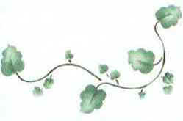
Greenhouses: Cultivating Student Understanding of Art, Materials, and Science
Susan Baldwin and Emily Kang
Subject: Art and Science
Grade Level: 6th grade

Rationale
Global Warming is an issue that concerns many people in our current society with increased CO₂ emissions from various industrial pollution sources. Educational efforts have been made to instruct students in the importance of conservation and the use of renewable resources. Visual arts provide an alternative means of communicating scientific concepts. Through this unit, we would like to create opportunities for students to construct increasingly complex original works of art reflecting personal choices and increased technical skill as they move to mastery of global warming, solar energy, and the greenhouse effect.

This lesson seeks to reinforce in students a three-fold theme:
- The scientific concept of the greenhouse effect: Greenhouse gases absorb thermal infrared radiation, emitted by the Earth’s surface, by the atmosphere itself due to the same gases, and by clouds. Atmospheric radiation is emitted to all sides, including downward to the Earth’s surface. Thus greenhouse gases trap heat within the surface-troposphere system.
- The importance of choosing the proper materials to enhance the features of a greenhouse: optimal sunlight transmission, and an ambient temperature level for plants to thrive.
- Exposure to the elements of art and principles of design as connected to a real-life inquiry activity. Students will experience the metamorphosis of their own 2-D design changing into their own 3-D form using materials from renewable resources.

Objectives
SCIENCE:
- Students will understand the concepts of global warming and solar energy as a renewable resource.
- Students will test their independent practice greenhouse for changes in air temperature.
- Students will modify their design based on their results to construct a final greenhouse.
- Students will justify their final design by writing an analysis of their results and communicate it to the rest of the class.

MATERIALS:
- Students will construct their independent practice greenhouse from using materials in class.
- Students gain experience manipulating the materials (glass, paper, foil, laminating film, vinyl, and Plexiglas).
- Students will identify the processes involved in creating glass from silica (sand), potassium or soda, and lime.
- Students will be exposed to the processes involved in manufacturing plastic.

ART:
- Students will predict their results, design and follow the scientific method during the hypothesis, construction, data collection, and conclusion phase of the unit.
- Students draw a 2 pt. perspective house (teacher guided step by step with PowerPoint lesson) using Microsoft Paint in the computer lab.
- Students expand their experience drawing their own individual 2 pt perspective house design building on prior knowledge from their Microsoft Paint experience using straight edge, paper and pencil.
- Students will construct a handheld greenhouse using Popsicle sticks for the frame and covering with foil, wax paper or plastic wrap.
- Students will change, edit, or revise their greenhouses after the critique, articulating reasons for their changes based on data gathered in science.

Standards
6th grade CA Science Content Standards

Heat (Thermal Energy) (Physical Sciences)
- Heat moves in a predictable flow from warmer objects to cooler objects until all the objects are at the same temperature. As a basis for understanding this concept:
a. Students know energy can be carried from one place to another by heat flow or by waves, including water, light and sound waves, or by moving objects.
d. Students know heat energy is also transferred between objects by radiation (radiation can travel through space).

Energy in the Earth System
- Many phenomena on Earth's surface are affected by the transfer of energy through radiation and convection currents. As a basis for understanding this concept:
b. Students know solar energy reaches Earth through radiation, mostly in the form of visible light.

Resources
- Sources of energy and materials differ in amounts, distribution, usefulness, and the time required for their formation. As a basis for understanding this concept:
c. Students know the natural origin of the materials used to make common objects.

Investigation and Experimentation
- Scientific progress is made by asking meaningful questions and conducting careful investigations. As a basis for understanding this concept and addressing the content in the other three strands, students should develop their own questions and perform investigations. Students will:
  - Develop a hypothesis.
  - Select and use appropriate tools and technology (including calculators, computers, balances, spring scales, microscopes, and binoculars) to perform tests, collect data, and display data.
  - Construct appropriate graphs from data and develop qualitative statements about the relationships between variables.
  - Communicate the steps and results from an investigation in written reports and oral presentations.
  - Recognize whether evidence is consistent with a proposed explanation.

Materials Science Content
- There are different kinds/classifications of materials
- Different materials have different structures
- Different structures have or lead to different properties
- Material properties determine functionality – material choices should be based on
  - Functional needs (strength, texture, temperature stability, flexibility, permeability, etc.)
  - Aesthetic needs (color, texture, density, etc.)

California Visual Art Standards 6th grade:
- Artistic Perception-
Processing, Analyzing, and Responding to Sensory Information Through the Language and Skills Unique to the Visual Arts
Students perceive and respond to works of art, objects in nature, events, and the environment. They also use the vocabulary of the visual arts to express their observations.
Develop Perceptual Skills and Visual Arts Vocabulary
1.3 Describe how artists can show the same theme by using different media and styles.
Analyze Art Elements and Principles of Design
1.4 Describe how balance is effectively used in a work of art (e.g., symmetrical, asymmetrical, radial).

2.0 Creative Expression-
Creating, Performing, and Participating in the Visual Arts
Students apply artistic processes and skills, using a variety of media to communicate meaning and intent in original works of art.
2.2 Apply the rules of two-point perspective in creating a thematic work of art.
2.3 Create a drawing, using varying tints, shades, and intensities.
Communication and Expression Through Original Works of Art
  - Create increasingly complex original works of art reflecting personal choices and increased technical skill.
3.0 Historical and Cultural Context-
Understanding the Historical Contributions and Cultural Dimensions of the Visual Arts
Students analyze the role and development of the visual arts in past and present cultures throughout the world, noting human diversity as it relates to the visual arts and artists.
3.2 View selected works of art from a culture and describe how they have changed or not changed in theme and content over a period of time.
4.0 Aesthetic Valuing-
Responding to, Analyzing, and Making Judgments About Works in the Visual Arts
Students analyze, assess, and derive meaning from works of art, including their own, according to the elements of art, the principles of design, and aesthetic qualities.
Derive Meaning
4.1 Construct and describe plausible interpretations of what they perceive in works of art.
4.3 Develop specific criteria as individuals or in groups to assess and critique works of art.
4.4 Change, edit, or revise their works of art after a critique, articulating reasons for their changes.

5.0 Connections, Relationships, Applications-
Connecting and Applying What Is Learned in the Visual Arts to Other Art Forms and Subject Areas and to Careers

Students apply what they learn in the visual arts across subject areas. They develop competencies and creative skills in problem solving, communication, and management of time and resources that contribute to lifelong learning and career skills. They also learn about careers in and related to the visual arts.
Careers and Career-Related Skills
5.5 Establish criteria to use in selecting works of art for a specific type of art exhibition

Time
5 44-minute Art class periods

3 44-minute Science class periods (The science lessons should be taught after the 5 Art days).

Lesson Procedures

Day 1
ART class

Big Idea:
Pre-instruction drawing and vocabulary

Materials: White paper and pencil

Procedure:
1. Students draw a house before any instruction to establish their drawing skill level. The pre-instruction drawing will be used to show drawing growth acquired during the unit.
2. Introduce the vocabulary words that will be used to transform students’ flat 2-D drawing into realistic 3-D drawing:
Foreshortening - a way of representing an object to convey the illusion of depth by shortening some of the object so that it appears
Perspective- Technique used to project an illusion of the 3 dimensional world on a 2 dimensional surface
1 point perspective-a form of linear perspective in which all lined (that represent straight lines) converge at one point (vanishing point) on the horizon line.
2 point perspective – an application of linear perspective in which all lines (representing edges that go from points nearer to points farther) appear to meeting at either of the two points on the horizon line.
vanishing point- the two points on the horizon line where lines seem to meet.
horizon line-a level line where land and sky seem to meet.
Two-dimensional (2-D)-having height and width but no depth. The object appears flat.
Three-dimensional (3-D)-Having or appearing to show height, width, and depth.
Shading-show a change from light to dark by darkening areas that are farther from the light source.
Shadow-an area that is not illuminated because an object blocks the light between the light source and the ground where the light would fall if it were not blocked.
3. Begin hypothesizing outcomes with the students and design possibilities of greenhouse.

Day 2
ART class
Big Idea: Students draw using a computer program.

Materials: 2 point perspective PowerPoint for step by step directions and a computer for each student or student group.

Procedure:
Students draw a 2 pt perspective house using Microsoft Paint or Microsoft Work using the step by step instructions found on the 2 Point Perspective PowerPoint in the computer lab.

Day 3
ART class
Big Idea: Students draw using a straight edge showing linear perspective

Materials: straight edge, paper, pencil and class samples, 2-pt perspective PowerPoint

Procedure:
- Students expand their experience drawing their own individual 2 pt. perspective house design from their Microsoft Paint experience in art class using straight edge, paper and pencil.
- Use the 2 point perspective PowerPoint in projected in the art room and draw using a pencil and paper each step as shown.

Day 4
ART class
Big Idea: Construct a 3-D form from the linear perspective drawing.

Materials: (per student) 20 craft sticks, tacky glue or cool glue gun

Procedure:
1. Create a 3-D greenhouse frame using tacky glue (or cool glue gun) and popsicle sticks. Begin by constructing the corners and sides of the frame using glue. Check for 90 degree angles for each corner. Rest the constructed pieces on wax paper or vinyl for ease of release when dry. Leave the constructed pieces to dry overnight.
Safety Issues:
Use cool glue for greenhouse skeleton structure; if hot glue is used, teacher should supervise use.

Day 5
ART class
Big Idea: Complete constructing a 3-D form from the linear perspective drawing. Add and glue the roof.

Materials: craft sticks, foil, tape, scissors, tacky glue or cool glue gun

Procedure:
- Complete the greenhouse construction using the pre-glued pieces that were left overnight to dry. See Instructions on Making a Greenhouse below.
- Compare house structures at the Metropolitan Museum of Art house structures online (http://www.metmuseum.org/toah/splash.htm)

Additional Art concepts/extensions to lesson:
Joints are levers and by simply changing the static glue joints to grommets the joints become a movable model.
Bonding of joints can be shown as a model for the use of bonds between elements. Show this by using colorful sticks and movable joints.
Glue evaporates and the properties of absorption, evaporation and density can be covered.
Glue and primer bores holes into surfaces and can become a point of discussion about how objects bond to each other in physical science.
Discuss malleability. Use different types of glue that you can stretch and pull when as it dries.
Pursue opportunities for students to transfer knowledge to the cube boxes (they will build other cube objects)

Day 6
SCIENCE class
Pre Knowledge:
The science lessons can be embedded in the Energy Resources Unit (Chapter 11 – Prentice Hall Earth Science 2008 or Chapter 5 – Holt Science and Technology) of 6th grade Earth Science. Day 1 can be taught after students have learned about natural resources as well as the difference between renewable and nonrenewable resources. The teacher will need to make a sample greenhouse frame (made of craft sticks and tacky glue) a day in advance. See Picture Instructions on Making a Greenhouse below.

Big Ideas:
1. What are materials?
2. What are the origins of common materials?
3. People make material choices depending on what people need.

Materials: common objects made of metal, plastic, wood, ceramic and glass (e.g. metal tube, aluminum foil, fabric, vinyl, plastics, ceramic mug, glass cup, paper), Internet access and computer (for YouTube video clips), sample greenhouse frame, Greenhouse Effect PowerPoint (slides 3-12)

- Have students in small groups and place various materials on their desks. Have students sort the materials based upon their characteristics (strength, texture, flexibility, density) and record their answers on the Materials Sorting Activity student worksheet. Sample answers include:

Material | Characteristics | What do the materials in this group have in common?
Glass cup | Hard, breakable, see through | Breakable, Smooth
Mug | Hard, breakable, not see through | Breakable, Smooth
Metal tube | Bendable, shiny | Bendable
Paper | Bendable, can be torn, white | Bendable
Fabric | Bendable, can be cut | Bendable
Plastic wrap | Clear, bendable | Bendable

- Use the Greenhouse Effect PowerPoint as a guide. (slide 3) Introduce what Materials are. (Materials = substances out of which a thing can be made). People use materials for many things based upon their characteristics. (slide 4) For example, if you wanted to go the beach on a sunny day, would you pack Coke in a plastic bottle, in a glass bottle, or in aluminum cans? Why?
- Ask if students have made similar material choices.
- Hold up a sheet of paper. Ask students how the paper was made.
- (slide 6) Show short video clips of how paper and glass made:

How Paper is made:*
http://www.youtube.com/watch?v=7SdJtYkAzTw&feature=related

If time permits, ask students if they know how glass is made. Show portion of the video:

How Glass is made:*
http://www.col-ed.org/cur/sci/sci180.txt

*These are videos from YouTube. Teacher may want to preview the videos and select only a few minutes of each clip to show students depending on time.

- (slides 7-8) Show the structure of glass. Ask students how the structure might be related to its properties (lots of spaces between molecules to allow light to transmit through).
- (slide 9-11) These are magnified images of some materials. Have students guess what they are. Keep reinforcing the link between what the material is and its use/function.
- Hold up a sample greenhouse frame and ask students what a greenhouse is for.
- (slide 12) Ask students what material they would use to cover it for plants to grow in. Cover the greenhouse with one of the materials the students suggested (e.g. plastic wrap). Have the students record on their Materials Sorting Activity Worksheet what they think will happen if they leave the covered greenhouse out in the sun. (Connect to the fact that the students build the model in Art class.)
- Have students share their responses.

Homework: Students should examine 5 materials at home and record their properties and uses.

Day 7
SCIENCE class
Big Ideas:
1. Students cover and test their greenhouses.
2. Different materials cause different temperature conditions inside the model greenhouse.

Materials: Greenhouse Effect PowerPoint (slide 13-15), wax paper, aluminum foil, plastic wrap, tape (masking or scotch).

Procedure:
- (slides 13-14) Review the process of constructing the greenhouse frame that the students did in Art class.
- Have students form groups of 3. Each student in the group will cover his/her greenhouse with a different material (foil, wax paper, or plastic wrap).
- Handout the Greenhouse Experiment worksheet and a thermometer for each student.
- (slide 15) Take the starting temperature for all students (so the initial temperature is the same for all students). Students take temperature readings outside classroom inside their handheld greenhouses in groups of 3. One with foil, one with paper and one with plastic wrap covering. Students record their data on their worksheet.
- Students return to the classroom once they’ve collected their data and begin answering the conclusion questions.

ELD support
- Provide sentence frames for writing the conclusion.
- Model how to collect data.
- Define vocabulary that students may be unfamiliar with: highest, lowest, thermometer, art studio, greenhouse, record, effect.

Extension: Take a field trip to a local botanic garden or greenhouse. Have students walk through the greenhouse and make observations on how it feels, smells, looks inside. Invite the guest speaker to talk about what they grow and how they maintain the ambient conditions in the greenhouse.

Day 8
SCIENCE class
Big Ideas:
1. What is the Greenhouse Effect? How is the Earth like a greenhouse?
2. What is Global Warming? How is the Greenhouse Effect related to Global Warming?

Materials: An Inconvenient Truth DVD, Greenhouse Effect PowerPoint (slides 16-18).

Procedure:
- Students finish conclusion and decide what they will do to improve their results. They will not be able to answer questions 4 and 5 of the conclusion until after today’s class on the Greenhouse Effect.
- Students should share out their findings from the experiment. Transition students to the idea of the greenhouse effect. How is the earth like a greenhouse? (slide 16) The following concepts should be discussed:
  - Solar energy – it’s the source of all energy; beginning of the food web
  - Define radiation (way sunlight reaches the earth and how it warms up the greenhouse) and demonstrate radiation with hot plate, thermometer and a variety of materials
  - Emphasize the fact that the Greenhouse Effect is a NECESSARY phenomenon. (Students often confuse the greenhouse effect with global warming).
- (slide 17-18) Ask the students what they already know about Global Warming (how CO2 levels in the Earth’s atmosphere is trapping in extra heat causing a steady rise in average global temperatures). Ask them to analyze the chart on slide 18.
- Have students brainstorm possible causes of Global Warming.
- Show the first 20 minutes of Al Gore’s An Inconvenient Truth DVD.
- If time permits, construct a list on the board of the causes and consequences of Global Warming.

Extensions to the experiment:
- Students can repeat their experiment and try to improve the way they covered their greenhouses to maximize their results (increase the efficiency of their greenhouse).
- Design and build a greenhouse with a different shape. How does the shape affect the temperature change?
- Construct a greenhouse with different materials (e.g. straws, balsa wood). How would this affect the greenhouse?
- Choose a different material to cover the building (e.g. glass, rigid plastic, wood). How would this affect the greenhouse?
- Grow plants inside the greenhouses.
- Work with light filters (red light) and how they change the plant growth.
- UV light (nail polish) is useful for students to see a resulting change for an environmental variable or unmeasured variable such as UV light.
- Construct a large PVC pipe skeleton greenhouse with a skin (vinyl) so that whole class can get inside and take ambient measurements as directed by teacher.

After this day, you can continue with the energy resources unit.
- Why is there global warming? What is causing all the CO2 emissions?
- Talk about coal, natural gas and petroleum use. What are some everyday products that we have made from these sources? What do the manufacturing plants look like?
- Why is it important to recycle and reuse materials?
- Have a debate on Global Warming: should we continue to use fossil fuels as the main source of our energy in the United States?
- Homework ideas: students measure the amount of energy they use at home (for lighting, cooking, heating water…)

Instructions on making a greenhouse

Step 1: Glue 2 craft sticks at a 90º angle to form a “joint.”  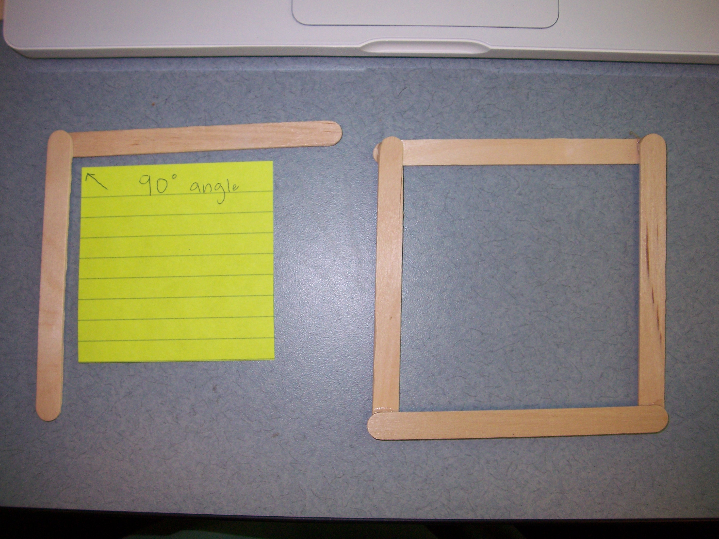 | Step 2: Glue 2 joints together.
Step 3: Glue on a roof piece. Create 2 of these “walls.”  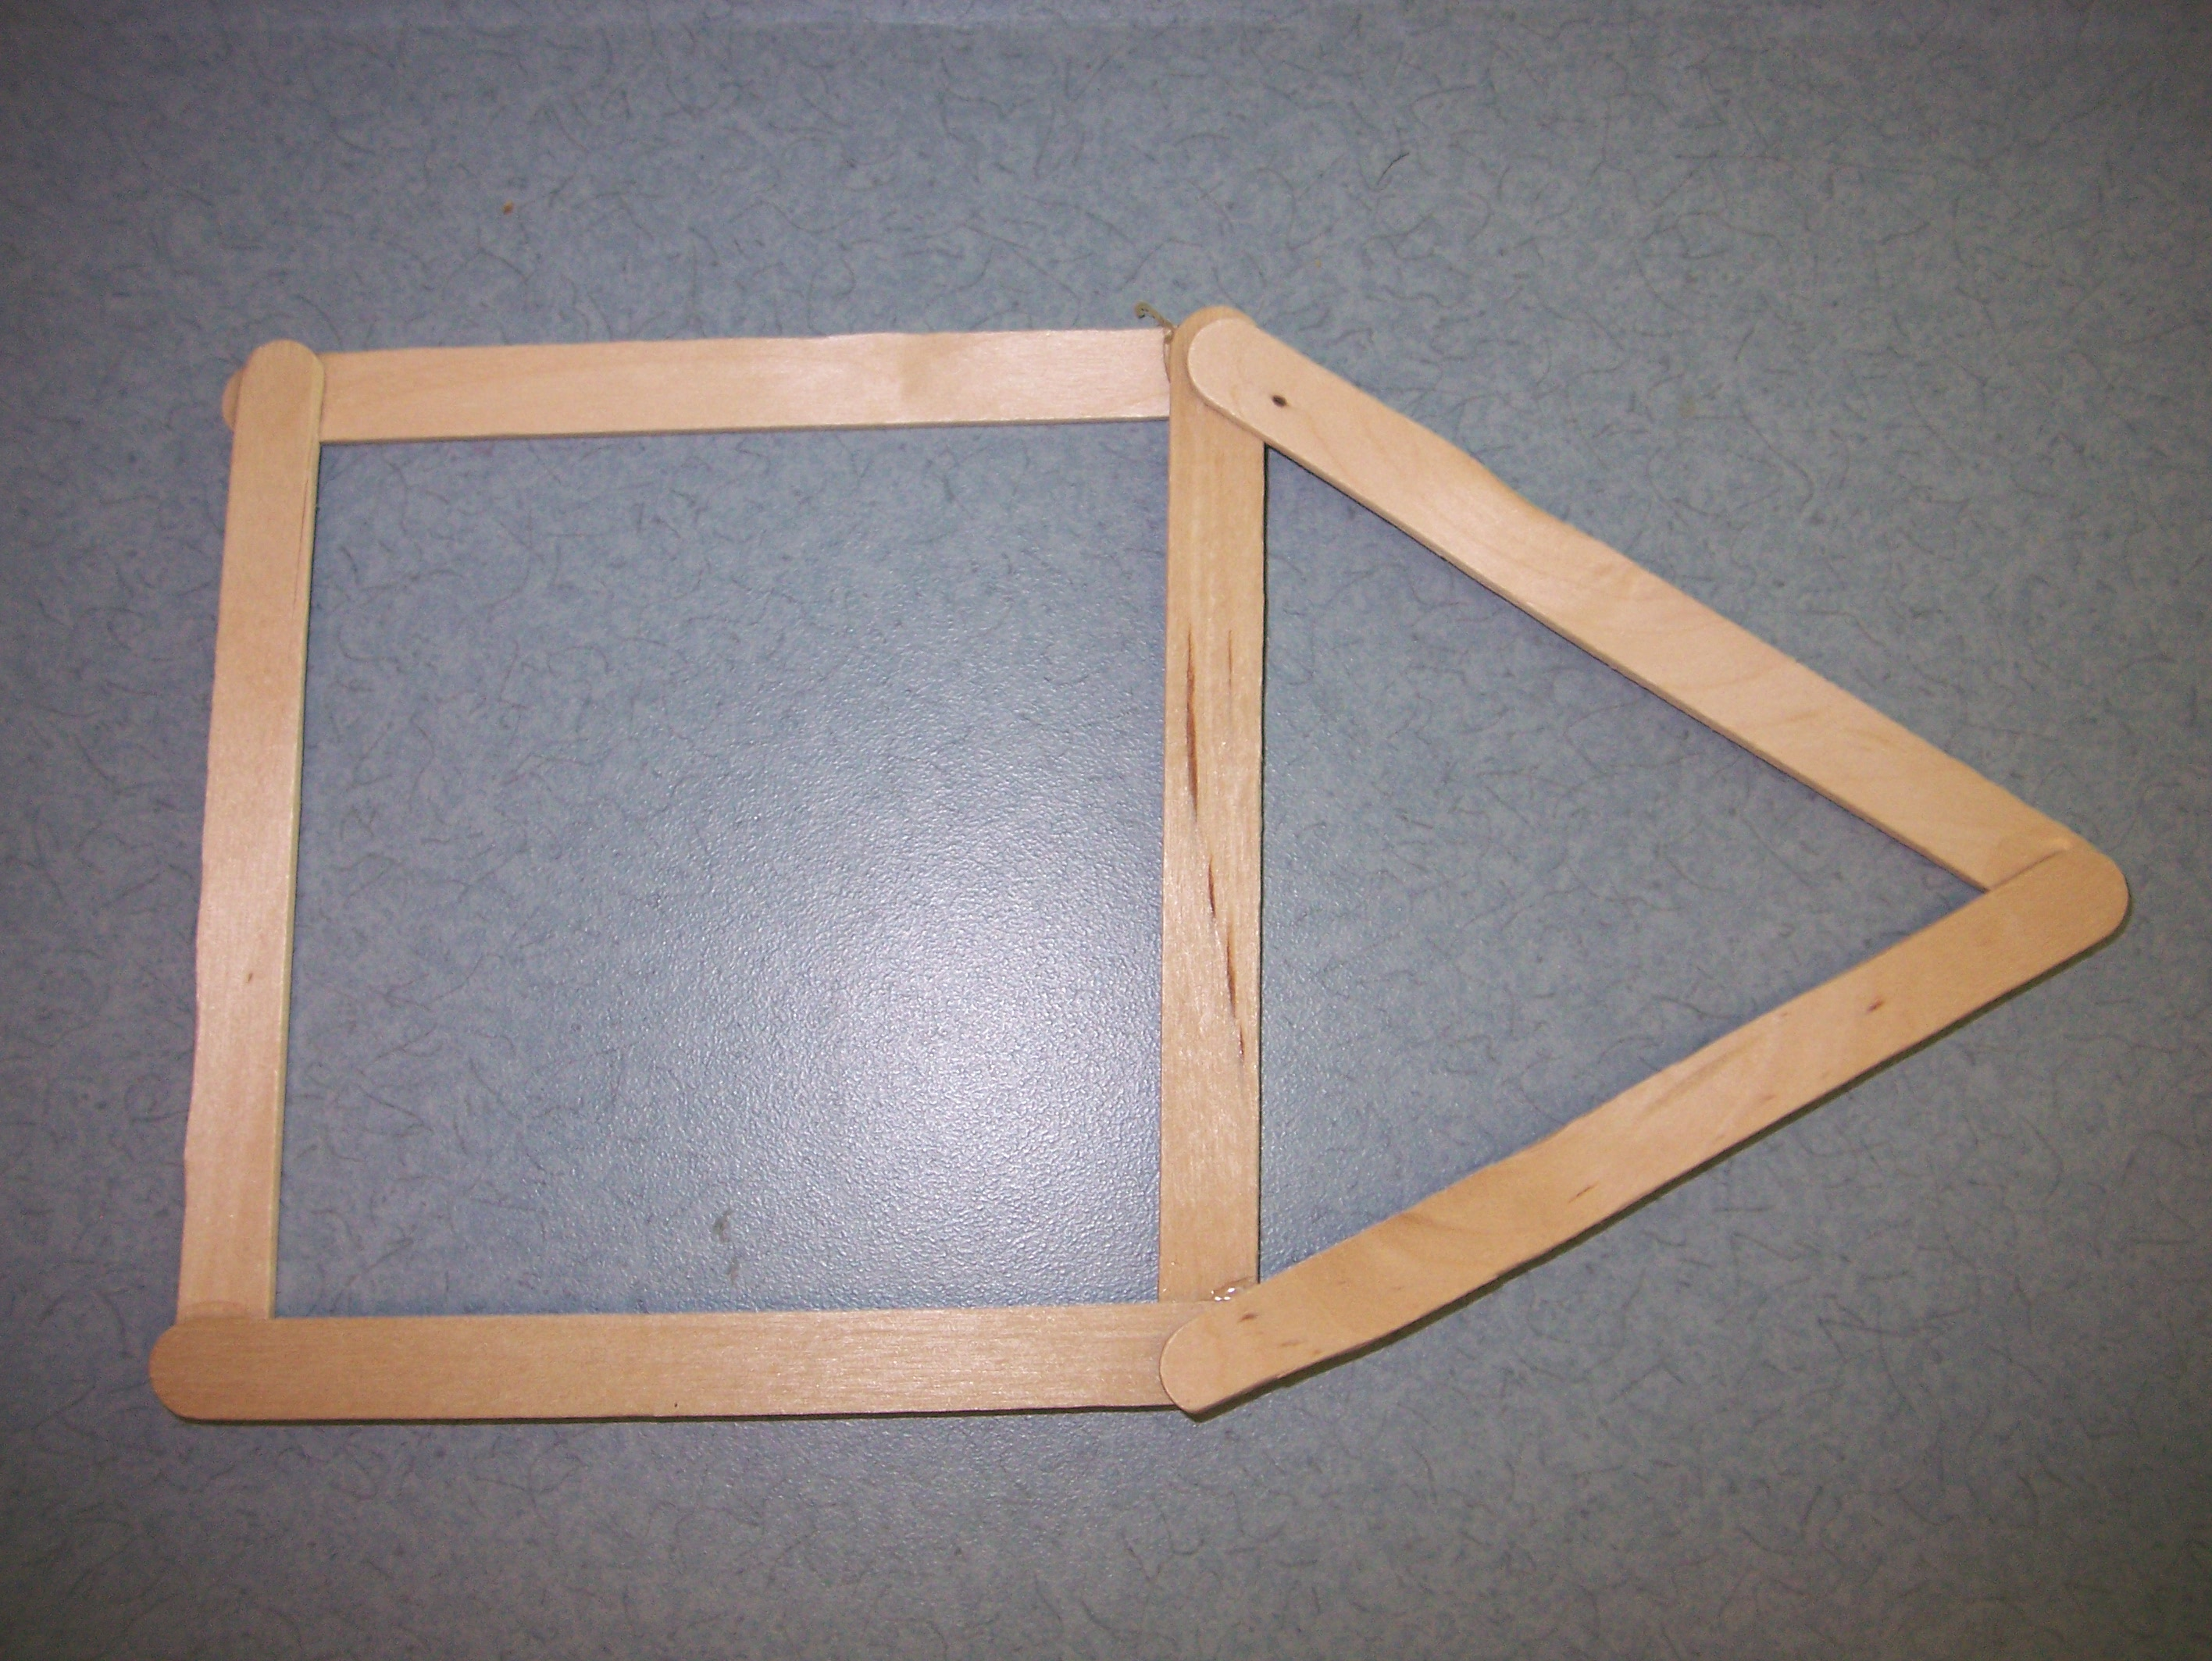 | Step 4: Add crossbars to join the two “walls.”  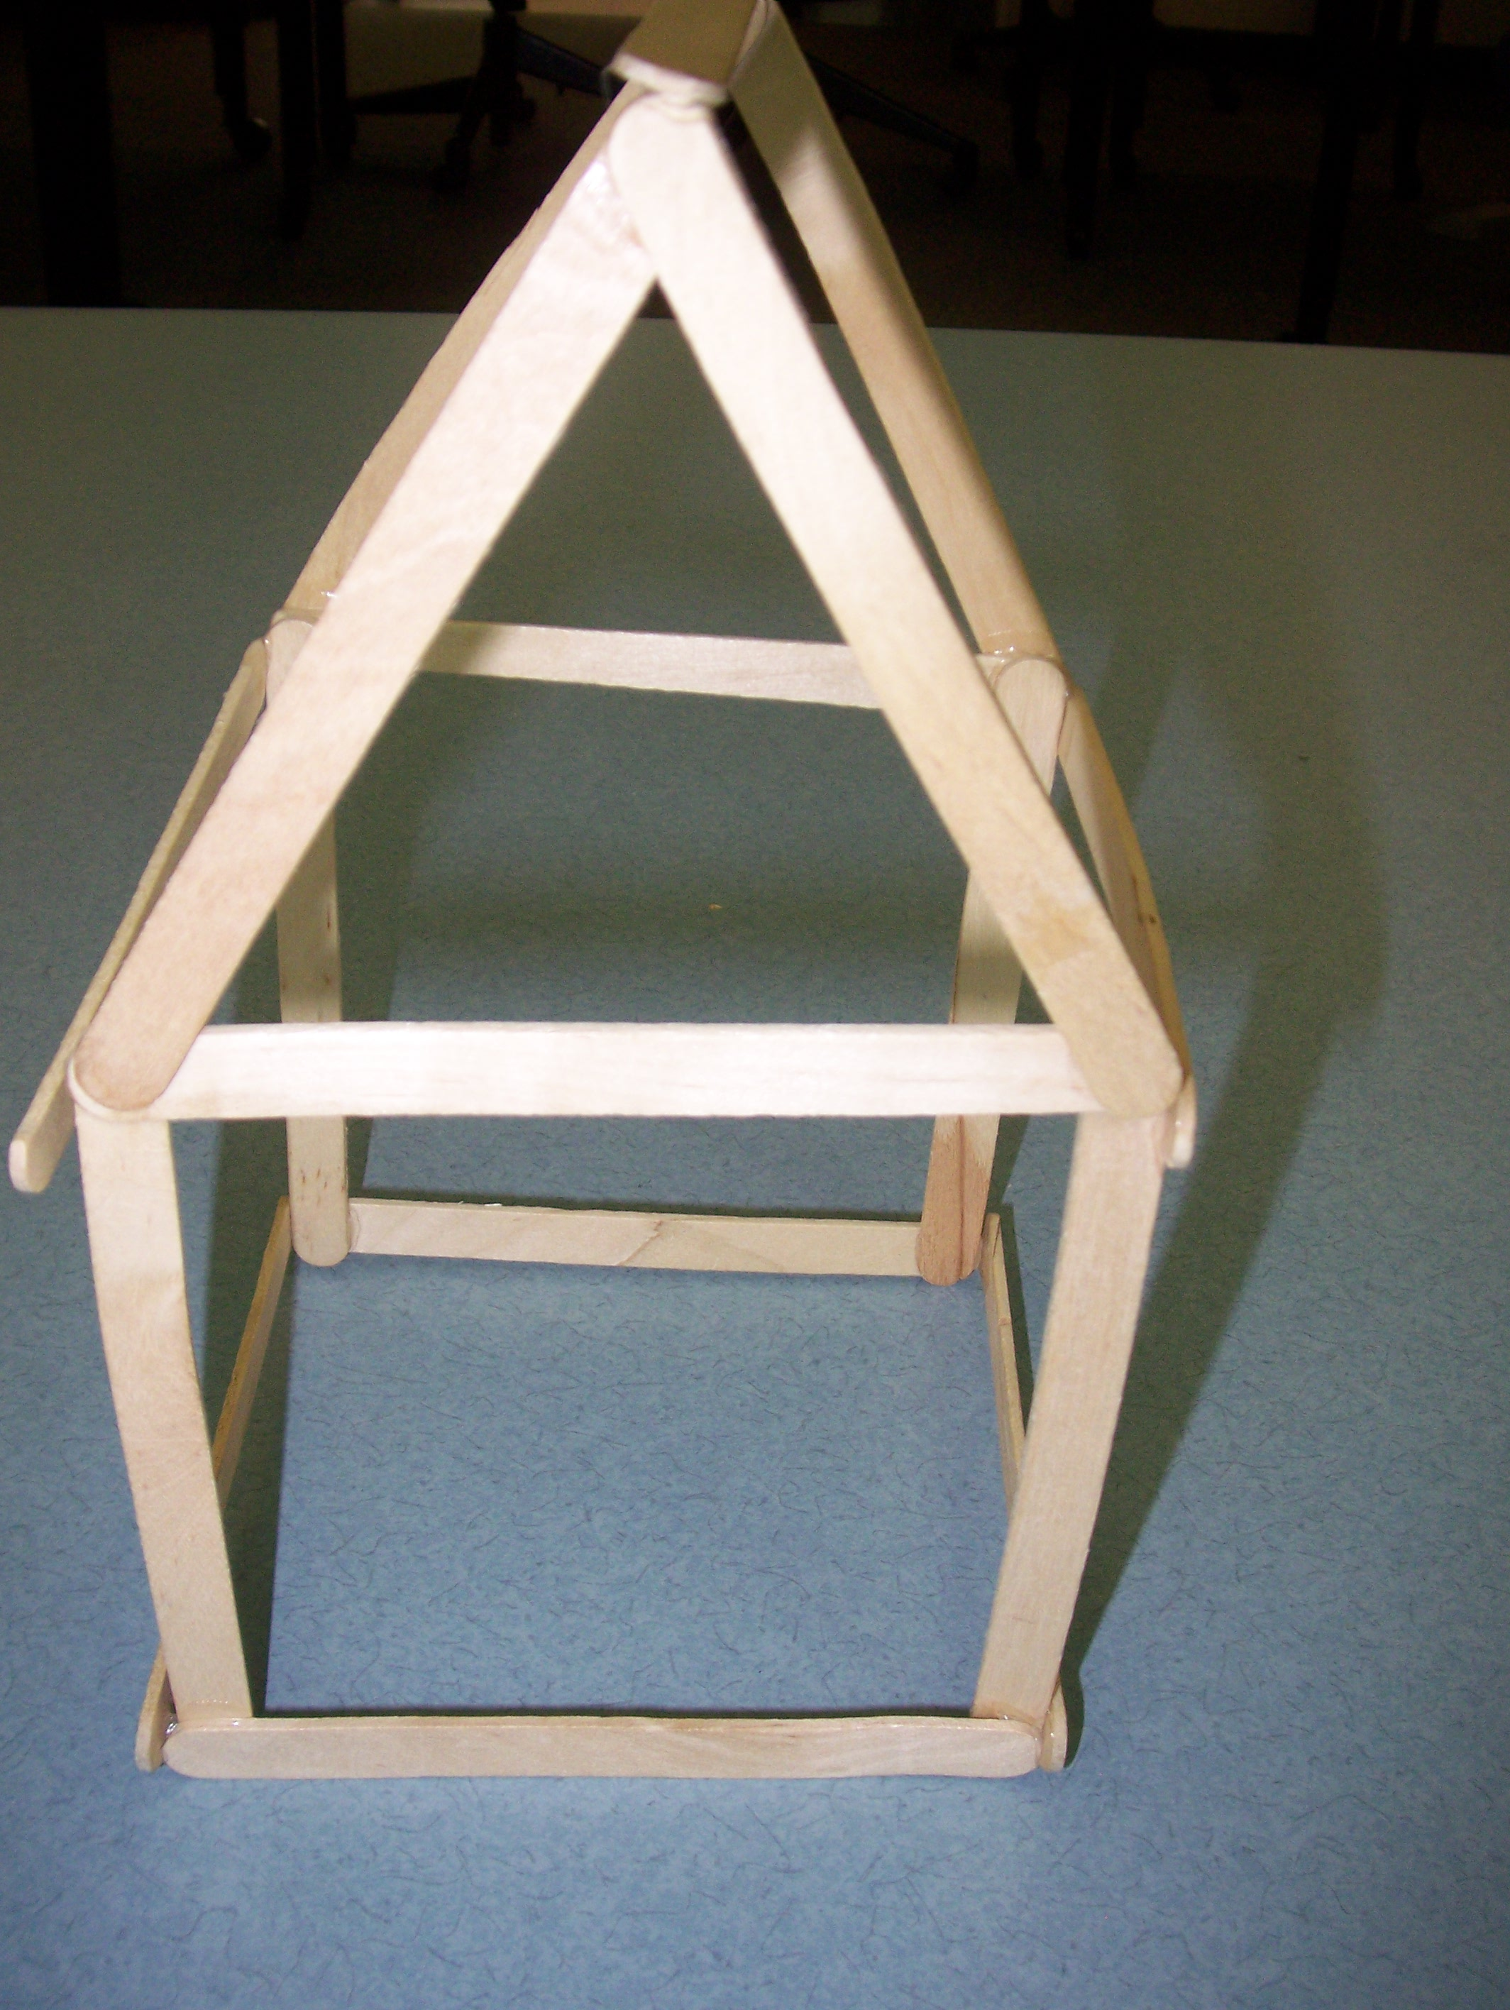
Another view of the finished greenhouse:
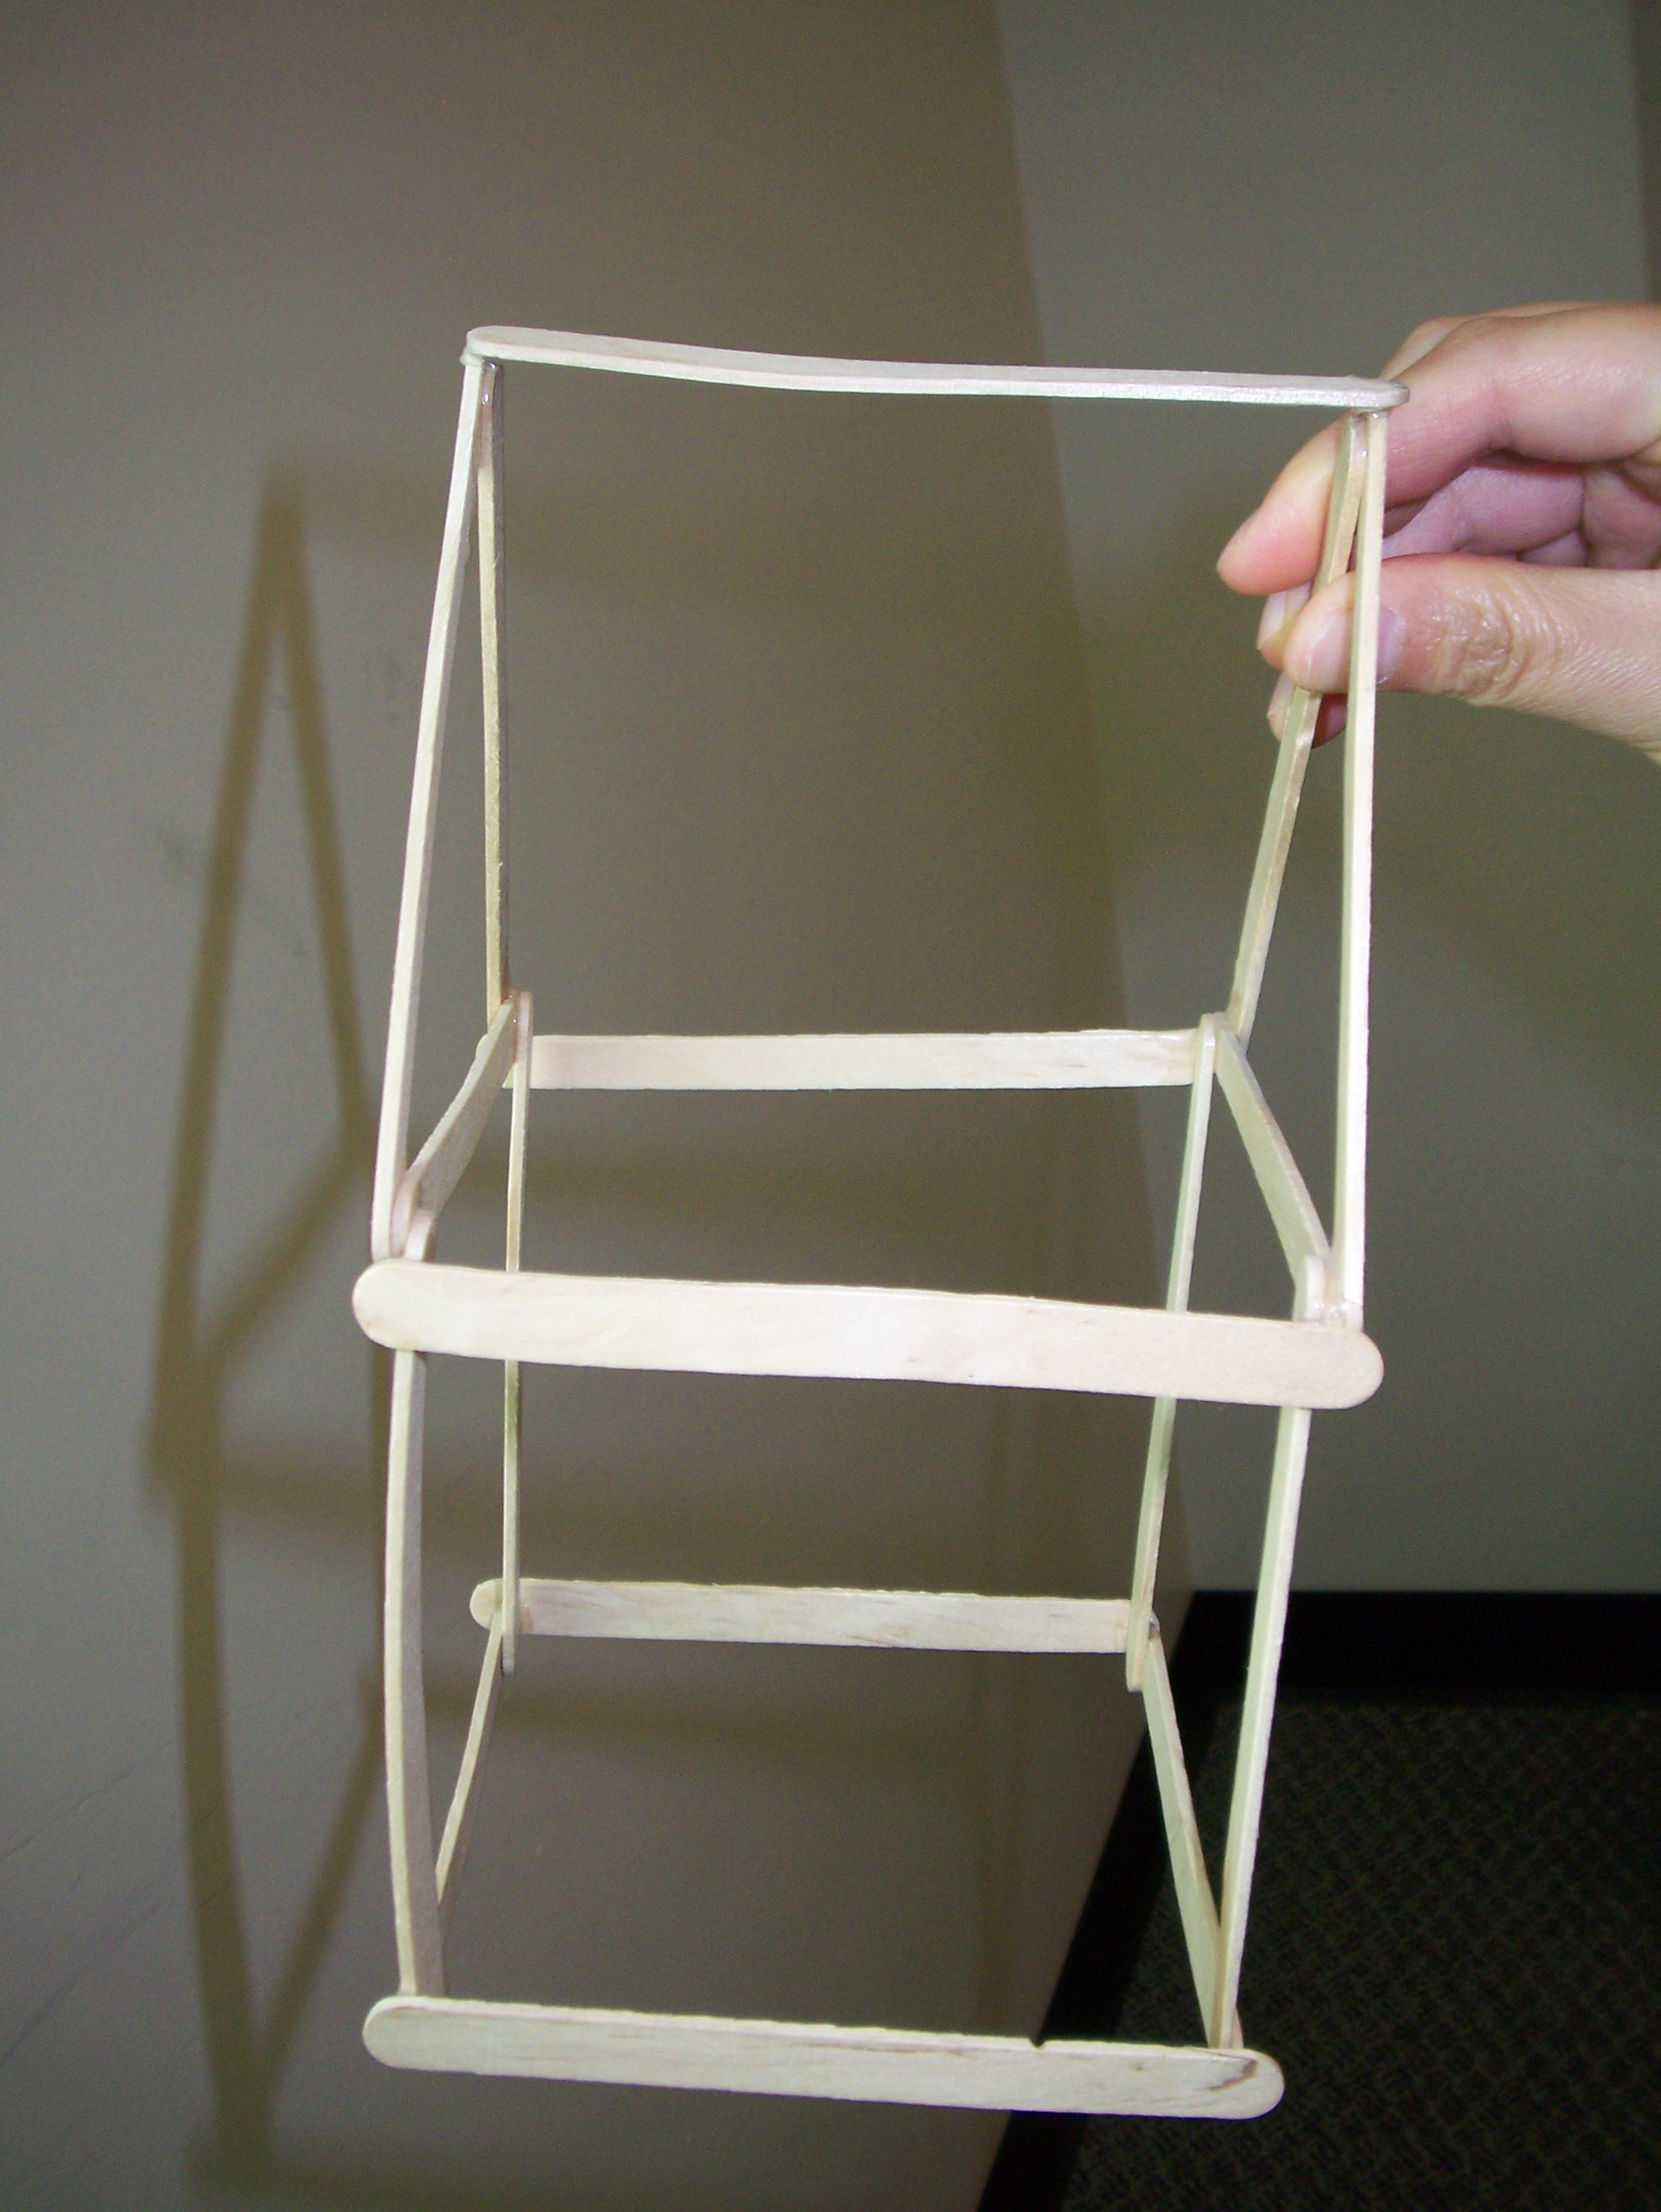
Name: Per.

Materials Sorting Activity

Material | Characteristics | What do the materials in this group have in common?

Greenhouse covering:
What do you think will happen inside the covered greenhouse if we leave it out in the sun?

Names: Per.

Greenhouse Temperature Experiment
Hypothesis (Which greenhouse covering do you think will create the highest and lowest temperatures? WHY?):
We think that will create the highest temperature and will create the lowest temperature in the greenhouse because .

Procedure
- Cover your building in one of the materials (foil, paper or plastic wrap).
- Record the starting temperature on your chart that your teacher gives you.
- Place your thermometer inside the greenhouse and place it in the sunlight.
- Wait 5 minutes and record your final temperature.
- Trade your building with another person in your group with a different material and repeat steps 3-4.

Data
Material used for building | Starting Temperature (°F) | Final Temperature (°F)
Foil
Plastic Wrap
Paper

Conclusion (Answer all questions in complete sentences).
- Which material created the highest temperature in the greenhouse? Why do you think so?

Which created the lowest temperature? Why do you think so?

- What are some of your sources of error?

- How would you improve the performance of your building?

- How is your greenhouse model like the Earth? How is your greenhouse NOT like the Earth?

- What are three causes of Global Warming? What is one effect?
Causes:
1.

2.

3.

Effect:

Assessment:

Art Class Rubric 1
Mark + or – in each box |  |  | Skill taught | If you received less than a + describe what you were doing instead
Self |  | Teacher
 |  |  | Warm up silently in your warm up book for 5 consecutive minutes
 |  |  | Focus during lecture or instruction time and take notes.
 |  |  | Practice the skill being taught for the entire working period. Time on task
 |  |  | Clean up to prepare for the next group.
Art Class Rubric 2

 |  | Exceeds expectations | Meets expectations | Does not meet expectations
PRE Instruction  Drawing  (5 PTS) |  | Students draw for the time allotted without prompts or deviating from task. Use the entire school heading before placing into inbox | Students draw for the time allotted with a few prompts to stay on task and follow steps. Student directing their own steps. | Students draw and require teacher prompts while horsing around. Distract others. Teacher directing steps.
Vocabulary  (20 PTS) |  | Students read and write vocabulary words and write them into sentences that show the meaning of the word. Use the class sample for form without copying the class sample word for word. | Students read and write vocabulary words and write them into sentences that show the meaning of the word. Use the class sample for form without copying the class sample word for word. | Students leave out one or more key steps, mis spell words or leave out sentences.
Greenhouse  (25 PTS) |  | Complete the greenhouse structure using an independent design that they create/ | Complete the greenhouse structure as shown in class. | Greenhouse structure is not upright or independent. Needs propping up or is flat on table
Computer Drawing  (25 PTS) |  | Correctly follows procedures and completes the steps. Add extras in addition to those shown in class. Turn in completed computer drawing with school heading to online folder. | Follow and complete the procedures send to folder online. | Students follow the drawing procedure. Student require prompts and leave out key steps.
Perspective Drawing  (25 PTS) |  | Follow the procedures and add extras in your drawing in addition to those shown in class. | Follow the procedures as those shown in class. | Students leave out one or more key steps, vocabulary words or sentences.

Science Rubric for Greenhouse Experiment

 | Exceeds expectations | Meets expectations | Does not meet expectations
Hypothesis  (5 PTS) | Students choose a material and provide a scientifically-based reason for choice. | Students choose a material and provide a reason (e.g. personal choice). | Students choose a material but provide no reason.
Procedure  (5 PTS) | Students accurately follow procedure and make modifications to enhance procedures. | Students follow procedure. | Students leave out one or more key steps.
Data  (5 PTS) | Data is accurately represented in the table. There are no anomalous data. | Data is accurately represented in the table. | Data is incomplete or contains significant anomalies.
Conclusion  (15 PTS) | - Conclusion is based upon data.  - Students explain patterns in data.  - Students provide reasonable connection between the greenhouse and the Earth  - Students provide a reasonable cause of Global Warming based upon lecture. | - Conclusion is based upon data.  - Students provide reasonable connection between the greenhouse and the Earth.  - Students provide a reasonable cause of Global Warming based upon lecture. | - Conclusion is not based upon data.  - Portions of the conclusion are incomplete or missing.

References:
- Sample greenhouse designs
http://www.wvu.edu/~agexten/hortcult/greenhou/building.htm
- Co2 test kit
http://www.4hydroponics.com/grow_room/co2test.asp
- Greenhouse supply store
http://www.growstore.com/lightmeasurement.asp
- All you need to know about greenhouses http://www.ces.ncsu.edu/depts/hort/greenhouse_veg/gtp_pages/ghstructures.html
- Solar Greenhouses
http://attra.ncat.org/attra-pub/solar-gh.html
- Recycling
http://www.wasteonline.org.uk/resources/InformationSheets/Glass.htm

