Synthetic Biology:
Breaking it Down and
Putting it Back Together

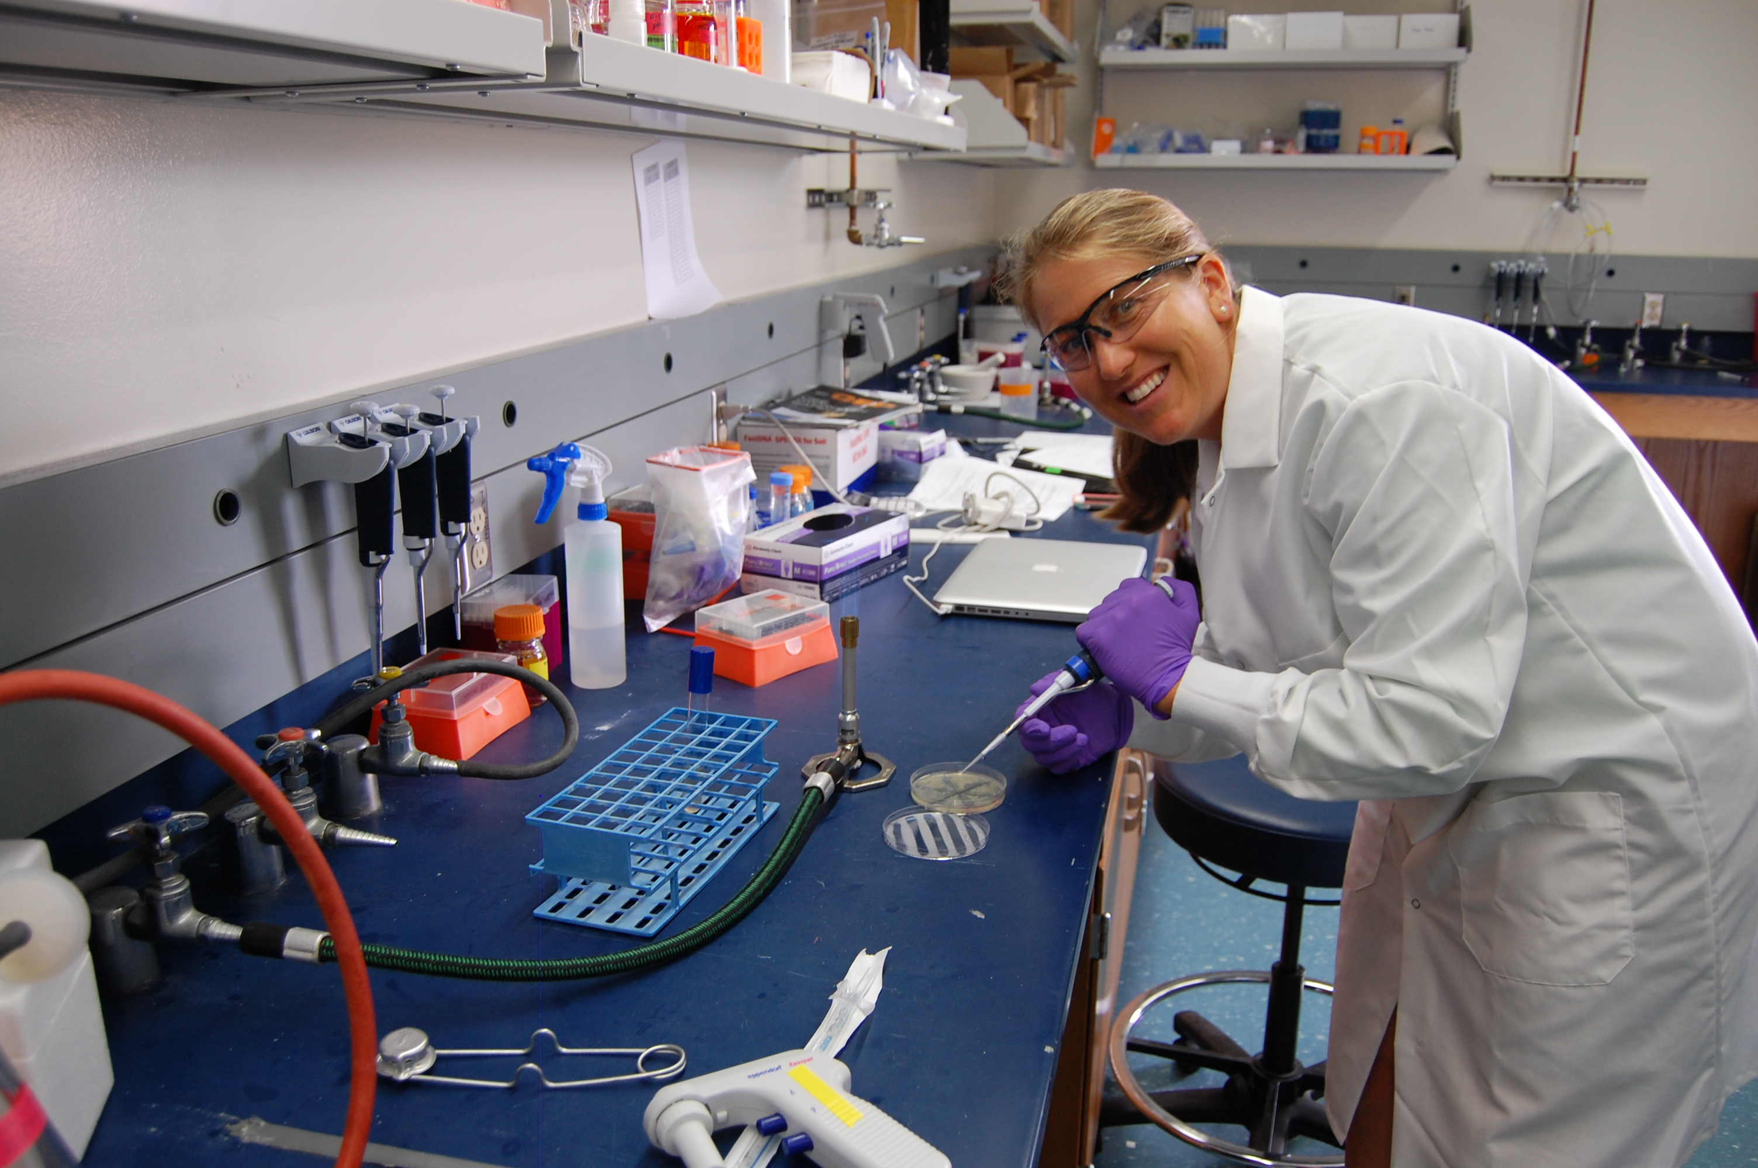

Megan Cotich
La Colina Junior High School
Santa Barbara, Ca

University of California, Santa Barbara
Materials Research Laboratory
Research Experiences for Teachers II

Table of Contents

Abstract and Project Overview | 1
Overview of Standards | 3
Module 1: Introduction to Synthetic Biology  1.1 Introduction to Synthetic Biology Presentation | 6
Module 2: Breaking it Down  2.1 How Small is Really Small?  2.2 Wheat Germ DNA Extraction Lab  2.3 Microbiology Presentations  2.4 Enzymes Break it Down  2.5 It’s All in the Family | 17  25  37  47  52
Module 3: Putting it Back Together  3.1 Bacteria Resistance to Antibiotic  3.2 Modeling Recombinant DNA  3.3 Bacterial Transformation Simulation  3.4 Gel Electrophoresis | 58  62  77  82
Module 4: Synthetic Biology Ethics  4.1 Synthetic Biology Ethics Debate | ?

Abstract
This portfolio includes four inquiry-based modules that focus on synthetic biology: “What is Synthetic Biology”, “Breaking it Down”, “Putting it Back Together” and “Genetic Engineering Ethics”. The modules are designed in succession to allow students to build on prior knowledge, and compile it with new concepts to culminate in a synthetic biology simulation in the third module. The final module is a debate in which they will form their own opinions about how the scientific community should move forward with regulating the field of synthetic biology. Each module is closely tied to Next Generation Science Standards for seventh grade life science, and also to Common Core reading, writing, and speaking and listening standards. There is an emphasis on incorporating informational texts, and technical writing of lab protocol. Modules one, three and four go beyond your typical life science curriculum, aiming to provide students with opportunities to apply their knowledge of the basics of genetics to cutting edge science and ethics. The four modules provide collaborative discussions, hands-on activities and labs, pose critical questions and require logical reasoning and analysis. After participating this unit, students will have a much deeper understanding of biological processes, and how scientists are using this information to solve complex problems improving society as a whole.

Project Overview

Introduction to RET 1 Research

My RET I project focused on synthetic biology. Working under Dr. Kevin Solomon in Michelle O’Malley’s chemical engineering lab, my project was to molecularly clone a cellulase from the fungus P. finn and insert it into the bacteria E. coli. Cellulases are enzymes that break down complex plant biomass into fermentable sugars. These sugars serve as feed stocks for microbial processes that generate a wide array of compounds including fuels, medicines, and bulk chemicals that form the majority of the items that we use as a society. The cellulases that we cloned from P. finn have the ability to break down a larger percentage of biomass than traditional methods of biofuel creation. The creation of this engineered bacteria will lead to further research into the regulation of microbial enzymes.

In completing this project we used the tools of molecular cloning, including gel electrophoresis, restriction digests, polymerase chain reactions (PCR), colorimetric assays, and microbiological techniques. This research continues in the O’Malley Lab and remains a promising alternative to current biofuel production practices.

Rationale

Junior high school life science is designed to provide students with an opportunity to explore the basics topics of cell biology, genetics, evolution, ecology and engineering. Though incredibly complex, the ability to show students in a regular classroom how the components of living systems can be engineered remains a daunting task. With this challenge in mind, these modules were designed to give students a “hands-on” experience without oversimplifying the processes. Extensions can be made to integrate current biomedical and scientific research as well as career education.

Each activity can be adapted to work nicely in a high school biology course. In addition, my aim is to challenge students to think like an expert in this field, questioning, modifying the course of their procedures, and analyzing their results. Students will have multiple opportunities in this unit to engage in Common Core standards of reading, writing, and making evidence based claims.

Learning Objective

You will find learning objectives in each lesson plan, but as an over-arching theme you will find them to be aimed at presenting students with tangible ways to understand microscopic concepts. In addition, the lessons will incorporate collaboration, reading of informational texts, writing procedures, analyzing data, and engineering skills.

Overview of Standards

Next Generation Science Standards

- LS1.A: Structure and Function
  - Within cells, special structures are responsible for particular functions, and the cell membrane forms the boundary that controls what enters and leaves the cell. (MS-LS1-2)
- LS1.B: Growth and Development of Organisms
  - Organisms reproduce, either sexually or asexually, and transfer their genetic information to their offspring. (secondary to MS-LS3-2)
  - Animals engage in characteristic behaviors that increase the odds of reproduction. (MS-LS1-4)
  - Plants reproduce in a variety of ways, sometimes depending on animal behavior and specialized features for reproduction. (MS-LS1-4)
  - Genetic factors as well as local conditions affect the growth of the adult plant. (MS-LS1-5)
- LS1.C: Organization for Matter and Energy Flow in Organisms
  - Plants, algae (including phytoplankton), and many microorganisms use the energy from light to make sugars (food) from carbon dioxide from the atmosphere and water through the process of photosynthesis, which also releases oxygen. These sugars can be used immediately or stored for growth or later use. (MS-LS1-6)
- LS2.A: Interdependent Relationships in Ecosystems
  - Organisms, and populations of organisms, are dependent on their environmental interactions both with other living things and with nonliving factors. (MS-LS2-1)
- LS3.A: Inheritance of Traits
  - Genes are located in the chromosomes of cells, with each chromosome pair containing two variants of each of many distinct genes. Each distinct gene chiefly controls the production of specific proteins, which in turn affects the traits of the individual. Changes (mutations) to genes can result in changes to proteins, which can affect the structures and functions of the organism and thereby change traits. (MS-LS3-1)
  - Variations of inherited traits between parent and offspring arise from genetic differences that result from the subset of chromosomes (and therefore genes) inherited. (MS-LS3-2)
- LS3.B: Variation of Traits
  - In sexually reproducing organisms, each parent contributes half of the genes acquired (at random) by the offspring. Individuals have two of each chromosome and hence two alleles of each gene, one acquired from each parent. These versions may be identical or may differ from each other. (MS-LS3-2)
  - In addition to variations that arise from sexual reproduction, genetic information can be altered because of mutations. Though rare, mutations may result in changes to the structure and function of proteins. Some changes are beneficial, others harmful, and some neutral to the organism. (MS-LS3-1)
- LS3.2
  - Develop and use a model to describe why asexual reproduction results in offspring with identical genetic information and sexual reproduction results in offspring with genetic variation.
- LS4.D: Biodiversity and Humans
  - Changes in biodiversity can influence humans’ resources, such as food, energy, and medicines, as well as ecosystem services that humans rely on—for example, water purification and recycling. (secondary to MS-LS2-5)
- Developing and Using Models
  - Modeling in 6–8 builds on K–5 experiences and progresses to developing, using, and revising models to describe, test, and predict more abstract phenomena and design systems.
  - Develop and use a model to describe phenomena. (MS- LS3-1),(MS-LS3-2)
- Influence of Science, Engineering, and Technology on Society and the Natural World
  - All human activity draws on natural resources and has both short and long-term consequences, positive as well as negative, for the health of people and the natural environment. (MS- ETS1-1)
  - The uses of technologies and limitations on their use are driven by individual or societal needs, desires, and values; by the findings of scientific research; and by differences in such factors as climate, natural resources, and economic conditions. (MS-ETS1-1)
- PS1.B: Chemical Reactions
  - Substances react chemically in characteristic ways. In a chemical process, the atoms that make up the original substances are regrouped into different molecules, and these new substances have different properties from those of the reactants. (MS-PS1-3) (Note: This Disciplinary Core Idea is also addressed by MS-PS1-2 and MS-PS1-5.)
- ETS1.B: Developing Possible Solutions
  - A solution needs to be tested, and then modified on the basis of the test results, in order to improve it. (secondary to MS-PS1-6)
  - There are systematic processes for evaluating solutions with respect to how well they meet the criteria and constraints of a problem. (secondary to MS-LS2-5)
- ETS1.C: Optimizing the Design Solution
  - Although one design may not perform the best across all tests, identifying the characteristics of the design that performed the best in each test can provide useful information for the redesign process—that is, some of the characteristics may be incorporated into the new design. (secondary to MS-PS1-6)
  - The iterative process of testing the most promising solutions and modifying what is proposed on the basis of the test results leads to greater refinement and ultimately to an optimal solution. (secondary to MS-PS1-6)

Common Core State Standards
- Reading:
  - Cite specific textual evidence to support analysis of science and technical texts.
  - Follow precisely a multistep procedure when carrying out experiments, taking measurements, or performing technical tasks.
  - Integrate quantitative or technical information expressed in words in a text with a version of that information expressed visually (e.g., in a flowchart, diagram, model, graph, or table).
- Writing
  - Write informative/explanatory texts, including the narration of historical events, scientific procedures/ experiments, or technical processes.
- Write arguments focused on discipline-specific content.
  - Introduce claim(s) about a topic or issue, acknowledge and distinguish the claim(s) from alternate or opposing claims, and organize the reasons and evidence logically.
  - Support claim(s) with logical reasoning and relevant, accurate data and evidence that demonstrate an understanding of the topic or text, using credible sources.
  - Use words, phrases, and clauses to create cohesion and clarify the relationships among claim(s), counterclaims, reasons, and evidence.
  - Establish and maintain a formal style.
  - Provide a concluding statement or section that follows from and supports the argument presented.
- Conduct short research projects to answer a question (including a self-generated question), drawing on several sources and generating additional related, focused questions that allow for multiple avenues of exploration.
- Gather relevant information from multiple print and digital sources, using search terms effectively; assess the credibility and accuracy of each source; and quote or paraphrase the data and conclusions of others while avoiding plagiarism and following a standard format for citation.
- Draw evidence from informational texts to support analysis reflection, and research.

- Speaking & Listening
  - Engage effectively in a range of collaborative discussions (one-on-one, in groups, and teacher- led) with diverse partners on grade 7 topics, texts, and issues, building on others’ ideas and expressing their own clearly.

