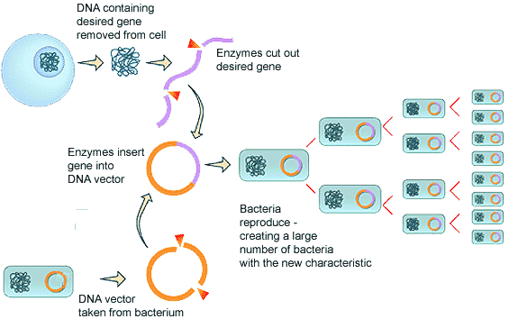
Bacteria as a Factory
Recombinant DNA Lab
Bacterial Transformation Simulation

