Recombinant DNA is a technology scientists developed that made it possible to insert a human gene into the genetic material of a common bacterium. This “recombinant” micro-organism could now produce the protein encoded by the human gene.
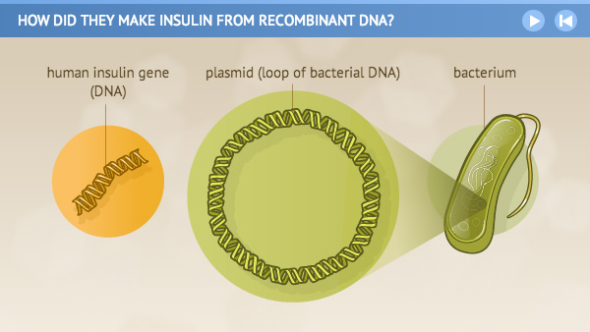  Scientists build the human insulin gene in the laboratory. Then they remove a loop of bacterial DNA known as a plasmid and… | 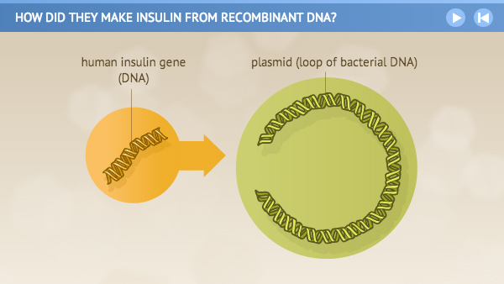  insert the human insulin gene into the plasmid.
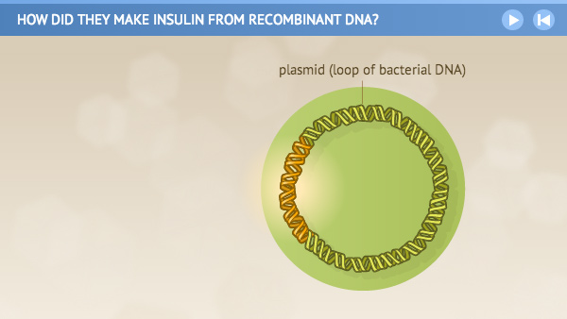 | 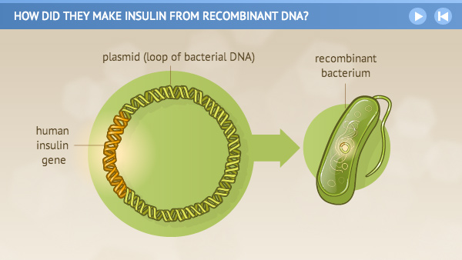  2.  1.  3.  4.  Researchers return the plasmid to the bacteria and…

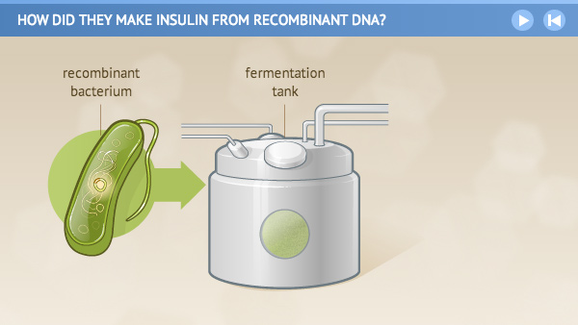  5.  put the “recombinant” bacteria in large fermentation tanks. | 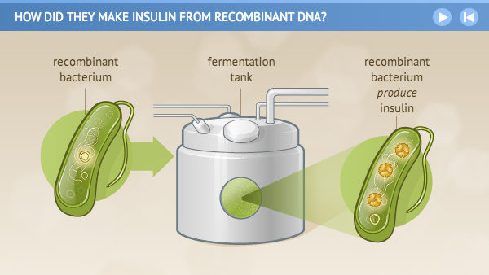  6.  There, the recombinant bacteria use the gene to begin producing human insulin.
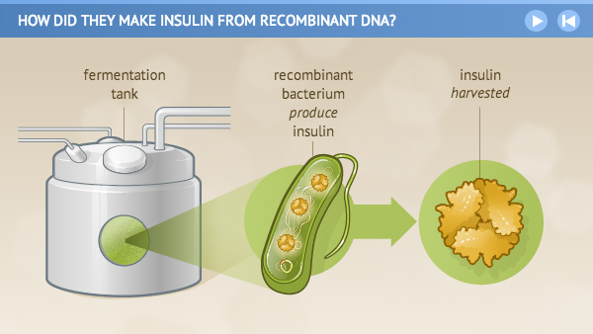  7.  Scientists harvest the insulin from the bacteria and… | 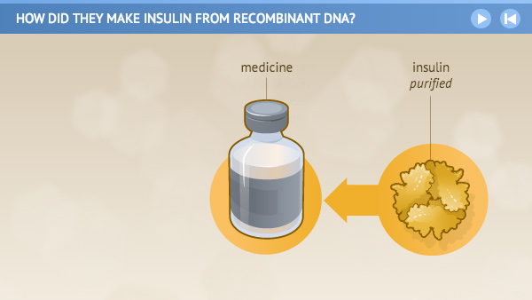  8.  purify the substance for use as a medicine for people.

