Purpose:

Recombinant DNA is used in a variety of ways to help people; one in particular is the production of insulin for people living with diabetes. In this activity you will learn the techniques and protocol for engineering recombinant DNA.

Background:
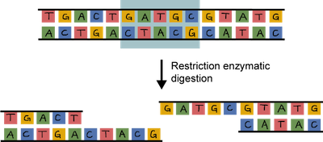
Recombinant DNA refers to the DNA that is created when the DNA of one organism is inserted into the DNA of another. In order to remove the desired gene from one organism and ready the DNA of the other, restriction enzymes are used, which can be thought of as DNA scissors. Enzymes occur naturally in organisms, particularly valuable to scientists are restriction enzymes found in bacteria. Each particular enzyme recognizes a specific, short, nucleotide sequence in DNA molecules. The restriction enzyme will cut the backbone of the molecules and result in a set of double-stranded DNA fragments with single-stranded “sticky ends.” These ends are referred to as “sticky” because they are easily paired with complementary bases on other DNA molecules.

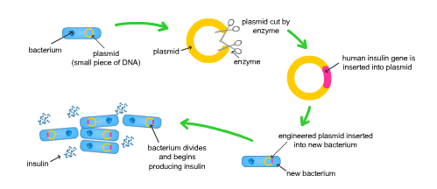
The desired gene must be able to replicate and function genetically within a cell. One very useful machine for replication is found inside a bacteria cell and is called a plasmid. Plasmids are small, circular, double-stranded DNA that are different from a cell’s chromosomal DNA. Small DNA fragments can be inserted into a plasmid, creating a recombinant plasmid, which will be reproduced every time the bacteria cell reproduces. The engineered plasmid will be bonded together permanently with DNA ligase at the sticky ends. The process by which the recombinant DNA is inserted into the bacteria cell is called transformation.

To learn more about how this process can be used to help people, read the article entitled “A new insulin given approval for use in U.S.” This article will explain the process used by a San Francisco based company to create the first recombinant DNA for use in medicine, opening the doors for the future of modern medicine.

Materials:

Plasmid DNA strips | Cell DNA strips
Enzyme cards | Scissors
Tape

Procedure:

- After reading the following procedures, fill in the transformation protocol flow chart. Have the protocol approved before you begin the activity.
- Cut out the Plasmid DNA strips. This plasmid is from a bacterium. Keep the strip with shaded region (where replication begins) and one other strip. You may discard the other two. Tape the two chosen strips together end to end.
- Cut out the Cell DNA strips. This strip contains the gene for insulin production. You must tape them end-to-end in order from #1-#6.
- Cut out the enzyme cards.
- Your job is to find one restriction enzyme that will cut your Plasmid DNA at ONE site, to open it so it is ready for the insertion of the insulin gene. As you test each enzyme against your Plasmid DNA, use a pencil to mark where it will cut, and label the enzyme that will make the cut.
- Next you will test the restriction enzymes on your Human Cell DNA. You must find one restriction enzyme that will cut your Human Cell DNA in TWO sites (around the insulin gene). As you test, mark with a pencil where it will cut, and which enzyme will make the cut.
- As you test each enzyme, mark your results in the table titled “Restriction Enzymes.”
- After completing your tests, decide which one enzyme you will use on both strands of DNA. (*If there is more than one enzyme that makes all three cuts, use the one that cuts closest to the insulin gene, limiting the amount of extra DNA nucleotides present.) Use a pair of scissors to cut out the insulin gene from your Human Cell DNA
- Cut the Plasmid DNA so it is an open ring.
- Align and tape your recombinant DNA together with the “sticky ends.” In the lab, ligase glues the “sticky ends” together with special bonds.
- In the lab, you would now mix your recombinant plasmid with a bacterial host and grow them on a petri dish. Some of the bacteria will absorb the plasmids, and replicate, producing human insulin.
- To test if the host cell (bacteria) has taken in the recombinant plasmid, you must test for the presence of the antibiotic resistance. Depending on what antibiotic resistance gene your plasmid has, you would place your recombinant DNA in a petri dish with that type of antibiotic. If it survives, you have successfully transformed the plasmid and it will make insulin.

