Draw the steps of creating a recombinant plasmid:
- Plasmid DNA and Human DNA (with shaded gene) | - Cut plasmid and insert DNA (separate) | - Recombinant plasmid
Step 1:
Step 3:

Step 4:

Step 5:

Step 6:

Step 7:
Step 8:
Step 9:

Step 2:

Record results from restriction enzyme testing:
Restriction  Enzyme | Cut Plasmid  (# or ∅) | Cut DNA  (# or ∅) | Final Result  (Used or Not Used)
1
2
3
4
5
6
7
8
9

Fill in the nucleotide bases for your chosen enzyme:
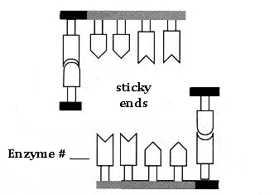

Antibiotic Resistance to: __________________________________

Define:
Recombinant DNA: __________________________________________________________________________________
_________________________________________________________________________________________________________
Restriction enzyme: _________________________________________________________________________________
_________________________________________________________________________________________________________
Sticky ends: __________________________________________________________________________________________
_________________________________________________________________________________________________________
Plasmid: ______________________________________________________________________________________________
_________________________________________________________________________________________________________
Transformation: _____________________________________________________________________________________
_________________________________________________________________________________________________________

Conclusion: Answer the questions in complete sentences, using the vocabulary from above.

- What are two purposes of a restriction enzyme?

- Why is important to chose an enzyme that only cuts the plasmid in one location?

- Imagine you engineered a recombinant plasmid, and prepare it grow on a culture overnight. You come back the next morning and nothing has grown on the plate. Explain what could have happened.

- Using information from article, explain how recombinant DNA lead to a breakthrough for diabetics.

- Explain another field (food science, clean energy, etc.) where this technology would be useful.

- What are some sources of error that you can anticipate encountering in an actual lab setting with this protocol?

