Topic:  Synthetic Biology | Name: ____________________________________________ Period: _________
Definition  Question (write your answer to the right)  Why Study Synthetic Biology?  Applications of Synthetic Biology  Recombinant DNA Technology | - Synthetic Biology is the design and construction of new biological components  - Enzymes  - Genetic circuits  - Cells  - Combines biology and engineering  - Understanding how life works and how to use it to benefit society  - Microorganisms can help solve some of the world’s most complex problems  - The diversity and amount of biological systems is immense  - As we learn more about how they work, biological organisms are becoming easier to engineer  - Biofuels: Engineering microorganisms to efficiently convert biomass  - Vaccine and Antibody Production: Sequencing genetic information  - Plant Sciences: Genetically engineering food sources  - Industrial Enzymes: Ex. Lactose free foods, laundry detergents  - Bio-based chemicals: Biodegradable plastics, plant based cleaning supplies, decrease reliance on oil  - Genetically engineered DNA prepared by cutting DNA with enzymes and splicing them back together  - Can be used to add, modify or delete genes
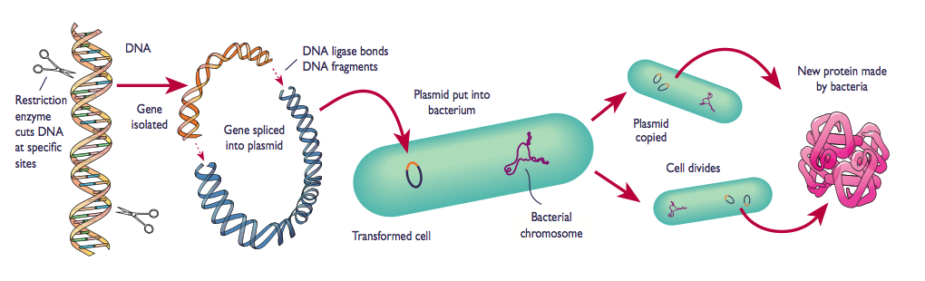  Restriction enzyme cuts DNA at specific sites | Isolated gene is spliced into plasmid and ligated |  | Plasmid put into bacterium; transformed |  | Cell divides, making copies of recombinant plasmid
Vocabulary | - Chasis: A host cell  - Vectors: Used to carry the transforming DNA to the host cell, bacterial plasmid  - Promoters: Acts as a catalyst, location of DNA where transcription of a gene begins
Plasmid |  | Enzyme | PCR (polymerase chain reaction) | Ligate
Bacterial in origin, extra-chromosomal, circular, double-stranded DNA, much smaller than the genome |  | A substance produced by a living organism that acts as a catalyst to bring about a specific biochemical reaction | To amplify a piece of DNA, generating thousands to millions of copies of the sequence | To link two ends of DNA or RNA
Reflection
- Based on what you just learned about synthetic biology, what is your position regarding it? Do you think it is largely positive or negative? Write a 3-sentence summary of your thoughts.

At the end of the unit, students will participate in a debate regarding the ethics of genetic engineering. The goal is to get them thinking about this. Today, they have only been provided with positive reasons for why we should engineer with biological organisms, but they will be able to come up with some negative points as well.

