Name____________________________________ Date________________ Period___________

Protein Bracelets
Modeling Transcription and Translation

Purpose: In this lab, you will model transcription and translation that occurs due to a negative feedback loop.

Vocabulary:
Transcription | the process in which RNA polymerase uses a DNA template to create a complementary mRNA strand
Translation | The process in which proteins are created:  - mRNA (contains codons) finds a ribosome  - tRNA (contains anticodons and carries amino acids) binds to the codon on the ribosome  - amino acids attached to tRNA molecules on the ribosome create a peptide bond  - translation continues until a stop codon is reached and the polypeptide chain is released
Codon | A sequence of three nucleotides on mRNA that codes for a specific amino acid
Anticodon | The complementary sequence to a codon; located on tRNA
Amino acid | Subunits of proteins
Polypeptide | A chain of amino acids
TATA box | A transcription promoter sequence (ATATTT on the sense strand)
Terminator Sequence | Sequence of mRNA that signals the end of transcription (AAUAAA on the mRNA strand)

Procedure:
- By the end of this lab, you will create a bracelet that you can keep or gift to someone else. You will simulate a negative feedback loop that will drive the expression of the protein needed. Determine what is lacking in you or someone you know. Dependent upon which protein is needed in the system, choose the appropriate DNA sequence.

Choose from the following protein options:
Act Now Bracelet  - Enzymes: This sequence is a portion of ATP synthase which catalyzes the production of ATP (major energy molecule)  - Give to: Someone who needs to act on something or make a decision about something in their life | Support Bracelet  - Structure Proteins: This sequence is a portion of keratin which gives structure/support to nails and hair  - Give to: Someone that needs encouragement. This bracelet says, “I support you.” | Breathe Bracelet  - Transport Proteins: This sequence is a portion of hemoglobin which is found in red blood cells and carries oxygen throughout the body  - Give to: Someone that needs to take a deep breath and relax
Here’s to Health Bracelet  - Antibodies: This sequence is a portion of gamma G immunoglobulin which protects your body from infection from bacteria, viruses and fungi  - Give to: Someone who is in need of better health, either physically, emotionally or mentally | Journey Well Bracelet  - Hormones: This sequence is a portion of Human Chorionic Gonadotropin which travels through the body to protect a developing fetus  - Give to: Someone who is going on a trip soon | Strength Bracelet  - Filamentous Proteins: This sequence is a portion of actin which aids in muscle contraction  - Give to: Someone who has an upcoming sport competition or could use some extra strength in life

DNA sequences:
Act Now – ATP Synthase | 3’CCGAGCTTCGATATTTTGGCACGTGGTTAGCCGGAGATAGTACGTCTTCTGACCGTGACGGCTCATTGGCAGGCTTCATTATTTCGAAGTTACCC-5’
Support–Keratin | 3’CCGAGCTTCGATATTTTGGCACGTGGTTAGCCGGAGATAGTACTCAGCTGTCAAATCAAGCGCCACTGGCAGGCTTCATTATTTCGAAGTTACCC-5’
Breathe– Hemoglo-bin | 3’CCGAGCTTCGATATTTTGGCACGTGGTTAGCCGGAGATAGTACTATGAATCAGGCCGTCTATTCATCGGCAGGCTTCATTATTTCGAAGTTACCC-5’
Health – γG Immunoglobulin | 3’CCGAGCTTCGATATTTTGGCACGTGGTTAGCCGGAGATAGTACTGAGTGTGGACAGGGGGTACGATTGGCAGGCTTCATTATTTCGAAGTTACCC-5’
Journey – hCG | 3’CCGAGCTTCGATATTTTGGCACGTGGTTAGCCGGAGATAGTACTCATTTCTCGGTGAGTCCGGGATCGGCAGGCTTCATTATTTCGAAGTTACCC-5’
Strength - Actin | 3’CCGAGCTTCGATATTTTGGCACGTGGTTAGCCGGAGATAGTACCCGCGCCCGCTGCTTCTCCAAACTGGCAGGCTTCATTATTTCGAAGTTACCC-5’
*Sequences were determined using the first seven amino acids in the protein. Although the amino acid sequence is accurate, DNA sequences may not be accurate.

TRANSCRIPTION
- Cut out the 8 strips of DNA template. Tape the strips together. Copy the sequence of your DNA chosen above. Label each box with the correct base.
- Cut each of the bases according the following diagram:
T
C
G
A

- Locate the TATA box. The transcription start site will be 25 nucleotides downstream of the beginning of this promoter region.
- Cut out and label the RNA nucleotides. Remember that Uracil replaces Thymine in RNA.
- Create a cut-out to represent RNA polymerase. As you slide RNA Polymerase down the DNA template, add the complementary RNA base pair (nucleotides are assembled in the 5’ to 3’ direction).
- Transcription will end when the terminator sequence is created on the mRNA strand. Tape all of your mRNA bases together.
*Note: In eukaryotes, the RNA strand created during transcription will undergo some modifications before beginning translation. This process will not be demonstrated in this activity. You should understand the definitions of introns and exons.

TRANSLATION
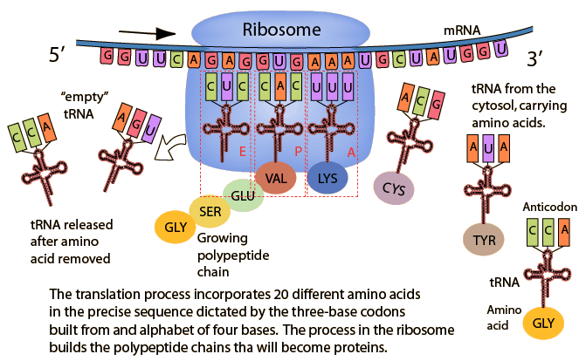
(http://hyperphysics.phy-astr.gsu.edu/hbase/organic/translation.html)

- Create a two-part paper representation of a ribosome to show the small subunit (40S) and the large subunit (60S). Label the E, P and A sites – these should be as large as 3 nucleotides each.
- Slide the mRNA strand through the ribosome. The 5’ end should enter the ribosome first. Find the start codon; this is where translation begins.
- For every codon, create a tRNA out of a paperclip. Label the anticodon using masking tape and attach the appropriate amino acid using the genetic code and key on the following page. Assemble all of your tRNA molecules ahead of time before you start modeling translation. REMEMBER: the amino acid is coded for by the codon on the mRNA strand.

Genetic Code:
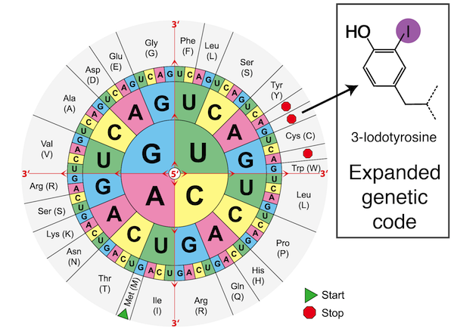
(http://beacon-center.org/blog/2013/07/22/beacon-researchers-at-work-expanding-the-genetic-code)

Amino Acid bead key:
Ala – solid pink | Gln – clear blue | Leu – solid red | Pro – solid white
Arg – solid green | Glu – clear green | Lys – solid lt. blue | Ser – solid purple
Asp – clear colorless | Gly – solid orange | Met – solid black | Thr – solid dk. blue
Cys – clear orange | His – solid yellow | Phe – clear red | Val – clear purple
Ile - clear yellow | Asn – solid cream

- Bring the appropriate tRNA that matches the codon into the ribosome at the A-site. In the next step, the codon and anticodon slide into the P-site allowing the next tRNA to enter the A-site.
- Simulate a peptide bond by stringing the two amino acids and disconnecting the amino acid from the tRNA in the P-site.
- The empty tRNA from the P-site slides into the E-site while the growing chain attached to the tRNA in the A-site slides into the P-site.
- Continue this process until a stop codon is reached. Your protein bracelet is finished. Tie your bracelet around your wrist or gift it to someone (be sure to explain the significance).

Analyze:
- What is the product of transcription?

- What is the product of translation?

- If a coding sequence of DNA is TGCAACTGG, what is the anticodon sequence?

- Discuss the relationship between genes and polypeptides.

- Insulin is a hormone that reduces blood glucose levels by increasing the rate at which glucose passes from the blood through the cell membranes into cells.What effect would eating a meal rich in carbohydrates have upon transcription/translation of insulin proteins?

- Why is gene expression more complicated in eukaryotes than it is in prokaryotes?

- Explain why your bracelet is so much shorter than your DNA strand, or even your mRNA strand.

- Your bracelet represents the primary structure of the first part of your protein. What has to happen in order to get the entire protein?

- Explain when a point mutation would have no effect and when a point mutation would have a large effect on the resulting protein.
5’
3’
DNA template
5’
3’
5’
3’
5’
3’
5’
3’
DNA template
5’
3’
5’
3’
5’
3’
RNA Nucleotides
A

U

G

C

