Hello?! I’m Talking Here…

COMMUNICATION IN THE SCIENCE CLASSROOM

By Emily Kang
6th Grade Health/Earth Science

Vandenberg Middle School
Mountainview Blvd.
VAFB, CA 93437
805-734-4391
emilykang@ureach.com

March 18, 2005



An NSF Materials Research and Engineering Center
- Abstract

After six weeks of research in an authentic scientific setting, I came away with skills not often fostered in classrooms but nonetheless indispensable to the advancement of real world science. My curriculum project centers on the incorporation of an aspect of research that I found prevalent in laboratories but somewhat lacking in my classroom: COMMUNICATION. Students learn better when they teach the concept to someone else. By the sheer act of communication, it forces the student to process the information into digestible bits and convey it to another.
This curriculum project will manifest itself throughout the year in the form of jigsaw labs, debates, and projects that have opportunities for peer review and oral presentations incorporated into them. The activities will be geared towards the 6th grade Earth Science and Health curricula and address the California Earth Science and Health standards.

II. RET II Project
Innovations:
The following activities have been designed to reinforce the communication skills:

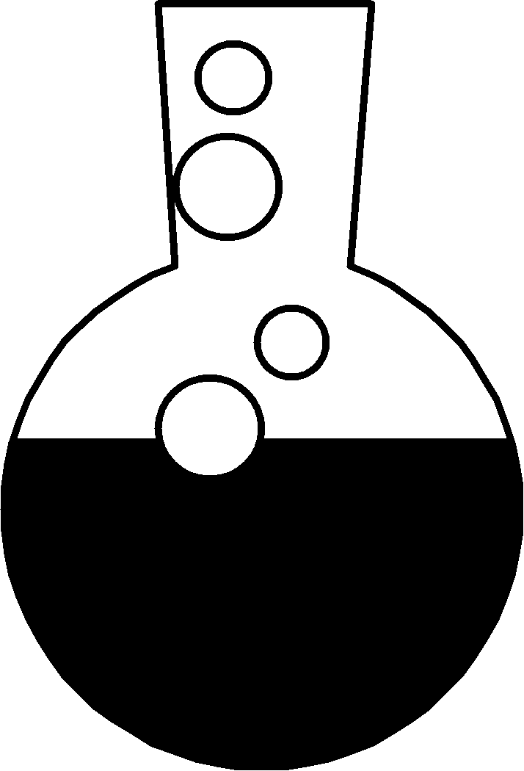
Jigsaw Labs – I tried one inquiry-based lab last year on crystal growth. Each lab group grew a different type of crystal and had to repeat the experiment as many times as necessary and change variables such as water temperature and type of salt used in order to maximize crystal growth. I’ve seen so many labs promoting inquiry but I have not seen many that hold each lab group accountable for their discovery so as to solve a larger mystery. I have designed “jigsaw” labs based upon some of my pre-existing labs.

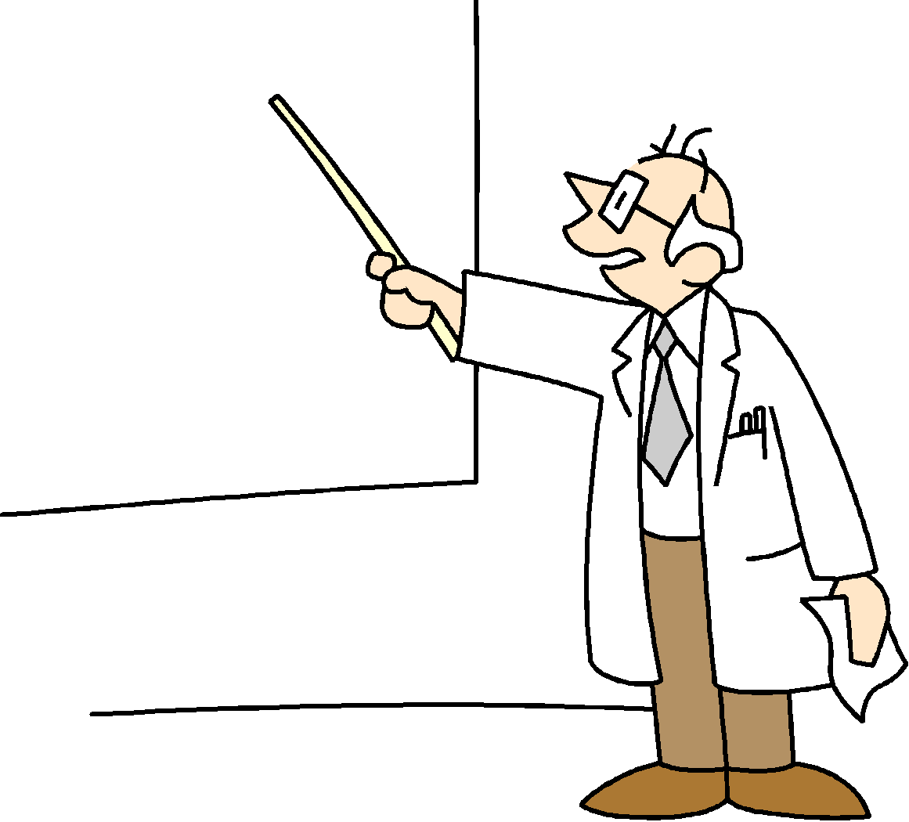
Presentations with Peer Review – I require science fair projects from my students. Each student was asked to make a presentation of their topic in class before they presented to the judges at the fair, as a form of practice for the judging. I had each student in the audience write down a commendation and recommendation for each presenter. (Examples: Great way of presenting that graph…Try to look more at the audience when you speak). These compliments and advice were meaningful to the presenters because it came from their peers. Their presentations before the judges were much more confident and informed because of the peer review.

Debates – Students took a stance on the use of fossil fuels for energy. They were asked to take sides in a debate as to whether or not we should continue to use fossil fuels as a major energy source. Even the quietest students participated as they all had a view on the matter. I have added more debates to the curriculum in the hope of fostering more critical thinking and improve oral communication skills.
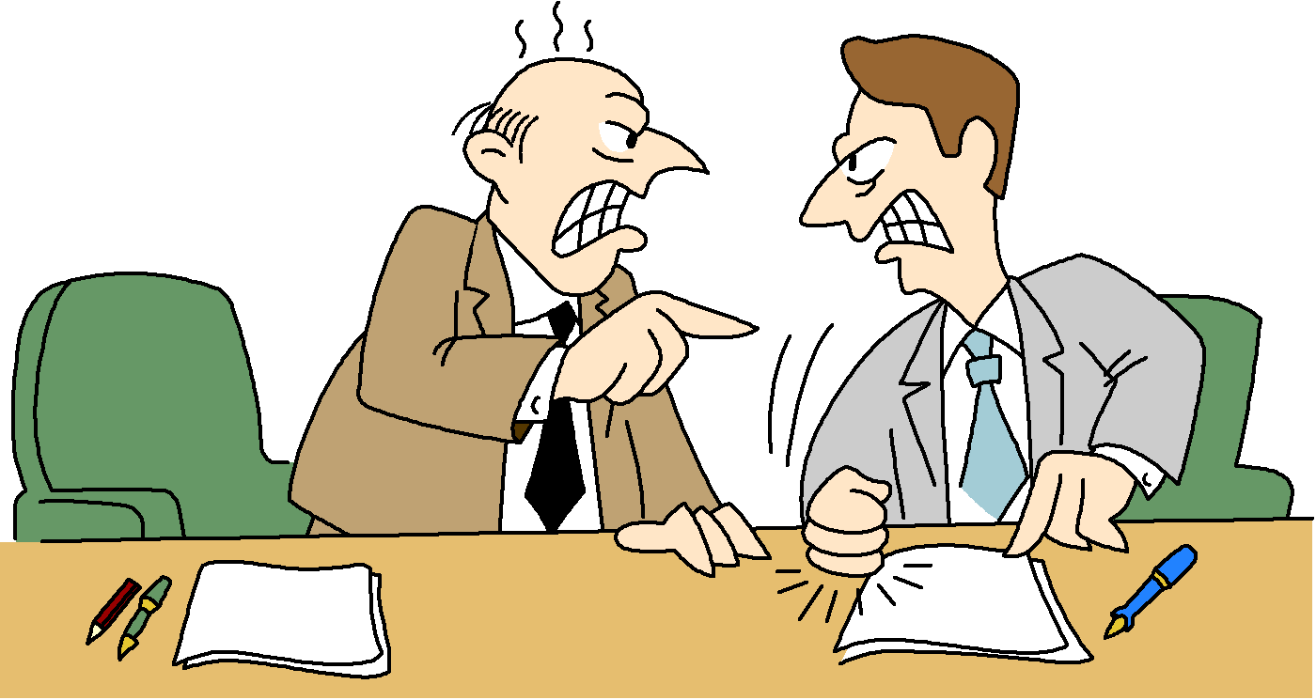

c. Standards/Student Objectives
Activities | Standards Addressed / Student Objectives*
Heat Exchange Lab  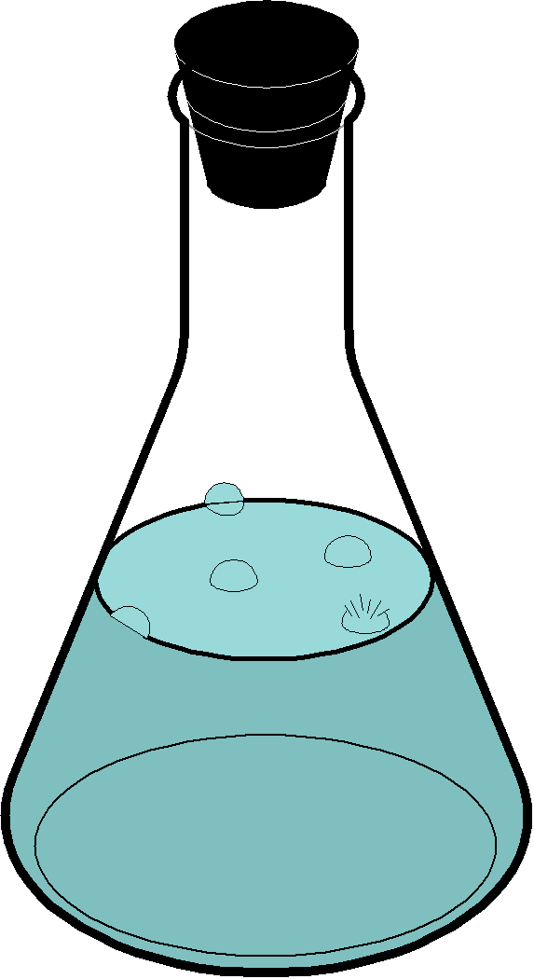   | Std 3.a. Students know energy can be carried from one place to another by heat flow or by waves, including water, light and sound waves, or by moving objects.  Std. 3.b. Students know that when fuel is consumed, most of the energy released becomes heat energy.  Std. 3.c. Students know when heat flows in solids by conduction and in fluids by conduction and convection (which involves flow of matter).  Std 7.a. Develop a hypothesis  Std 7.b. Select and use appropriate tools and technology to perform tests, collect data, and display data.  Std 7.c. Construct appropriate graphs from data and develop qualitative statements about the relationships between variables.  Std 7.d. Communicate the steps and results from an investigation in written reports and oral presentations.  Std 7.e. Recognize whether evidence is consistent with a proposed explanation.
Earthquake Building Contest   | Std 2.d. Students know earthquakes, volcanic eruptions, landslides, and floods change human and wildlife habitats.
Science Fair Presentations  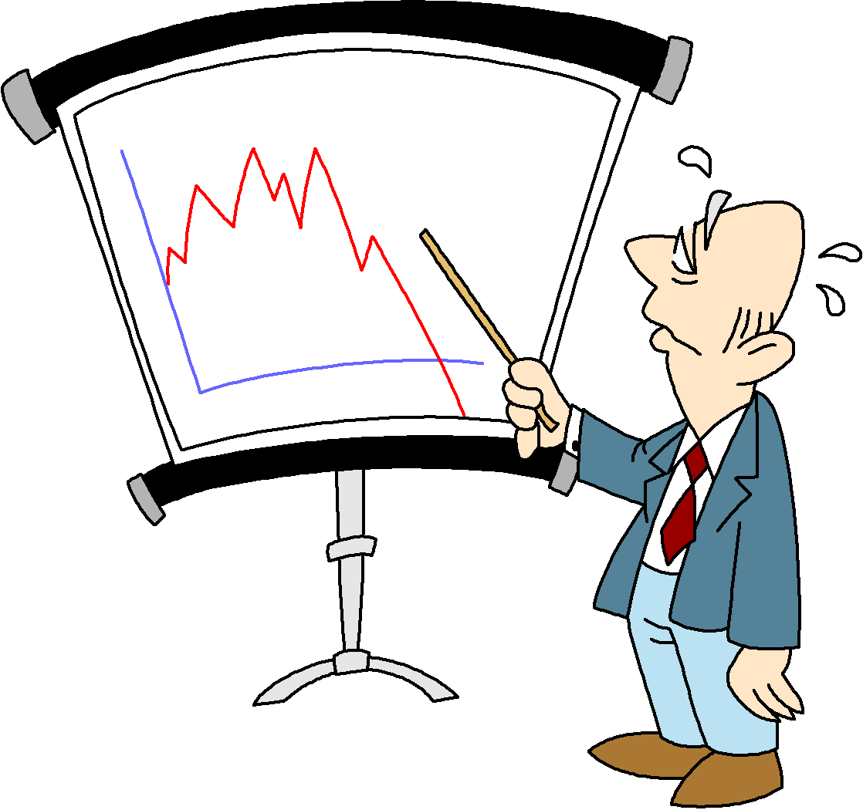 | Std. 7.d. Students will communicate the steps and results from an investigation in written reports and oral presentations.
Fossil Fuel Use Debate   | Std. 7.e. Students will recognize whether evidence is consistent with a proposed explanation.

*CA State Content Standards for 6th grade Earth Science and Middle School Health

NAMES: DATE:
PERIOD:
Heat Exchange Lab
**NOTE: Each lab group will be performing different versions of this experiment. Be sure to pay attention to what your group is doing. Our whole class will need your accurate results to finish this lab, so work carefully!

- Purpose - Students will understand the concept of thermal equilibrium and heat flow.

- Materials – Erlenmeyer flask, beaker, 2 thermometers, aluminum foil (used by only some groups), graph paper

- Hypothesis – answer in complete sentences:
  - What will happen to the two temperatures of the waters after several minutes?
  - Do you think the hot water or cold water will change in temperature more or will they change equally? Why do you think so?

Hot
Cold

- Procedure –
1. As a group, circle which of the 4 experiments you want to try:
a. Hot water inside flask with no foil cover, cold water outside in beaker

b. Hot water inside flask and covered with foil, cold water outside in beaker

c. Cold water inside flask, hot water outside in beaker with no foil cover

- Cold water inside flask, hot water in outside beaker and covered with foil

- Get your materials
- Add 100 mL of hot water from the hot plate in the back of the room into your container. Put one thermometer in. Measure temperature.
- Add 100 mL of cold water to your other container. Put other thermometer in. Measure temperature.
- Leave both thermometers in their containers. Measure temperature every 30 seconds until both thermometers reach the same temperature (thermal equilibrium).
- Clean up (return thermometers to rack, dump waters, return beaker and flask to cart)

- Data -
Time (min:sec) | Temp of Hot Water (˚C) | Temp of Cold Water (˚C)
0:00
0:30
1:00
1:30
2:00
2:30
3:00
3:30
4:00
4:30
5:00
5:30
6:00
Change in temp*

Some groups may finish before 6:00 minutes. If your group needs MORE than 6 minutes to reach thermal equilibrium, continue your chart on another sheet of paper.
*To find change in temperature, subtract your smallest temp. from your largest (ex. Hot water started at 55˚C and cooled to 15˚C. The change in temp. is 55-15 = 40˚C … Cold water started at 0˚C and warmed to 15˚C. The change in temp. is 15-0 = 15˚C)

- Results -
1. Get a sheet of graph paper from Ms. Kang
2. Graph your results.
3. You must: Label each axis – Temperature (˚C) vs. Time (min:sec)
Include a key (hot, cold)
Color code your lines
4. Why do you think scientists use graphs to show their results?

- Conclusion –
1. What is thermal equilibrium?
2. What is heat flow? 3. Each group shares results. What do you notice about Group A’s result? Group B’s? C’s? D’s?
4. If you were a scientist who wanted to have your hot and cold water container temperatures to meet exactly half way from their starting points, how would you design your experiment? (clue: which container would hold what type of water? Would you use foil?)
Answer all of the following questions in one, giant paragraph.
5. Which parts of your hypothesis were correct?
6. Why do you think we only covered the hot water with foil and not the cold water?
7. Why did your group get the results that it did?
8. What problems/mistakes did you have/make during the lab?

EARTHQUAKE BUILDING CONTEST*

PURPOSE: Students will explore earthquake hazards and damage to buildings by constructing model buildings and subjecting the buildings to ground vibration (shaking similar to earthquake vibrations) on a shake table. The buildings are constructed by three-person teams of students. After construction, the buildings are tested by subjecting them to earthquake shaking to see which designs and constructions are successful. Comparison of the results of the building contest with photographs of earthquake damage is used to reinforce the concepts of building design and earthquake risk.

MATERIALS:

- Shake table or stack of books
- Posterboard
3 – 8 x 8 cm squares (floors)
8 – 1.5 x 10 cm strips
8 – 1.5 x 15 cm strips
- Scotch Tape (2 cm or 3/4” wide) 100 cm length (Plan accordingly!)
- Scissors
- 30 cm ruler

RULES:
- You must use only the supplies given. (You don’t need to use every piece, though.)
- Your building must be at least 18 cm tall.
- It must stand on its own.
- It must withstand P, S, and Surface wave vibrations.
- It must withstand weights that are put on it (I usually place a bottle of white-out on the 2nd floor and see if the building can stay balanced).

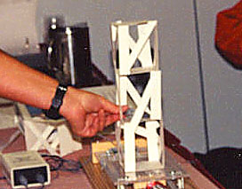

* (Posterboard Buildings, May, 1999; revised, March 2003, October 2003) L. Braile, Purdue University
For original version of lession, visit www.eas.purdue.edu/~braile

Science Fair Experiment Rubric
*Read each category carefully. You will be graded according to how you perform in each category.

Student Name: _______________________ _______ Score: __________

CATEGORY | 10 | 7 | 5 | 3
Idea/Hypothesis Originality | Thought of a question that was interesting and innovative (not done by anyone else - or at least a different version of an experiment). | Thought of a question that was interesting but done exactly the same way by someone else. | Thought of a question that student was not interested in. | Thought of a question that could not be tested/ investigated.
Background Research | Thorough investigation into the history/ previous research of the project which was used as a basis for experiment. | Thorough investigation into the history/ previous research of the project but was not used as a basis for experiment. | Some investigation into the history/ previous research of the project. | No/ very little investigation into the history/ previous research of the project.
Data Collection | Data was collected several times (more than 3 times). | Data was collected 2-3 times. | Data was collected 2-3 times with adult help. | Data was collected only once.
Results (Data Summary) | Data was summarized clearly in a table AND graph without adult help. | Data was summarized clearly in a table OR graph without adult help. | Data was summarized in a table OR graph WITH adult help. | Data was NOT summarized in a table or graph.
Description of Procedure | Procedures were outlined in a step-by-step fashion that could be followed by anyone. No adult help was needed. | Procedures were outlined in a step-by-step fashion that could be followed by anyone. Some adult help was needed to accomplish this. | Procedures were outlined in a step-by-step fashion, but had 1 or 2 gaps that require explanation. | Procedures that were outlined were seriously incomplete or not in order.
Diagrams/ Pictures | Provided an accurate, easy-to-follow diagram with labels to illustrate the procedure or the process being studied. | Provided an accurate diagram with labels to illustrate the procedure or the process being studied. | Provided an easy-to-follow diagram with labels to illustrate the procedure or process, but one key step was left out. | Did not provide a diagram OR the diagram was quite incomplete.
Conclusion/Summary | Student provided a detailed conclusion clearly based on the data and related to the hypothesis. | Student provided a somewhat detailed conclusion clearly based on the data and related to the hypothesis. | Student provided a conclusion with some reference to the data and the hypothesis. | No conclusion was apparent OR important details were overlooked.
Display | Each element in the display had a function and clearly served to illustrate a part of the experiment. ALL sections, pictures, and graphs were neatly and correctly labeled. | Each element had a function and clearly served to illustrate a part of the experiment. MOST sections, pictures, and graphs were neatly and correctly labeled. | Each element did not clearly have a function. | The display seemed incomplete or chaotic with no clear plan. Many labels were missing or incorrect.

Score (total points): 72-80 = A 64-71 = B 56-63= C 48-55 = D 24-47 = F

Oral Presentation Rubric
*Read each category carefully. You will be graded according to how you perform in each category.
Student Name: ____________________________ Score:____________

CATEGORY |  | 4 | 3 | 2 | 1
Eye Contact |  | Holds attention of audience with direct eye contact. | Displayed eye contact most of the time. | Displayed minimum eye contact with audience. | No eye contact with audience.
Pacing |  | Good use of drama and student meets 5 minute time interval. | Delivery is patterned, but does not meet time interval. | Delivery is in bursts and does not meet time interval. | Delivery is either too quick of too slow to meet time interval.
Voice |  | Uses fluid speech and maintains audience interest. Voice is easily heard across the room. | Uses an occasional UM or LIKE . Voice is audible. | Uses UM or LIKE more than 4 times. | Speaks in a monotone or is difficult to hear.
Poise |  | Student displays relaxed, self-confident nature about self, with no mistakes. | Makes minor mistakes, bu quickly recovers from them; displays little or no tension. | Displays mild tension; has trouble recovering from mistakes. | Tension and nervousness are obvious; has trouble recovering from mistakes.
Understanding of Topic |  | Clearly understood the topic in-depth and answered all questions from the audience thoroughly. | Undestood the topic in-depth and answered most questions from the audience thoroughly. | Understood the main points of the topic and answered some of the audience’s questions. | Did not show an adequate understanding of the topic.

Score (total points): 18-20 = A 12-13 = D
16-17 = B 0 - 11 = F
14-15 = C

Guidelines for Presenting in Front of the Class

- Speak slowly and loud enough so that the back of the room can hear you.
- Be as confident and relaxed as possible.
- Make your talk interesting and fun.
- Make eye contact with the audience.
- Use your display board only to show data and results. Do NOT read information off your display board word-for-word.
- You may use note cards but do NOT read off of them word-for-word.
- Avoid saying “um” and “like”.
- Know your material. Be able to answer questions from the audience and teacher.

Debate Guidelines

The definition of debate is “to consider something; to argue by discussing opposite points; to participate in a formal discussion or argument

Debate preparation:
- Either assign homework or allow 1 class period for the students to research the debate topic. Have them form into their groups (Pro, Con) and formulate their arguments. Sometimes they will be assigned to a side that they may not necessarily agree with. Explain that a good debater can convince his/her audience no matter which side he/she is on.
- Show debate grading rubric before they begin to delineate expectations.
- Practice good argumentation skills: speak clearly, listen carefully to opponent’s argument and reiterate in your rebuttal.
- Practice mini-debates: PS2 vs. XBox, cats vs. dogs, apple vs. orange

Debate Procedure:
- You will be assigned to one of three groups: Pro – support a topic
Con – against a topic

- The purpose of this debate is to convince the other side that your argument is valid.

Format
PART I: Introduction
Teacher’s introduction (1 minute)

PART II: Opening speeches
Pro side’s opening argument (1 minute)*
Con side’s opening argument (1 minute)*

PART III: Open Debate (10 minutes) **

PART IV: Closing statements
Pro side’s closing statement (1 minute)
Con side’s closing statement (1 minute)

*Pick one responsible person to give the Opening Argument
**Only one person is allowed to speak at a time during the Open Debate and each side takes turns to speak.

Debate Topics
  - Should we continue using Fossil Fuels to power our cars?
  - It is okay to donate organs/body
  - Should marijuana be legalized?
  - Should there be further restrictions on the advertising, selling, and smoking of tobacco? Should it be banned?
  - Should the sale and consumption of alcohol – the world’s favorite drug – be further restricted, or even banned?
  - Should we ban the keeping of animals in zoos?
  - There should be soda machines/junk food in schools
  - Is it morally acceptable to experiment on non-human animals to develop products and medicines that benefit human beings?
  - Should we stop eating other animals? What are the moral, environmental, and health issues involved?
  - Should we be trying to prevent species becoming extinct? If so, why?
  - Are there environmental, moral, or health issues associated with genetically modified food? Should it be banned?
  - Images in movies/magazines tell you to be a certain way.

www.debatabase.com
www.multcolib.org/homework/sochc.html

Science Debate Rubric
*Read each category carefully. You will be graded according to how you perform in each category.
Student Name: _____________________________ Score:___________

CATEGORY | 4 | 3 | 2 | 1
Information | ALL information presented in the debate was clear, accurate and thorough. | MOST information presented in the debate was clear, accurate and thorough. | Most information presented in the debate was clear and accurate, but NOT thorough. | Information had several inaccuracies OR was not clear.
Rebuttal | ALL counter-arguments were accurate, relevant and strong. | MOST counter-arguments were accurate, relevant, and strong. | Most counter-arguments were accurate and relevant, but several were weak. | Counter-arguments were NOT accurate and/or relevant
Use of Facts/Statistics | Every point was WELL supported with several relevant facts, statistics and/or examples. | Every point was ADEQUATELY supported with relevant facts, statistics and/or examples. | Every major point was supported with facts, statistics and/or examples, but some were not relevant. | Every point was NOT supported.
Presentation Style | Team ALWAYS used gestures, eye contact, tone of voice and a level of enthusiasm in a way that kept the attention of the audience. | Team USUALLY used gestures, eye contact, tone of voice and a level of enthusiasm in a way that kept the attention of the audience. | Team SOMETIMES used gestures, eye contact, tone of voice and a level of enthusiasm in a way that kept the attention of the audience. | One or more members of the team had a presentation style that did not keep the attention of the audience.
Organization | ALL arguments were tied to an idea and organized in logical fashion. | MOST arguments were tied to an idea and organized in a logical fashion. | All arguments were tied to an idea not organized. | Arguments wandered off the idea.
Understanding of Topic | The team clearly understood the topic in-depth and presented their information forcefully and convincingly. | The team clearly undestood the topic in-depth and presented their information with ease. | The team seemed to understand the main points of the topic and presented those with ease. | The team did not show an adequate understanding of the topic.

Score (total points): 21-24 = A
17-20 = B
13-16 = C
9-12 = D
5-8 = F

