The Cold Fusion Story
Keywords: Cold fusion and methodology.
cold fusion n. A hypothetical form of nuclear fusion occurring without the use of extreme temperature or pressure.

methodology n. A body of practices, procedures, and rules used by those who work in a discipline or engage in an inquiry; a set of working methods.
A Brief Account of The Cold Fusion Story (Collins and Pinch, 1994: pp 57-79).
Nuclear fusion is often thought to be the ultimate, unlimited form of energy. To produce it, deuterium (a naturally occurring isotope of hydrogen) is used as fuel in fusion plants which duplicate reactions occurring within the sun, at a temperature of millions of degrees. For nearly forty years, high-temperature experiments have been carried out in experimental plants to bring about nuclear fusion, with the ultimate aim of producing cheap and abundant energy. These experiments have cost millions of dollars, and by the late 1980s, governments throughout the world were cutting the funding offered to such work, since it did not appear to be producing successful results.
Alongside these high-temperature, high-cost experiments, several small groups of scientists were working on a different way of producing nuclear fusion altogether. One such group was headed by Fleischmann and Pons. Fleischmann was a British electrochemist, forced to take early retirement from Southampton University during cuts to university funding in the Thatcher years. He became a freelance researcher, and took a post at the University of Utah, working with Pons, one of his former PhD students. Funding experiments with $100,000 of their own money, Fleischmann and Pons were investigating their theory that reactions with palladium in heavy water could produce nuclear fusion. This was not a new idea; chemists as long ago as the 1920s had carried out similar experiments in attempts to produce the helium, which would result from such an experiment. More recently another group of scientists at Brigham Young University (also in Utah) had been experimenting in a similar way, although until 1988 they were unaware of Fleischmann and Pons work.
By 1989, after much adjustment and fine-tuning of their equipment, Fleischmann and Pons observed results that seemed to suggest that fusion was occurring: excess heat, free neutrons and the presence of tritium. The group at Brigham Young University had also observed unexpected neutrons, but not tritium or excess heat, a result that need not have suggested atomic fusion. Nonetheless, the Brigham Young group was about to publish their results and released an abstract publicly about their work. This jolted Fleischmann and Pons into action. Fearing that the Brigham Young group would usurp their ideas, they wrote a joint submission to the journal Nature, claiming that they had achieved cold fusion - a paper which was leaked to the Financial Times. A press release followed, before the full scientific paper was published.
Because of the energy generating potential of nuclear fusion, this generated a huge controversy. The idea of energy too cheap to meter (once said about traditional nuclear power) was raised; and the effects (in particular the environmental effects) of switching to energy sources based on nuclear fusion rather than fossil fuels were widely discussed. But within the scientific world, there was much skepticism. Most nuclear physicists argued that cold fusion was impossible in principle, or that if it were possible it would be too slow to produce observable results - or that Fleischmann and Pons should be dead from radiation sickness! A few physicists did attempt to speculate as to how such results might be possible - but such speculations were unpopular in physics departments, and the tenured position of at least one physicist was jeopardized by his persistence in such speculation. Fleischmann and Pons work was generally rejected by physicists as being the result either of faulty observations or equipment; or of being explained by a chemical rather than a nuclear reaction.
Amongst chemists, the reaction was more mixed. The Brigham Young group was furious that Fleischmann and Pons had gone public. In part this was because their own, more modest results were overshadowed; but also because the strength of reaction against Fleischmann and Pons results from nuclear physicists was extended to include their own. Other groups of electrochemists, however, were keen to begin their own experiments to test Fleischmann and Pons results, to see whether they were repeatable or whether further tests would show that Fleischmann and Pons claims could not be substantiated. The experiment was (in theory at least) easy to conduct and relatively cheap, and was repeated by chemists across the world.
Initially, several universities reported positive results - enough for the US Government to consider switching its fusion research funding from traditional high-temperature nuclear fusion projects to cold fusion research. However as weeks passed more and more research groups - most importantly an influential group at Massachusetts Institute of Technology - could detect none of the results (neutrons, tritium and excess heat) that would indicate that nuclear fusion was happening. Various accusations were made about errors in Fleischmann and Pons methodology and equipment; the New Scientist in 1990 even suggested that fraud was involved in the reported results of some experiments that claimed to replicate Fleischmann and Pons success. Fleischmann and Pons withdrew their paper from Nature and a substantially revised form did not appear until July 1990.
By July the furor over cold fusion had died down and the idea was widely thought to have been discredited along with those who had proposed it. The careers of Fleischmann and Pons were permanently blighted. It was widely believed that the scientists involved claimed too much, based it on too little, and publicized it too widely. Those few scientists who continued to work on the question played down their relationship to the controversy and its possible implication for other scientists by publishing papers with titles like Anomalous phenomena in the Palladium-Deuterium lattice. Currently, some experiments are still being carried out in this area, but even though some positive results have been reported, little funding is available for cold fusion research.
 Blue Book
Write your name on the cover. On the first page, write the project title: “Science Article Methodology and Science Article Review.” Turn to the last page of the book and begin a “Glossary of Scientific Terms”. You will use this glossary throughout the project. Grading will be done according to a Rubric. Each section of your Blue Book will receive points. Your final grade for the project will be based on a summary of all the Rubric points.

On page 2 answer the questions below.
Study Questions
- What is Cold Fusion (how is it different than Hot Fusion – when hydrogen atoms are fused into helium)?
- State the 3 main things that Pons and Fleishman did wrong?
- Define the word Methodology. What part of a science report contains the Methodology?
- What role did Methodology play in the Cold Fusion fiasco?
Homework: Using the internet (search engine) research another controversy in science and compare it with the cold fusion story. Why was it a controversy? How was Methodology involved? Define one word in the article that you did not know the definition – and had to look up in a dictionary.

UCSB Science Line in Computer Lab

- In your Blue Book, write down a question (related to science) that you have always wondered about. (ex: can we make diamonds? Is there life on other planets?)
- Using the UCSB Science Line try and find out the answer.
Answers

Study Questions
1. Cold Fusion - Not to be confused with ColdFusion, a software product, cold fusion is a hypothetical process in which hydrogen fusion supposedly occurs at room temperature. The topic is controversial, because the notion appears to defy the laws of physics. Some scientists believe that cold fusion represents a real phenomenon and that it will someday form the basis for an abundant, cheap source of energy. Others maintain that cold fusion, like perpetual motion, is impossible.Hydrogen fusion as it is currently known is the process responsible for the energy output of the sun and most other stars. It does not ordinarily take place unless there is extreme heat (millions of degrees Celsius) and extreme pressure. The only officially documented examples of human-generated fusion involve the explosions of hydrogen bombs. In the hydrogen fusion process, the nuclei of hydrogen atoms are driven together to form helium nuclei. It takes four hydrogen nuclei to ultimately produce a single helium nucleus. Energy, and certain subatomic particles, are emitted as byproducts. After the first hydrogen bombs were successfully tested, scientists and engineers began searching for a way to control hydrogen fusion reactions and harness the energy in a constructive manner. Hydrogen fusion generates no dangerous nuclear waste, is far more efficient than the fission processes currently used in nuclear reactors, and has as its basis the most abundant element in the universe (hydrogen). In 1989, Stanley Pons and Martin Fleischmann of the University of Utah claimed to have produced hydrogen fusion in a controlled experiment at room temperature. The news created a stir among scientists, engineers, government agencies, and the public. It also caused a controversy among physicists that has been going on ever since. The cold-fusion experiments conducted by Pons and Fleischmann involved deuterium, an isotope of helium in which the nucleus contains a neutron as well as a proton. (Ordinary hydrogen has a nucleus consisting of a single proton only.) The deuterium was packed into electrodes made of a metallic element known as palladium. Under certain conditions, it appeared that energy was produced along with helium nuclei at room temperature, in the same way, and according to the same mathematical formulae, as observed in hydrogen fusion at high temperatures. But these results have proven difficult to reproduce. Even in apparently successful cold-fusion experiments, no one has yet harnessed the energy and thereby built a functional reactor.
2. Pons and Fleishman did many things wrong including: no peer review before paper went to press, did not have other groups look at experimental techniques, poor explanation of experimental techniques, steps left out of methodology and experimental section, no follow up work
- Methodology - formally refers to the study of the methods involved in some field, endeavor, or in problem solving. Most sciences have their own specific methodology. Methodology is sometimes used synonymously with "method", particularly a complex method or body of methods, rules, and postulates employed by a discipline. Some usage arbiters regard this usage as pretentious and questionable. In software engineering and project management, a methodology is a codified set of recommended practices, sometimes accompanied by training materials, formal educational programs, worksheets, and diagramming tools. What part of a science report contains the Methodology? The Experimental Section (usually the 2nd part)
- What role did Methodology play in the Cold Fusion fiasco? Pons, et al did not write down all of their steps explicitly - as such, other researchers were unable to duplicate their results with any precision
Homework: Answers will vary

UCSB Science Line in Computer Lab

- Should have question
- Check to see if answer is provided.

Introduction to Chemistry

Learning Chemistry is like learning a new language.

The purpose of learning a new language is to communicate with others, and to express ideas and thoughts that cannot be expressed to others unless one uses the new language. The language must be mastered, at least at a rudimentary level.

As with any language, we first need to learn the letters. In chemistry, those letters are the element symbols. Chapter 3 will focus on elements and the Periodic Table. The Periodic Table is THE reference (or Dictionary) for the language of chemistry.

With our new alphabet we will then learn to form simple words. Using element symbols (from the Periodic Table of Elements), we will form compounds. In order to pronounce words in a new language, we need to apply the rules of pronunciation. Similarly, in chemistry we write and name compounds according to rules that involve electron configuration and bonding. We will accomplish these tasks in Chapter 4.

Finally, by joining words together, we can begin to form sentences with which we can communicate with others in our new language. In chemistry, a sentence is called a chemical reaction. There are different types of sentences (reaction types), which we use in different situations (depending on what chemicals are present). As in learning grammar for a new language, there are rules that must be applied to chemical reactions to ensure that they make sense. In chemistry we call this – balancing a chemical equation. Chapter 5 will focus on reaction types and balancing chemical equations.

Here is an example of a sentence in Chemistry. By the time you finish this unit, you will understand how decipher it completely (and pronounce all the compounds). You will also be able to describe the reaction (that is, you will be able to tell what is happening without actually conducting the experiment).
3CuCl₂ + 2H₂O + 2Al _{(s)} 2AlCl₃ + 3Cu _{(s)} + 2OH⁻ + H_{2 (g)}
Assignment: Using the Spectrum glossary, define all the words/phrases below.

Element and Element Symbol
Periodic Table
Compound
Chemical Reaction and Reaction Type
Balancing a chemical equation

Answers

Element - Chemistry & Physics. A substance composed of atoms having an identical number of protons in each nucleus. Elements cannot be reduced to simpler substances by normal chemical means.

Periodic Table - A tabular arrangement of the elements according to their atomic numbers so that elements with similar properties are in the same column

Compound - Chemistry. A pure, macroscopically homogeneous substance consisting of atoms or ions of two or more different elements in definite proportions that cannot be separated by physical means. A compound usually has properties unlike those of its constituent elements.

Chemical Reaction and Reaction Type - A chemical reaction is a process involving one, two or more substances (called reactants), characterized by a chemical change and yielding one or more product(s) which are different from the reactants. A chemical change is defined as molecules attaching to each other to form larger molecules, molecules breaking apart to form two, or more, smaller molecules, or rearrangement of atoms within molecules. In order to make the refered transformations possible, chemical reactions usually involve the making or breaking of chemical bonds. An important aspect of the definition is that a chemical reaction does not change the nucleus of the atom in any way, only the interaction of the electron clouds of the involved atoms. Nuclear reactions are not considered chemical reactions, although chemical reactions may follow a nuclear transformation.
Types
There are several types of chemical reactions. Some common and widely known are:
Synthesis, where two or more compounds unite to form a more complex product;
Chemical decomposition, where a substance is decomposed into smaller compounds;
Combustion, where a substance reacts with oxygen gas;
Single displacement reaction, also called a single replacement reaction, characterized by an atom of an element which is part of a compound being displaced out of it by a more reactive atom;
Double displacement reaction, also called a double replacement reaction, where compounds (usually ionic) exchange ions to form different compounds;
Acid-base neutralization, where an acid and an base react producing water;
The enormous diversity of chemical reactions makes it difficult to estabilish simple criteria for classification. However, some kinds of reactions have similiarities which make it possible to define some larger groups. A few examples are:
organic reactions, which encompass several different kinds of reactions involving compounds which have carbon as the main element in their molecular structure.
redox reactions, which involve electron transference between compounds (metallic single displacement and combustion are two common examples)
acid-base reactions

Balancing a chemical equation - When balancing equations, there are several things you should bear in mind:
You may only put numbers in front of molecules, never altering the formula itself.
H₄O₅ No! No!
Don't worry if the numbers turn out to be fractions - you can always double or treble all the numbers at a later stage.
¹ / ₃ H₂O
Balance complicated molecules with lots of different atoms first. Putting numbers in front of these may mess up other molecules, so use the simpler molecules to adjust these major changes.
Leave molecules representing elements until last. This means that any numbers you put in front of those molecules won't unbalance any other molecule.

Introduction to “Deconstructing a Scientific Article”

Scientific articles written by scientists are NOT easy to read. They are generally long, seemingly over-exact and a bit dry. But if they are written well, they are complete because they describe all the important steps and conclusions that the scientist made while conducting the experiment. Reading a scientific paper cover to cover takes a long time. The reading is dense (difficult to understand). If you are a scientist, you made need to read hundreds of papers a year. In order to accomplish this efficiently, it is important to know HOW to read a science paper, or how to pick out the most important parts.

The purpose of this assignment is to learn the skills necessary to investigate, characterize and “deconstruct” a typical science paper. We will focus on 3 parts of the paper: the Abstract, the Methodology section and the Conclusion. We will also review graphs and tables, which is something we have been working on this class since the first week of class.

Background
In the summer of 2003, I spent 6 weeks working at a UC Santa Barbara laboratory. The goal of the research was to find a new material that could be used for LED lighting. In the U.S. alone, producing electricity costs $60 billion a year, but the cost should not measured in dollars alone, there is also the environmental cost of smog and CO₂ pollution. About 20% of electricity is used in lighting (about $12 billion/year). Current lighting from incandescent and fluorescent bulbs is not that efficient. Researchers are trying to develop a white light LED. Why? Solid State LED (Light Emitting Diode) lighting has the potential to be more energy efficient, more durable and longer lasting than current incandescent or fluorescent lighting technology.

Comparison of Lighting Technologies
Incandescent Bulb 1,000 hours

Fluorescent Lamp 10,000 hours

Today’s White LEDs 20,000 hours
Future White LEDs 100,000 hours

In the U.S. alone costs savings for the improved lighting could be $100 billion between 2000-2020 and a reduction of 28 MILLION TONS of carbon emission annually! As you can see, SSL will lead to massive energy and environmental savings and change the way we think about lighting. But how do we make these new LEDs?

During my summer research, the hope was that by mixing, heating and then drying certain chemicals together we could get the product to fluoresce after being exposed to ultraviolet (UV) light. In the process of creating the powder, the product was “doped” (seeded or flavored) with a small amount of a lanthanide. These very small particles (1x10⁻⁹ m or 1 millionth of a millimeter!) are called nanoparticles. In addition, recall from earlier chapters that UV light has a smaller wavelength, but higher energy than visible light. When an atom is “excited” by a higher energy light wave (UV), an electron can be pushed into an electron shell further from the nucleus. When the electron returns to its lower energy shell, it gives off energy – usually visible light.

The process for conducting the research was:
- Research current scientific work similar to ours (internet, magazines, journals, etc.) See Article:
- Reproduce the methodology section
- Modify the methodology to include our new ideas
- Characterize (test) the new materials with UV light (luminescence and fluorescence)

Definitions:
Abstract A brief, objective summary of the essential content of an article, presenting the main points in the same order as the original.
Methodology A body of practices, procedures, and rules, that is, the orderly arrangement of parts or steps to accomplish an end.
Peer review A scholarly process used in the publication of manuscripts and in the awarding of funding for research that forces authors to meet the standards of their discipline. Publications and awards that have not undergone peer review are likely to be regarded with suspicion by scholars and professionals in many fields.

Assignment

Part I: “Synthesis and luminescence properties of BaCrO₄ nanoparticles”
- Write down the 4 main parts of a scientific article in your Blue Book.
- Write out the definition of a scientific article “Abstract”.
- What is the main purpose of an Abstract and why is it so important?
- What is the “Methodology” section called in this article?
- Using only the first paragraph of the Methodology, count the total number of steps.
- Write out the first 3 steps.
- What is the definition of a “peer review” in your own words?

Part II: (Article from Nature Magazine or Scientific American)
- Pick an article in a magazine of your choice that has an Abstract and a Methodology (or Experimental section).
- From the Abstract, write out the steps of the experiment conducted.
- From the Methodology section, compare the experimental steps with what you got from the Abstract.
- Write out the first 3 steps of the Methodology.
- Summarize the paper (what is it generally about and what was the Conclusion).
Answers

Part I: “Synthesis and luminescence properties of BaCrO₄ nanoparticles”
- 4 main parts of a scientific article: Introduction, Experimental, Results, Conclusion.
- “Abstract” - A statement summarizing the important points of a text
- The main purpose of an Abstract is to give a concise, but complete summary of the important parts of a science article
- The Methodology section is the Experimental Section
- Answers vary
- The first 3 steps are
- Peer review – People with similar expertise as the writer review the article for accuaracy

Part II: (Article from Nature Magazine or Scientific American)
- Answers vary
- Answers vary
- Answers vary
- Answers vary
- Answers vary

LAB Graphs Review

What is a graph? A graph is a graphic representation of the data table. The x-axis (independent axis) is generally the axis (variable) controlled by the experimenter, while the y-axis (dependent axis) is the data (variables) “discovered” or determined by the experiment (the “answer” to our problem/hypothesis).

Part I
Using the Graphs A and B, answer the following questions.. Put the answers into your Blue Book (Project). (Note: a.u. = arbitrary units; nm = nanometers)
A. B.

- From both graphs - What is on the x-axis? What is on the y-axis?
- The highest peak on each graph is located at what wavelength?
- Using the attached sheet on Light, what part of the light spectrum does the answer to question 2 correspond to?
- Why would we use this term to describe each of the graphs: Intensity vs. Light Spectrum

Part II
Answer the following questions from your textbook. Put the answers into your Blue Book (Project) glossary.

Define Wavelength
Define Fluorescence
Define Intensity
Part III
Using the Graphs below, answer the following questions. Put the answers into your Blue Book (Project).

C.D.
- For Graphs C and D - What is on the x-axis? How does the scientist have control of this variable?
- What part of the spectrum (type of light) do these values correspond to?
- For Graph C, what kind of light does the highest peak correspond to?
- For Graph D, list the three colors that correspond to the 3 highest peaks.

E. Mr. Svoboda’s Original LAB work graph (Element signature)

- What is on the dependent axis? What do you think “cps” stands for?
- At what “2 Theta” value were the intensity results the highest?
Lab and Graph Notes for Light

http://cwx.prenhall.com/petrucci/medialib/media_portfolio/09.html

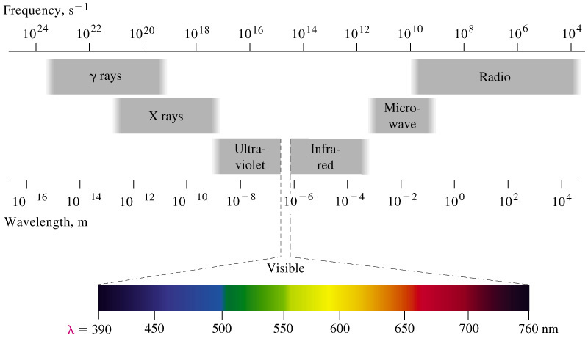
Specific Colors
Note: Ultraviolet and infrared are given as a point of reference. They are not visible colors.
Color | Wavelength mµ  (billionths of a meter) | Explanation
Ultraviolet | 380-280 | The smaller the wavelength, the smaller the structures with which they interact and the more powerful the energy. Gamma rays (the size of a nucleus) are more powerful than A.M. radio waves (the size of a village) Violet at 400 mµ is stronger than red at 700 mµ.  mµ =nanometers
Violet | 430-390
Indigo | 450-440
Blue | 480-460
Green | 530-490
Yellow | 580-550
Orange | 640-590
Red | 750-650
Infrared | 1000-750

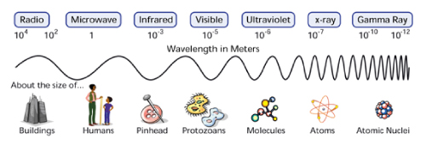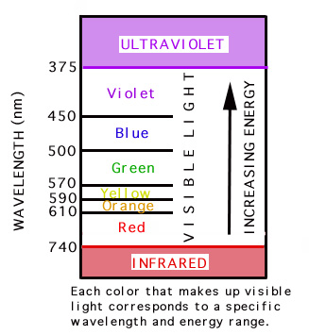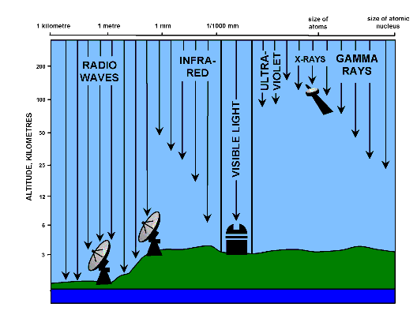
Color Notes for Light – Luminescent Powder LAB

We see white light because of a combination of all the colors of visible light. Use the below diagram to predict the color from the addition of two other colors and then check it with the diagram on the right.

A. CIE Diagram B. CIE Map
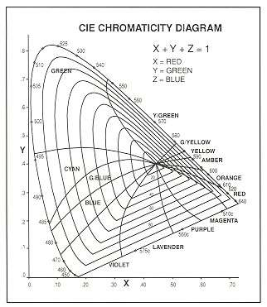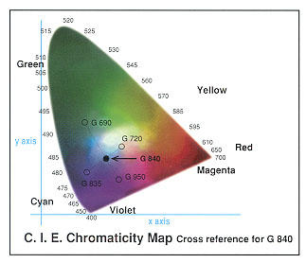
Using the graph in C, what wavelength does this represent? Can you see it? Does it have a color? Graph B shows human sensitivity to light. Where is our sensitivity strongest? What color?

C. LED Color Graph D. Human Eye Senstitivity

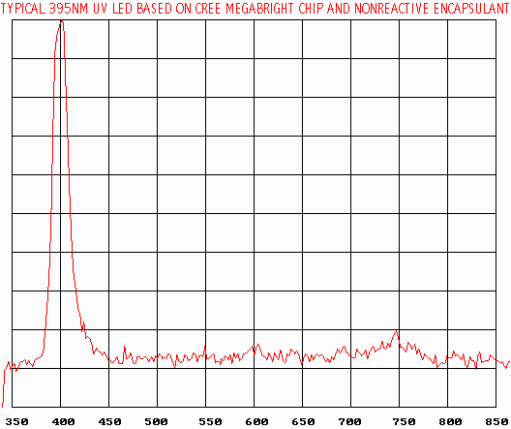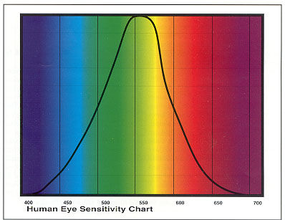

Using Graph E, determine what color will be the most intense for the arc discharge lamp. What is the range of visible light according to the Information below the pictures?

E. CIE Diagram F. LED Light

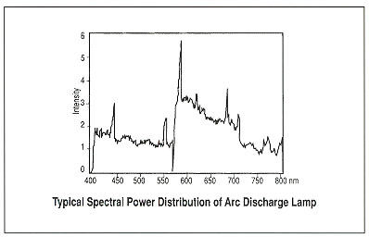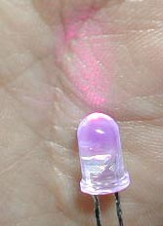

Information
WHITE 5500-6500K InGaN+phosphor ULTRAVIOLET 370-390nm GaN BLUE 430nm GaN+SiC
BLUE 450 and 473nm InGaN BLUE Silicon Carbide TURQUOISE 495-505nm InGaN GREEN 525nm InGaN
YELLOW-GREEN 555-575mn GaAsP & related YELLOW 585-595nm AMBER 595-605nm ORANGE 605-620nm ORANGISH-RED 620-635nm RED 640-700nm INFRARED 700-1300nm

Black light makes fluorescent powders glow  
Q: Why, under a "black light", do white objects appear to be illuminated?
A: The "black light" makes phosphors glow. Only objects with phosphor will appear to be illuminated. A white T-shirt or white socks may glow, not because they're white, but rather because they were laundered with detergent that contained phosphors.
Phosphors are fluorescent powders that, if you expose them to ultraviolet light, absorb the light energy and immediately re-emit some of it as visible light. This process is called fluorescence.
A black-light bulb is a fluorescent tube that generates ultraviolet light similar to a normal fluorescent lamp with a fluorescent layer coating the inner side of the bulb. The low-pressure mercury vapor present in these lamps produces short-wave resonance radiations at about 185 and 253.7 nanometers, says Mazime Gendre of the Technical University at Eindhoven in the Netherlands.
The phosphor helps convert these harmful radiation frequencies to "black light" centered around 360 nanometers. These lamps produce some visible light, too, in the violet, blue, green, and yellow part of the spectrum. We would see this light, of course, and the light would not be black. However, a bulb made of wood glass (glass containing nickel oxide) blocks the visible and only transmits the black-light frequencies, says Gendre.
Our eyes see the colors in a rainbow from red to violet, but not as high as the black-light frequencies. So the light seems black.
Some of the phosphors in laundry detergents stick to laundered clothes, like a white T-shirt. Shine a black, ultraviolet light on the laundered shirt and its phosphors convert the ultraviolet light to visible light. The white T-shirt glows in the converted light. Many detergents now have little or no phosphor in them so the white shirts remain dark or, at best, dimly lit--unless, of course, dipped in fluorescent paint.

LAB - Synthesis 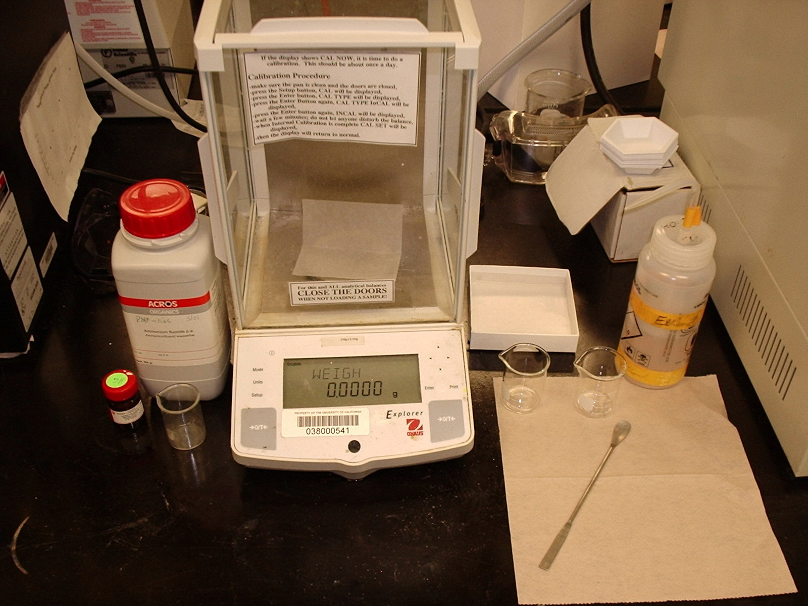 and Fluorescence Properties of Doped Nanoparticles 
Svoboda S., Seshadri R.; Masala O.; and Toquin, R.

Abstract. Lanthanum Fluoride (LaF₃) was used as a host material for the synthesis of nanoparticles doped with Lanthanides and related capping agents in order to synthesized new materials for LED white lighting. The LaF3 was synthesized in solution at temperatures ranging from 60°-75°C for times ranging between 2 and 20 hours. Formed precipitates were dried and pulverized into a powder, and subsequently analyzed and characterized by X-Ray Diffraction (XRD), Photoluminescence Spectrometry (PL), and Transmission Electron Microscopy (TEM). Dopants included Europium (as Eu(NO₃)₃) and Cerium (Ce(NO₃)₃). The capping agent used was Polyvinyl Alcohol (PVA). Compounds synthesized showed weak fluorescence under a UV Lamp and only weak identifying peaks on the PL Spectrometer. XRD results showed a good match for LaF₃ and wide peaks were good initial identifiers that nanoparticles had been synthesized.
TEM analysis showed both elongated and spherical nanoparticles in the size range of 10-20 nm. Amorphous and agglomerated particles were also observed. A possible explanation for the poor luminescent qualities of the materials is the existence of the amorphous particles. It is unlikely that much capping took place, as the results with the capping agent PVA did not demonstrate an improvement in size and shape distribution of the nanoparticles. Spectrometer analysis imbedded with the TEM did confirm the likelihood of doping. Further work should include the use of higher temperatures and longer heating periods during the synthesis phase in order to improve the doping process and for the improvement of luminescent properties.

Keywords: Lanthanum Fluoride; capping agents; nanoparticles; LED Lighting; precipitates; X-Ray Diffraction (XRD); Photoluminescence Spectrometry (PL); and Transmission Electron Microscopy (TEM); dopants; Europium; Cerium; Polyvinyl Alcohol; fluoresce; amorphous and agglomerated; luminescent

1. Introduction

Nanocrystalline (nanoparticle) materials are receiving extensive attention due to their unusual properties. Especially, controlling of nanocrystalline morphology and size is a new challenge to synthetic chemists and materials scientists. The fabrication of nanocrystals has been subjected to special intense research because of promising application in various fields of technology with respect to their collective optical, magnetic and electronic properties. The synthesis of controlled sizes and shapes is critical to these applications since the particle shapes influence these properties. Thus various studies on the development of new synthetic methodologies of such inorganic materials have been reported.

In this report we present a wet (solution) chemical method for morphology control of inorganic materials. We synthesized Lanthanum Fluoride doped with a Lanthanide (Eu or Ce) and characterized these nanoparticles by XRD, PL (UV light) and TEM.

Note: Luminescence is a general term applied to all forms of cool light, i.e., light emitted by sources other than a hot, incandescent body. Luminescence is caused by the movement of electrons within a substance from more energetic states to less energetic states. Conversely, Fluorescence occurs when a molecule absorbs a high-energy photon, and re-emits it as a lower-energy (longer-wavelength) photon. Usually the absorbed photon is in the ultraviolet, and the emitted light (luminescence) is in the visible range.

2. Experimental

Lanthanide Fluoride doped nanoparticles were synthesized through wet chemistry (solution) methods. Mass measurements were made of the reactants, including: Lanthanum Acetate (La (Acetate)), Ammonium Fluoride (NH₄F), and the dopants, including; Europium Nitrate (Eu(NO₃)₃), Cerium Nitrate (Ce(NO₃)₃) and Strontium Nitrate (Sr(NO₃)₂. The reactants were collected in a beaker and heated/stirred at 60 °C until an adequate precipitate was formed. The precipitate was washed in acetone, centrifuged and then dried. The material was then pulverized into a powder for analysis by Ultraviolet light (254 and 312 nm). Those samples that fluoresced were then characterized by X-Ray Diffractometer and Transmission Electron Microscope (TEM) to determine whether or not nanoparticles had been synthesized.

3. Results

Lanthanide Fluoride doped nanoparticles were synthesized through wet chemistry according to the following:

La(CH₃CO₃) ₃ + NH₄F + Dopant → LaF₃ : Ln (Ln = Eu or Ce)

The dopant was either a Europium (Eu) or Cesium (Ce) compound.

Ultraviolet excitation produced a weakly violet color when the Cesium doped resultant powder was fluoresced at 254 and 312 nm (or 2540 and 3120 Angstroms). Europium doped powder fluoresced weakly red. The weak fluorescence and the subsequent characterization by XRD and TEM indicated some success in creating doped nanoparticles that fluoresce.

Please see attached sheets for results related to XRD and TEM analysis.

4. Conclusion
In summary, we report in this paper that nanoparticles were synthesized and confirmed by XRD. In addition, doping was confirmed by TEM. Finally, amorphous structures may be responsible for weak fluorescence.
Once a material with a predictable percentage of nanoparticle sizes is generated, it will be possible to predict emission wavelengths to fine tune color. Mixing of these new materials may be an efficient way to produce higher quality white LED lighting. New materials may be better synthesized if the solutions are heated longer (for better doping) and at higher temperatures (for better luminescence).
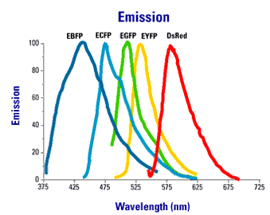
What color does each wavelength (line) correspond to?
STUDENT LAB ASSIGNMENT
Part I
- In your lab groups, review the Abstract. When you are finished, have each lab member define one word in your Blue Book from the “Keywords”. Exchange words so that each of you has 4 words.
- Draw a full page table in your Blue Book like the one below:
 | Introduction | Experimental | Results | Conclusion
Comparisons to ABSTRACT
- In each box, list as many discrepancies between the ABSTRACT and the LAB section indicated. What things are different? Missing? For example: the ABSTRACT mentions “capping agents”, but the Introduction does not.
- Do you think it is appropriate for a discussion of Luminescence to be included in the Introduction? Why or why not?
- List the method or procedure steps listed in the Experimental section.
Part II
- Assume that you were able to repeat the Experimental procedure steps in this LAB. Examine the four vials of powder provided to you. Make a table in your Blue Book to record results for each. Write down the original color of each powder, then expose them to the UV Lamp and record the results.
 | Vial 1 | Vial 2 | Vial 3 | Vial 4
Color before
Color when exposed
- Why do you think that 2 of the vials must be stored in SECONDARY (opaque) containers?
- Why do you think it would be difficult to do the XRD and TEM analysis for this LAB?
- Answer the question for the “Emission” Graph.
- Why is it important in Light Research (LED lighting, etc.) to find materials that fluoresce in all the colors of the visible spectrum?
Conclusion/Discussion Questions
- List at least 3 things that are different between the Scientific Articles you read in class and OUR LABORATORY METHODS.
- List at least 2 sources of error in this LAB.
- How could you make this LAB better?
Extension Questions
- Explain what would be the next step in the process of making a new material for LED lighting (after the powders - basic LED material - is created).
- What is a “natural” way to detect UV radiation? (Yes, YOU have done this already at some time in your life!) Why would you NOT want to employ this method?
Extra Credit: Besides LED/Lighting, where else could you use these materials or something like them?

 IMPORTANT: You and your group will use the information in the LAB to create a LAB Project Poster (using PowerPoint) that will then be graded by your PEERS in class. Don’t lose this information!

ANSWERS
Part I
- Blue Book check of glossary
- Table
 | Introduction | Experimental | Results | Conclusion
Comparisons to ABSTRACT
- Answers include: things mentioned in Abstract that are not mentioned in rest of LAB.
- Not really, but it is important for the student’s understanding.
- Listed Methods -
Part II
- Table.
 | Vial 1 | Vial 2 | Vial 3 | Vial 4
Color before | Yellow | White | Yellow | White
Color when exposed | Yellow | Blue | Green | Red
- They are photoreactive (they degrade or go through chemical changes when exposed to light).
- Too expensive. We don’t have the instruments. XRD costs $25-50 per sample. TEM costs $80-120
- Violet – 425 nm, Blue/Indigo – 475 nm, Green – 500 nm, Yellow – 530 nm, Red – 580nm.
- With ALL of the colors, we will be able to get TRUE white light (which has all of the colors in it…)
Conclusion/Discussion Questions
- The Materials are not LISTED. No mention of common lab equipment used for Solution Synthesis: like the Electronic Balance (+/- 0.0005), Scoopula, Balance paper, Beakers, Heating/Stirring plate and rod, Centrifuge, acetone for drying, mortar/pestle and sample containers. No characterization Tools (XRD and TEM and Fluorescence microscopes) are identified. No exact amounts of reactants and solutions are given. How much?
- Answers vary (color…)
- Answers vary
Extension Questions
- Mount powders into a container device which would then be placed in a bulb (connected to electrical terminals) etc.
- SUNTAN! Too much exposure to your skin can cause skin CANCER!

Fluorescent Light Mini-Labs (Fluorescent Minerals and Ozone Detection and Protection)
1. Introduction (Background, Problem/Purpose and Hypothesis)

Luminescence is a general term applied to all forms of cool light, i.e., light emitted by sources other than a hot, incandescent body. Luminescence is caused by the movement of electrons within a substance from more energetic states to less energetic states. Conversely, Fluorescence occurs when a molecule absorbs a high-energy photon, and re-emits it as a lower-energy (longer-wavelength) photon. Usually the absorbed photon is in the ultraviolet, and the emitted light (luminescence) is in the visible range.
What color does each wavelength (line) correspond to?
The purpose of these mini-labs is to demonstrate fluorescence and where it occurs in our daily lives. So far in this class, we have investigated the following things: light waves, the ozone layer, rocks and minerals, and general chemistry. We will use fluorescent lighting (UV light) to extend our understanding of these subjects.

Use the Laboratory Report Guidelines provided during the first week of classes for each lab. Include the 4 Sections: Introduction (Background, Problem, and Hypothesis), Materials and Methods, Results and Conclusion.

Basic Information about LASERS (from “How it Works.com”)

Lasers show up in an amazing range of products and technologies. You will find them in everything from CD players to dental drills to high-speed metal cutting machines to measuring systems. They all use lasers. But what is a laser? And what makes a laser beam different from the beam of a flashlight?

Absorbing Energy
Consider the illustration from the previous page. Although more modern views of the atom do not depict discrete orbits for the electrons, it can be useful to think of these orbits as the different energy levels of the atom. In other words, if we apply some heat to an atom, we might expect that some of the electrons in the lower-energy orbitals would transition to higher-energy orbitals farther away from the nucleus.

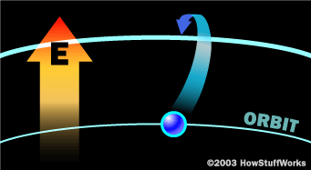
Absorption of energy:
An atom absorbs energy in the form of heat, light, or electricity. Electrons may move from a lower-energy orbit to a higher-energy orbit.
This is a highly simplified view of things, but it actually reflects the core idea of how atoms work in terms of lasers. Once an electron moves to a higher-energy orbit, it eventually wants to return to the ground state. When it does, it releases its energy as a photon -- a particle of light. You see atoms releasing energy as photons all the time. For example, when the heating element in a toaster turns bright red, the red color is caused by atoms, excited by heat, releasing red photons. When you see a picture on a TV screen, what you are seeing is phosphor atoms, excited by high-speed electrons, emitting different colors of light. Anything that produces light -- fluorescent lights, gas lanterns, incandescent bulbs -- does it through the action of electrons changing orbits and releasing photons.

The Laser/Atom Connection
A laser is a device that controls the way that energized atoms release photons. "Laser" is an acronym for light amplification by stimulated emission of radiation, which describes very succinctly how a laser works.

Although there are many types of lasers, all have certain essential features. In a laser, the lasing medium is “pumped” to get the atoms into an excited state. Typically, very intense flashes of light or electrical discharges pump the lasing medium and create a large collection of excited-state atoms (atoms with higher-energy electrons). It is necessary to have a large collection of atoms in the excited state for the laser to work efficiently. In general, the atoms are excited to a level that is two or three levels above the ground state. This increases the degree of population inversion.

The population inversion is the number of atoms in the excited state versus the number in ground state. Once the lasing medium is pumped, it contains a collection of atoms with some electrons sitting in excited levels. The excited electrons have energies greater than the more relaxed electrons. Just as the electron absorbed some amount of energy to reach this excited level, it can also release this energy. As the figure below illustrates, the electron can simply relax, and in turn rid itself of some energy. This emitted energy comes in the form of photons (light energy). The photon emitted has a very specific wavelength (color) that depends on the state of the electron's energy when the photon is released. Two identical atoms with electrons in identical states will release photons with identical wavelengths.

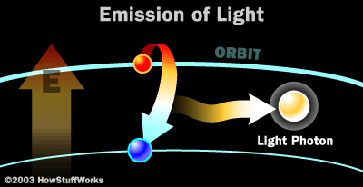

Laser Light
Laser light is very different from normal light. Laser light has the following properties:
- The light released is monochromatic. It contains one specific wavelength of light (one specific color). The wavelength of light is determined by the amount of energy released when the electron drops to a lower orbit.
- The light released is coherent. It is “organized” -- each photon moves in step with the others. This means that all of the photons have wave fronts that launch in unison.
- The light is very directional. A laser light has a very tight beam and is very strong and concentrated. A flashlight, on the other hand, releases light in many directions, and the light is very weak and diffuse.
To make these three properties occur takes something called stimulated emission. This does not occur in your ordinary flashlight -- in a flashlight, all of the atoms release their photons randomly. In stimulated emission, photon emission is organized.

The photon that any atom releases has a certain wavelength that is dependent on the energy difference between the excited state and the ground state. If this photon (possessing a certain energy and phase) should encounter another atom that has an electron in the same excited state, stimulated emission can occur. The first photon can stimulate or induce atomic emission such that the subsequent emitted photon (from the second atom) vibrates with the same frequency and direction as the incoming photon.

Types of Lasers
There are many different types of lasers. The laser medium can be a solid, gas, liquid or semiconductor. Lasers are commonly designated by the type of lasing material employed:
- Solid-state lasers have lasing material distributed in a solid matrix (such as the ruby or neodymium:yttrium-aluminum garnet "Yag" lasers). The neodymium-Yag laser emits infrared light at 1,064 nanometers (nm). A nanometer is 1x10⁻⁹ meters.
- Gas lasers (helium and helium-neon, HeNe, are the most common gas lasers) have a primary output of visible red light. CO2 lasers emit energy in the far-infrared, and are used for cutting hard materials.
- Excimer lasers (the name is derived from the terms excited and dimers) use reactive gases, such as chlorine and fluorine, mixed with inert gases such as argon, krypton or xenon. When electrically stimulated, a pseudo molecule (dimer) is produced. When lased, the dimer produces light in the ultraviolet range.
- Dye lasers use complex organic dyes, such as rhodamine 6G, in liquid solution or suspension as lasing media. They are tunable over a broad range of wavelengths.
- Semiconductor lasers, sometimes called diode lasers, are not solid-state lasers. These electronic devices are generally very small and use low power. They may be built into larger arrays, such as the writing source in some laser printers or CD players.

What's Your Wavelength?
A ruby laser (depicted earlier) is a solid-state laser and emits at a wavelength of 694 nm. Other lasing mediums can be selected based on the desired emission wavelength (see table below), power needed, and pulse duration. Some lasers are very powerful, such as the CO2 laser, which can cut through steel. The reason that the CO2 laser is so dangerous is because it emits laser light in the infrared and microwave region of the spectrum. Infrared radiation is heat, and this laser basically melts through whatever it is focused upon.

Other lasers, such as diode lasers, are very weak and are used in today’s pocket laser pointers. These lasers typically emit a red beam of light that has a wavelength between 630 nm and 680 nm. Lasers are utilized in industry and research to do many things, including using intense laser light to excite other molecules to observe what happens to them.
Here are some typical lasers and their emission wavelengths:

Laser Type | Wavelength (nm)
Argon fluoride (UV) | 193
Krypton fluoride (UV) | 248
Xenon chloride (UV) | 308
Nitrogen (UV) | 337
Argon (blue) | 488
Argon (green) | 514
Helium neon (green) | 543
Helium neon (red) | 633
Rhodamine 6G dye (tunable) | 570-650
Ruby (CrAlO₃) (red) | 694
Nd:Yag (NIR) | 1064
Carbon dioxide (FIR) | 10600

LAB: Commercial Laser Lines and Optical Materials Activity
Introduction: Lasers show up in an amazing range of products and technologies. You will find them in everything from CD players to dental drills to high-speed metal cutting machines to measuring systems. They all use lasers. But what is a laser? And what makes a laser beam different from the beam of a flashlight?
Problem: What are Commercial Laser Lines and Optical Materials, what are they made from and at what part of the Electromagnetic Spectrum do they operate?

Hypothesis: ________________________________________________

Materials: Information on Lasers (included) and Commercial Laser Lines poster

Methods: 1. Review the Laser Information. Define unfamiliar terms.
- Examine a Poster (either the Commercial Laser Lines poster or the Optical Materials poster).
- Identify each of the lasers or optical materials (look at elemental composition, wavelength operation and range). Define unfamiliar terms (like YAG).
- Write down your observations.
- Create at least 3 questions and write them down. Share with another group (with the OTHER poster).

Results: Create a table describing your observations after sharing.

Conclusions: Follow the Lab Report guidelines for your conclusion (include errors
& improvements).

LAB: Introduction to Ozone using UV Light

Introduction
The Ozone Hole. The Ozone Hoax. Pollution. Skin Cancer. The topic of ozone makes headlines on a regular basis, but why does a single molecule merit such media coverage? How important is the ozone in our atmosphere and why are scientists so concerned about its increase near the surface of the earth and its disappearance higher up in the atmosphere?
First things first - what is ozone? Ozone is made of three oxygen atoms (O₃). The oxygen we find in our atmosphere is made up of two oxygen atoms (O₂). Because of its chemical formulation, a single atom of oxygen (O) is unstable. That is, it wants to combine with something else. That is why oxygen is almost always found in pairs, in its (diatomic) form, where it is more stable. O₃ is less stable than , because it wants to return to the diatomic state by giving up an oxygen atom.
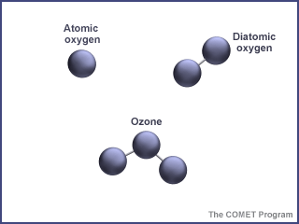
When enough ozone molecules are present, it forms a pale blue gas. It is an unstable molecule that readily combines with other atoms. Ozone has the same chemical structure whether it is found in the stratosphere or the troposphere. Where we find ozone in the atmosphere determines whether we consider it to be Dr. Jekyll or Mr. Hyde.

In the troposphere, the ground-level or "bad" ozone is an air pollutant that damages human health, vegetation, and many common materials. It is a key ingredient of urban smog. In the stratosphere, we find the "good" ozone that protects life on earth from the harmful effects of the sun's ultraviolet rays.

Electromagnectic Spectrum
To understand how ozone is generated and the functions it serves in the earth's atmosphere, it is important to know something about the electromagnetic spectrum — the energy emitted from the sun. Electromagnetic energy is sometimes described as traveling in waves and sometimes as traveling in packets of energy referred to as photons.
Progressing from short wavelengths to long wavelengths, scientists have identified gamma rays, x-rays, ultraviolet radiation, visible light (between 400 and 700 nanometers), infrared radiation (heat), microwaves, and radio waves. Short wavelengths have more energy per photon than long wavelengths.
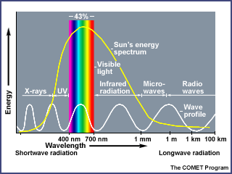
Ozone is constantly being formed in the earth's atmosphere by the action of the sun's ultraviolet radiation on oxygen molecules. Ultraviolet light splits the molecules apart by breaking the bonds between the atoms. A highly reactive free oxygen atom then collides with another oxygen molecule to form an ozone molecule. Because ozone is unstable, ultraviolet light quickly breaks it up, and the process begins again.
Ozone in the Stratosphere
Ozone and oxygen molecules in the stratosphere absorb ultraviolet light from the sun, providing a shield that prevents this radiation from passing to the earth's surface. While both oxygen and ozone together absorb 95 to 99.9% of the sun's ultraviolet radiation, only ozone effectively absorbs the most energetic ultraviolet light, known as UV-C and UV-B, which causes biological damage. The protective role of the ozone layer in the upper atmosphere is so vital that scientists believe life on land probably would not have evolved - and could not exist today - without it.
The term "shield" as a description of ozone in the stratosphere is a bit misleading because the molecules do not form an impermeable sphere around the earth. Ozone continuously breaks apart into its oxygen atoms and reforms as ozone molecules, so a particular ozone molecule doesn't last very long. The "shield" changes constantly, but the atmospheric chemical processes maintain a dynamic equilibrium that keeps the overall amount of ozone constant - that is, it would if humans did not contribute to the chemical processes.
About 90% of the ozone in the earth's atmosphere lies in the region called the stratosphere between 16 and 48 kilometers (10 and 30 miles) above the earth's surface. Ozone forms a kind of layer in the stratosphere, where it is more concentrated than anywhere else, but even there it is relatively scarce. Its concentrations in the ozone layer are typically only 1 to 10 parts of ozone per 1 million parts of air, compared with about 210,000 parts of oxygen per 1 million parts of air.
Ozone in the Troposphere
The other 10% of the ozone in the earth's atmosphere is found in the troposphere, which is the portion of the atmosphere from the earth's surface to about 12 km or 7 miles up. In the troposphere, ozone is not wanted. Ozone is even more scarce in the troposphere than the stratosphere with concentrations of about 0.02 to 0.3 parts per million. But even in such small doses, this molecule can do a lot of damage.
And just to confuse things even further, ozone in the troposphere is one of the greenhouse gases. As discussed in the Greenhouse Effect section, the naturally occurring greenhouse gases (including ozone) are what make earth habitable for life as we know it. But scientists are very concerned about the warming effects of increased greenhouse gases caused by human activity. So, in the troposphere, accelerated ozone levels deal us a double whammy - as a key ingredient in smog and as a powerful greenhouse gas.
Concluding Thoughts
Ozone is found in two different layers of the atmosphere - the troposphere and the stratosphere. The stratospheric ozone, or "good ozone," protects life on earth from harmful effects of the sun's UV rays. We have good reason to be concerned about the thinning of the ozone layer in the stratosphere. Tropospheric ozone, or "bad ozone," is an air pollutant that damages human health, vegetation, and many common materials. We have good reason to be concerned about the buildup of ozone in the troposphere. In this and the following sections, we will explore the various aspects of ozone to help your students better understand this complex, and sometimes seemingly contradictory, molecule. Although simplistic, the saying "Good up high and bad near by," sums up ozone in the atmosphere.

Additional Information and Summary

This section provides an overview of ozone and why it is considered to be 'bad' when found in the troposphere, and 'good' when found in the stratosphere. Ozone has the same chemical structure whether it is found in the stratosphere or troposphere. The general concepts found in this section include the following:
- Ozone is a form of oxygen. The molecule contains three oxygen atoms (.)
- Ozone is unstable and will readily combine with other atoms.
- Ozone is found in the stratosphere, where it blocks the sun's ultraviolet (UV) waves and prevents them from reaching the earth's surface.
- Ozone is also found in the troposphere, where it can damage living tissue and human-produced objects. It is generated both from certain types of pollution and natural sources.

Detecting Ultraviolet Light Using Tonic Water
This activity is a simple method for demonstrating UV light presence.

Background
The energy from the sun includes not only visible light but also wavelengths longer (infrared) and shorter (ultraviolet) than visible light. The wavelengths of visible light increase from violet to red across the spectrum. Shorter than violet are wavelengths referred to as ultraviolet (UV). Ultra means beyond, so ultraviolet means beyond (actually, shorter than) violet.

The amount of UV radiation reaching the earth's surface at a particular point depends on the distance it travels through the atmosphere. During morning hours, UV radiation must travel through more of the earth's atmosphere because the sun is lower on the horizon. At noon the rays travel a shorter distance through the atmosphere because the sun is more directly overhead. The amount of UV radiation in both the stratosphere and the troposphere is an important concept. This activity is a simple method for demonstrating UV light presence. When a photon of UV energy is absorbed, it is reemitted by the quinine in tonic water as a photon of visible light. This process is called fluorescence. The extent of fluorescence that occurs is related to the amount of UV light resulting from the angle of the sun (time of day and season of year).

Materials
- 2 clear, plastic cups
- Permanent markers
- One liter of tonic water
- One liter of tap water
- Black paper, felt, or cloth (approximately 8" x 11")
- Fluorescent Light (UV Light Source)

Sunlight (The most dramatic results will occur around noon when the sun is directly overhead. In some parts of the country with cloudy winters, you will get better results doing this activity in the months closest to summer. Results will vary according to the position of the sun and the time of day)
For days of inclement weather use a quartz 300-watt halogen light for UV light or a black light that produces UV radiation. A slide projector using a 250 - 300 watt halogen light could provide a good alternative source of light.

Procedure
- Label plastic cups "tonic water" and "tap water."
- Fill the tonic water cup almost to the brim.
- Fill the tap water cup almost to the brim.
- Place the cups outdoors so that direct sunlight strikes the surface of the liquid in both cups OR Use a Fluorescent Lamp to illuminate the water in each cup.
- Hold a piece of paper or cloth behind the cups. Look across the surface of the tonic water and tap water through the sides of the glasses

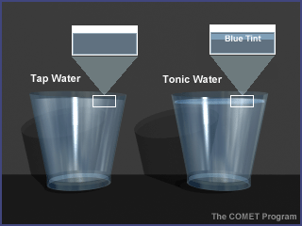

Observations and Questions
- Looking at the top quarter-inch of the liquids, what do you see? (The upper quarter-inch of the tonic water cup should "glow" blue.)
- Did both liquids appear the same? (No, the tap water should show no change.)
- What effect does the black cloth or paper have on your observation? (The black cloth increases the contrast, which makes the glow of blue easier to see.)
- What is contained in the sunlight that causes the observed results? (Ultraviolet radiation.)
- Give an explanation for the observed difference between the tonic water and the tap water. (There must be a difference between the tonic water and the tap water. Teacher can explain the presence of the quinine during post-lab discussion.)
- Have you observed similar occurrences in other materials? (Answers will vary. Some students might be aware of the fluorescence of minerals under UV light.)
- How might the position of the sun affect your results? (The higher the sun is in the sky, the shorter the path length through the atmosphere (ozone layer), allowing more ultraviolet to get through.)

  - Extension: To demonstrate that UV light is causing the blue glow, place a Plexiglas sheet between the sun and the glass of tonic water. The Plexiglas should absorb some of the UV, preventing the fluorescence of the quinine. Do glass and Plexiglas have the same effect? What effect do suncreens have? Try coating some sunscreen (maybe use varying strengths?) on a thin glass or Plexiglas filter.
  - Your students could do a full inquiry lab with cellulose acetate (CA) plastic sheets (some overhead transparencies may be cellulose acetate - check the box). The CA will transmit UV, unlike glass or Plexiglass, so it can be used as a backing for various strengths of sunscreens. Students could design their own studies and collect qualitative data on the amount of blue glow associated with different sunscreens or tanning creams.
  - You may want to consider doing this activity at different times of the day so that students can compare the differences.

Group Poster and Peer Review Rubric

This Peer Review Rubric of the Posters should be completed by each member of your lab group. When you are finished, turn the rubric for each group in with your Blue Book. You must have a rubric for each group or you will lose points.

Peer Review Rubric

Using the attached rubric, you will go around the room and grade the PowerPoint posters. Someone from your lab group must be stationed at YOUR POSTER at all times to answer questions (you should take turns). DO NOT WRITE ON THIS PAGE.

 | 0 Points | 1 Points | 2 Points | 3 Points | 4 Points | 5 Points | Total Points
Title Page | None | Title, names, and date – all missing - but neat | Title, names, and date – two missing | Title, names, and date – one missing | Title, names, and date. | Title, names, and date. Neat.
Abstract | None | No statement of purpose or results. Something written | Purpose or results but not both, not neat | Purpose or results but not both | The purpose of the lab stated, the results stated | The purpose of the lab stated, the results stated and no discussion
Introduction | None | Little or no introduction to the work done | Purpose restated but variables not explained. Not neat. | Purpose restated but variables not explained. | The purpose of the lab stated, all terms used are defined | The purpose of the lab stated, all terms used are defined and variables identified
Methodology | None | Not sequential, most steps are missing or are confusing. | Some of the steps are understandable; most are confusing and lack detail | Most of the steps are understandable; some lack detail or are confusing | Steps are understandable, but not neat | Presents easy-to-follow steps which are logical and adequately detailed
Results | None | Data table and/or graph missing information and are inaccurate. | Both complete, but there are inaccuracies and/or illegible characters. | Both complete, minor inaccuracies and/or illegible characters. | Both accurate, some ill-formed characters, not very neat. | Data table and graph neatly completed and totally accurate.
Conclusion or Summary | None | Illogical explanation for findings. | Presents an illogical explanation for findings, but is organized | Presents a logical explanation for findings and addresses some of the questions. | Presents a logical explanation for findings and addresses most of the questions. | Presents a logical explanation for findings and addresses all of the questions.
Total  Points |  |  |  |  |  |  | TOTAL:  ________

Group Poster and Peer Review Rubric

Peer Review Rubric
Group Name:  ____________ | 0 Points | 1 Points | 2 Points | 3 Points | 4 Points | 5 Points | Total Points
Title Page
Abstract
Introduction
Methodology
Results
Conclusion or Summary
Total  Points |  |  |  |  |  |  | TOTAL:  ________

Peer Review Rubric
Group Name:  ____________ | 0 Points | 1 Points | 2 Points | 3 Points | 4 Points | 5 Points | Total Points
Title Page
Abstract
Introduction
Methodology
Results
Conclusion or Summary
Total  Points |  |  |  |  |  |  | TOTAL:  ________

Peer Review Rubric
Group Name:  ____________ | 0 Points | 1 Points | 2 Points | 3 Points | 4 Points | 5 Points | Total Points
Title Page
Abstract
Introduction
Methodology
Results
Conclusion or Summary
Total  Points |  |  |  |  |  |  | TOTAL:  ________

Group Poster and Peer Review Rubric

This is the final part of the Article Review Project that you have been working on in your Blue Books. There are 3 sections for you to complete. First, you will construct a PowerPoint POSTER with your lab partners showing your results for the LED/Luminescence LAB. Secondly, you will fill out a Peer Review Rubric of the Posters completed by the other groups. Finally, you will answer a few short questions in your Blue Book regarding the project (a summary and conclusion). When you are finished, turn in your Blue Book for final grading.

PowerPoint POSTER
In your LAB groups, collect the information from the LAB – Synthesis and Fluorescence Properties of Doped Nanoparticles. Open up PowerPoint and begin a new Presentation. Create a slide show with the following parts: Title Page, Abstract, Introduction, Methodology, Results, and Conclusion/Discussion (6 slides minimum). Your group’s presentation should be UNIQUE from the others. Use pictures, graphs, color, etc. You may use your own font, backgrounds, etc. You need at least one graph/table. When you are finished as a group, print the slides on 8 ½ X 11” paper. Place the slides on a poster board for class review.

Peer Review Rubric
Using the attached rubric, you will go around the room and grade the PowerPoint posters. Someone from your lab group must be stationed at YOUR POSTER at all times to answer questions (you should take turns). Turn the completed rubric in with your Blue Book at the end of the day. You MUST turn in completed rubrics for EACH of the other posters or you will get a 0!

Summary and Conclusion

Please answer the following questions (in your Blue Book) regarding the Article Review Project.

- What was the overall purpose of this project?
- What was the most useful part of the project?
- Do you think that you are able to do a better job figuring out what a scientific article is about now? Why or why not?
Answers

- To Develop a student’s ability to review, summarize and critique a scientific article, with an emphasis on deciphering the Abstract, reproducing the Methodology and performing Peer Reviews (Articles/Labs).
- Answers vary
- Answers vary

PROJECT RUBRIC

Assessment Goal

Description of Student’s Product (points per item)

Total Points Possible

1 Study Questions (4), Homework on Internet (5) and Computer Lab question and answer (6)

15 Points
2 Glossary – Defining terms

5 Points
3 Deconstructing a Science Article – Part I (7) and Part II (5) and Graphs Analysis

25 Points
4 LED Synthesis and Fluorescence LAB Questions and Review

15 Points
5 Mini-Labs (for 1 of 3 activities)

10 Points
6 Group Poster and Peer Review (and Final Project Conclusion)

30 Points

100 points

All work is completed in the Student’s Blue Book (including the Glossary at the end). Blue Book is turned in at the end of the Project, but each Rubric Item may be graded upon completion of the element.

The Cold Fusion Story – Blue Book
Rubric 1 | The Cold Fusion Story – Blue Book | Points
Study Questions | Study Questions (4 questions, 1 point each) | 4
Homework | Homework (3 questions, 2 points each) | 6
Science Line UCSB | Science Line UCSB (5) | 5
 |  | 15 Total

Introduction to Chemistry (Glossary)
Rubric 2 | 0 points | 1 point | 2 points | 3 points | 4 points | 5 points
Glossary (5 points Total) | No words defined | 1 of 5 words defined | 2 of 5 words defined | 3 of 5 words defined | 4 of 5 words defined | All 5 words defined

Introduction to Deconstructing a Science Article
Rubric 3 | Introduction to Deconstructing a Science Article | Points
Part I | Synthesis and Luminescence properties of BaCro4 nanoparticles QUESTIONS (7 questions, 1 point each) | 7
Part II | Article from Nature Magazine or Scientific American QUESTIONS (5 questions, 1 point each) | 5
Part III | Graphs Analysis | 13
 |  | 25 Total

LAB Rubric
Group Name:  ____________ | 0 Points | 1 Points | 2 Points | 3 Points | 4 Points | 5 Points | Total Points (25 points)
Title Page | Title, names, and date. Neat.
Abstract | None | No statement of purpose or results. Something written | Purpose or results but not both, not neat | Purpose or results but not both | The purpose of the lab stated, the results stated | The purpose of the lab stated, the results stated and no discussion
Introduction | None | Little or no introduction to the work done | Purpose restated but variables not explained. Not neat. | Purpose restated but variables not explained. | The purpose of the lab stated, all terms used are defined | The purpose of the lab stated, all terms used are defined and variables identified
Methodology | None | Not sequential, most steps are missing or are confusing. | Some of the steps are understandable; most are confusing and lack detail | Most of the steps are understandable; some lack detail or are confusing | Steps are understandable, but not neat | Presents easy-to-follow steps which are logical and adequately detailed
Results | None | Data table and/or graph missing information and are inaccurate. | Both complete, but there are inaccuracies and/or illegible characters. | Both complete, minor inaccuracies and/or illegible characters. | Both accurate, some ill-formed characters, not very neat. | Data table and graph neatly completed and totally accurate.
Conclusion or Summary | None | Illogical explanation for findings. | Presents an illogical explanation for findings, but is organized | Presents a logical explanation for findings and addresses some of the questions. | Presents a logical explanation for findings and addresses most of the questions. | Presents a logical explanation for findings and addresses all of the questions.
Total  Points |  |  |  |  |  |  | TOTAL:  ________

Lab Graphs Review
Rubric 5 | Mini-Lab | Points
Part I | LAB: UV Fluorescence and Minerals | 10
Part II | Detecting Ultraviolet Light Using Tonic Water | 10
Part III | LAB: Commercial Laser Lines and Optical Materials Activity | 10
 |  | 103 Total for any (1 only)

Group Poster and Peer Review
Name:  ____________ | 0 Points | 1 Points | 2 Points | 3 Points | 4 Points | 5 Points | Total Points  (25 points)
Title Page | Title, names, and date. Neat.
Abstract | None | No statement of purpose or results. Something written | Purpose or results but not both, not neat | Purpose or results but not both | The purpose of the lab stated, the results stated | The purpose of the lab stated, the results stated and no discussion
Introduction | None | Little or no introduction to the work done | Purpose restated but variables not explained. Not neat. | Purpose restated but variables not explained. | The purpose of the lab stated, all terms used are defined | The purpose of the lab stated, all terms used are defined and variables identified
Methodology | None | Not sequential, most steps are missing or are confusing. | Some of the steps are understandable; most are confusing and lack detail | Most of the steps are understandable; some lack detail or are confusing | Steps are understandable, but not neat | Presents easy-to-follow steps which are logical and adequately detailed
Results | None | Data table and/or graph missing information and are inaccurate. | Both complete, but there are inaccuracies and/or illegible characters. | Both complete, minor inaccuracies and/or illegible characters. | Both accurate, some ill-formed characters, not very neat. | Data table and graph neatly completed and totally accurate.
Conclusion or Summary | None | Illogical explanation for findings. | Presents an illogical explanation for findings, but is organized | Presents a logical explanation for findings and addresses some of the questions. | Presents a logical explanation for findings and addresses most of the questions. | Presents a logical explanation for findings and addresses all of the questions.
Total  Points |  |  |  |  |  |  | TOTAL:  ________

Conclusion (Group Poster &Peer Review)– Blue Book
Rubric 7 | Conclusion (Group Poster & Peer Review) – Blue Book | Points
Final Conclusion Questions | Questions (3 questions) | 5

PROJECT RUBRIC

Assessment Goal

Description of Student’s Product (points per item)

Total Points Possible

1 Study Questions (4), Homework on Internet (5) and Computer Lab question and answer (6)

15 Points
2 Glossary – Defining terms

5 Points
3 Deconstructing a Science Article – Part I (7) and Part II (5)

12 Points
4 Science Article and Methodology LAB (and Poster)

25 Points
5 Graphs Analysis

13 Points
6 Group Poster and Peer Review (and Final Project Conclusion)

30 Points

100 points

All work is completed in the Student’s Blue Book (including the Glossary at the end). Blue Book is turned in at the end of the Project, but each Rubric Item may be graded upon completion of the element.

The Cold Fusion Story – Blue Book
Rubric 1 | The Cold Fusion Story – Blue Book | Points
Study Questions | Study Questions (4 questions, 1 point each) | 4
Homework | Homework (3 questions, 2 points each) | 6
Science Line UCSB | Science Line UCSB (5) | 5
 |  | 15 Total

Introduction to Chemistry (Glossary)
Rubric 2 | 0 points | 1 point | 2 points | 3 points | 4 points | 5 points
Glossary (5 points Total) | No words defined | 1 of 5 words defined | 2 of 5 words defined | 3 of 5 words defined | 4 of 5 words defined | All 5 words defined

Introduction to Deconstructing a Science Article
Rubric 3 | Introduction to Deconstructing a Science Article | Points
Part I | Synthesis and Luminescence properties of BaCro4 nanoparticles QUESTIONS (7 questions, 1 point each) | 7
Part II | Article from Nature Magazine or Scientific American QUESTIONS (5 questions, 1 point each) | 5
 |  | 12 Total

LAB Rubric
Group Name:  ____________ | 0 Points | 1 Points | 2 Points | 3 Points | 4 Points | 5 Points | Total Points (25 points)
Title Page | Title, names, and date. Neat.
Abstract | None | No statement of purpose or results. Something written | Purpose or results but not both, not neat | Purpose or results but not both | The purpose of the lab stated, the results stated | The purpose of the lab stated, the results stated and no discussion
Introduction | None | Little or no introduction to the work done | Purpose restated but variables not explained. Not neat. | Purpose restated but variables not explained. | The purpose of the lab stated, all terms used are defined | The purpose of the lab stated, all terms used are defined and variables identified
Methodology | None | Not sequential, most steps are missing or are confusing. | Some of the steps are understandable; most are confusing and lack detail | Most of the steps are understandable; some lack detail or are confusing | Steps are understandable, but not neat | Presents easy-to-follow steps which are logical and adequately detailed
Results | None | Data table and/or graph missing information and are inaccurate. | Both complete, but there are inaccuracies and/or illegible characters. | Both complete, minor inaccuracies and/or illegible characters. | Both accurate, some ill-formed characters, not very neat. | Data table and graph neatly completed and totally accurate.
Conclusion or Summary | None | Illogical explanation for findings. | Presents an illogical explanation for findings, but is organized | Presents a logical explanation for findings and addresses some of the questions. | Presents a logical explanation for findings and addresses most of the questions. | Presents a logical explanation for findings and addresses all of the questions.
Total  Points |  |  |  |  |  |  | TOTAL:  ________

Lab Graphs Review
Rubric 5 | Lab Graphs Review | Points
Part I | Study Questions (4 questions, 1 point each) | 4
Part II | Glossary Terms (3 definitions, 1 point each) | 3
Part III | Graph Study Questions (6 questions, 1 point each) | 6
 |  | 13 Total

Group Poster and Peer Review
Name:  ____________ | 0 Points | 1 Points | 2 Points | 3 Points | 4 Points | 5 Points | Total Points  (25 points)
Title Page | Title, names, and date. Neat.
Abstract | None | No statement of purpose or results. Something written | Purpose or results but not both, not neat | Purpose or results but not both | The purpose of the lab stated, the results stated | The purpose of the lab stated, the results stated and no discussion
Introduction | None | Little or no introduction to the work done | Purpose restated but variables not explained. Not neat. | Purpose restated but variables not explained. | The purpose of the lab stated, all terms used are defined | The purpose of the lab stated, all terms used are defined and variables identified
Methodology | None | Not sequential, most steps are missing or are confusing. | Some of the steps are understandable; most are confusing and lack detail | Most of the steps are understandable; some lack detail or are confusing | Steps are understandable, but not neat | Presents easy-to-follow steps which are logical and adequately detailed
Results | None | Data table and/or graph missing information and are inaccurate. | Both complete, but there are inaccuracies and/or illegible characters. | Both complete, minor inaccuracies and/or illegible characters. | Both accurate, some ill-formed characters, not very neat. | Data table and graph neatly completed and totally accurate.
Conclusion or Summary | None | Illogical explanation for findings. | Presents an illogical explanation for findings, but is organized | Presents a logical explanation for findings and addresses some of the questions. | Presents a logical explanation for findings and addresses most of the questions. | Presents a logical explanation for findings and addresses all of the questions.
Total  Points |  |  |  |  |  |  | TOTAL:  ________

Conclusion (Group Poster &Peer Review)– Blue Book
Rubric 7 | Conclusion (Group Poster & Peer Review) – Blue Book | Points
Final Conclusion Questions | Questions (3 questions) | 5

