ORGANIC CHEMISTRY UNIT:

WHY DOES YOUR GRANDMOTHER HAVE ALZHEIMER’S?

MATERIALS:
Six organic model building kits, methanol, ethanol, propyl alcohol, isopropyl alcohol, butanol, pentanol acetic acid, salicylic acid, butyric acid (very bad smell but makes some great esters), or substitute your own organic acids and alcohols

PREVIOUS: Cover Lewis dot structure so the students know which elements have free electron pairs when they are in compounds/molecules, like oxygen.

Day 1: Description of Alzheimer’s disease, lack of the neurotransmitter acetylcholine caused by an excess of the enzyme, acetyl cholinesterase, and how it results from misfolded proteins. The process of amyloidal formation by the amyloid beta peptide (Abeta), i.e., the misassembly of Abetapeptides into soluble quaternary structures (the final form of a protein) and, ultimately, amyloid fibrils, appears to be at the center of Alzheimer's disease (AD) pathology. Amyloid plaques (AM-uh-loyd plaks) are clumps of protein that accumulate outside the brain’s nerve cells. Junk in the brain that takes up space and reduces functionality of nerve cells.
.
ACETYLCHOLINE:
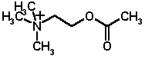

RXN MECH:
: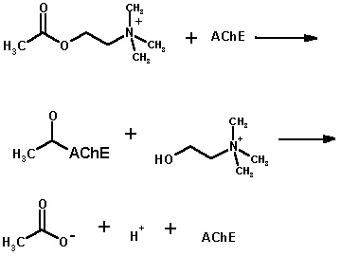

AChE is acetylcholine esterase,
an enzyme.

NOTICE THAT THE ACETYLCHOLINE IS DESTROYED IN THIS REACTION.
Day 2: The basics of organic chem alkanes, alkene, alkynes and naming each (see teacher resources in PowerPoint)

Day 3: Model building lab #1
Learn and draw the basic types of organic structures. Taking note of where electron pairs are on the oxygen and nitrogen atoms and the shape that results from the different bond types. Teacher resource: Model Building Lab handout.

Day 4: Reminded of solution chemistry that was just completed, how the different products are formed and the sequencing of the reaction. Polar vs. nonpolar molecules and the structure that results in polar bonds with emphasis on alcohols, organic acids, esters and water.
Isomer and Functional Group Model Building Lab: Build models of alcohols, organic acids and esters especially methanol, ethanol, butanol, acetic acid, butyric acid, and methyl acetate as examples. Show the free electron pairs on oxygen.

Day 5: Esters lab, label all the products and reactants and show that it is a condensation reaction. The product is different, by smell than either of the reactants, indicating a change in molecular structure. Hypothesize as to what is the dominant molecule in the ester for each reaction and theorize a solution.

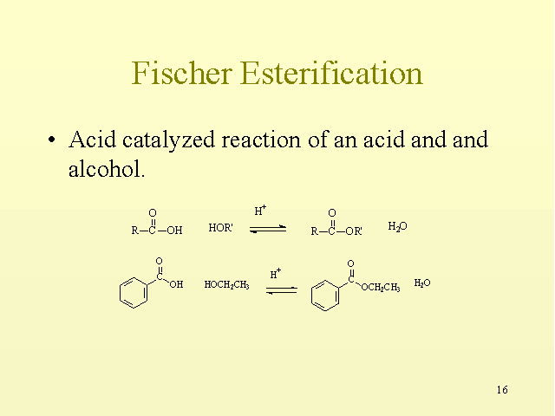
Benzoic
acid

ethanol
Ethyl
benzoate

Day 6: Amino acids, the peptide bond and how proteins form
Resource: handout of 20 amino acids
Peptide bond:

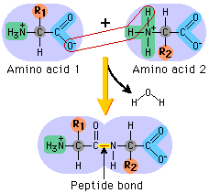

Day 7: Simple proteins often fold up into α-helices, like a slinky, so what happens to a slinky that doesn’t fold up properly?

Day 8: Build amino acids and then make them fold into α-helices showing the difference the side-chain makes in its ability to fold.
Amino Acid building lab

Day 9: review

Day 10: test

WEBSITES:
http://wishart.biology.ualberta.ca/moviemaker/gallery/index.html

GRADING: I usually make the model building type labs worth 20 points and the Esters type lab worth 30 points.
All labs will have the usual parts and it is expected that they are written in ink or typed except for possibly the data table. They get 5 points off for turning in a lab in pencil for the first two labs then ½ credit thereafter.

Part | Expected results | Points possible 20/30
problem | Usually given | 1
Hypothesis | “If…..then” statement | 3
Materials | Usually given | 1
Procedure | Usually given | 1
Data | Clear tables/graphs | 5/10
Results | What happened? How accurate was  your data? | 5
Questions | Answered with complete sentences | 1 point each
Conclusion | Answers the problem/hypothesis with complete sentences. This takes about a paragraph and should show some independent thinking. What did you learn and liked about the lab. | 4/8
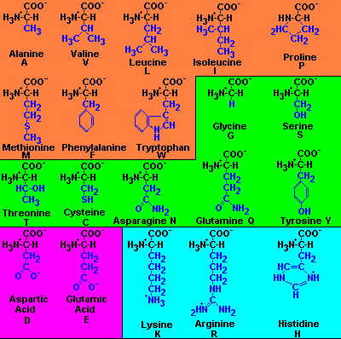

MODEL BUILDING LAB #1
ALKANES, ALKENES AND ALKYNES

PROBLEM: Correlate the different types of basic organic compounds with their 3-D shape.

HYPOTHESIS:

MATERIALS: model kits, pen/pencil, paper, ruler

PROCEDURE:
- Build, name and draw the first six alkanes; methane through hexane.
- Measure the distance between any two carbon atoms.
- Now build and draw 1-butene, 1-pentene and 2-hexene.
- Measure the distance between the two carbon atoms around the double bond.
- In your drawings make note of how the double bond changes the shape.
- Finally build 2-butyne, 2-pentyne and 3-hexyne.
- Measure the distance between the two carbon atoms around the triple bond.
- In your drawings make note of how the triple bond changes the shape.

DATA: Neatly done drawings with their names below each. Point out the double and triple bonds in the alkenes and alkynes. Record the distances you measured above the bonds measured.

QUESTIONS:
- What happens to the distance between carbon atoms as you increase the number of bonds between carbon atoms?
- Discuss the affect the numbers of bonds have on the ability to rotate and the relative strength of the bonds.
- Why do welders use acetylene (ethyne) instead of methane to weld and cut metal? Answer in terms of bonding and bond strength.
- If an unsaturated fat (peanut oil) has double bonds and saturated fats (butter or lard) have all singly bonded carbon atoms, why are saturated fats worse for you? (think about the change in shape)

CONCLUSION:

ISOMER AND FUNCTIONAL GROUP
MODEL BUILDING LAB
AND THE EFFECTS THEY HAVE ON STRUCTURE AND FUNCTION

PROBLEM: We want to correlate names with structures then hypothesize on the effect that added functional groups would have on reactivity.

HYPOTHESIS:

MATERIALS: models, pen/pencil, paper

PROCEDURE:
- Build the following molecules then draw and name each. Note the difference in shape that changing from single to double to triple bonds make.
  - C₆H₁₄ make at least 2 isomers, same chemical formula but different structural formula. Name each of the isomers.
  - C₆H₁₂ make at least 2 isomers, same chemical formula but different structural formula. Name each of the isomers.
  - C₆H₁₀ using either two double or a triple bonds make at least 2 isomers, same chemical formula but different structural formula. Name each of the isomers.
- Now we will add some oxygen atoms to the formula. If you see –COOH it means that both the oxygen atoms are bonded to the carbon atom in the molecule. COOH means the molecule is an organic acid so the ending of the root molecule is changed to “-ic”. Build and name each organic (carboxylic) acid.
  - C₃H₇COOH
  - C₃H₅COOH
  - C₆H₆COOH (think ring)

- Another common functional group is alcohols, -OH, and they change the ending of the root molecule to “-ol”. Its position must be specified if it is not on the end of the chain of carbons. Build and name each alcohol.
  - CH₃OH
  - C₇H₁₅OH
  - C₇H₁₁OH

DATA:
QUESTIONS:
- Were you able to see a pattern in naming these compounds?
- How did the number of bonds; single, double and triple affect the final structure of the molecule?
- Which types of compounds would be miscible (mix completely) with water? Can you explain why?
- An ester has a –COC- bond and doesn’t dissolve in water, why do you think this is?
CONCLUSION:
SOME ANSWERS
1a. hexane
1b. hexene or 1-hexene
1c. hexyne or 1-hexyne
2a. butanoic acid
2b. butenoic acid
2c. benzoic acid, benzene ring with organic acid functional group added on.
3a. methanol
3b. heptanol or heptan-2-ol isomer
3c. 1-heptynol or 1heptyn-4-ol for an isomer

AMINO ACID BUILDING LAB:

PROBLEM: How do the side chains affect the ability for a protein to fold into an α–helix? (like a “Slinky”)

HYPOTHESIS:

MATERIALS: Structural formulas of Alanine, Glycine, Lysine and Phenylalanine (each bend in the chain represents a C atom and a bare stick represents a methyl, –CH₃, group)
model building kits, pencil and paper(you will probably have to combine groups to have enough model parts)
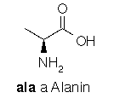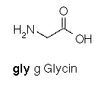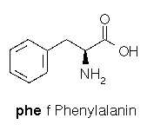

PROCEDURE:
- Build a chain of three amino acids, first making 3 glycines, then making a chain of three amino acids using alanine and glycine and try to fold each around the peptide bond.
- Draw each model and label the C, O, and N atoms. Use colors to denote the different atoms. Try to fold into an α–helix (spiral) and record how far around the spiral you were able to go. (90°, 180°, etc) You cannot move the atoms that make up the peptide bond.
- Then put the phenylalanine in the chain, first at the end and then in the middle and observe what happens to the ability to fold into and α–helix. Draw each of the chains that you make and record the how far around the spiral you were able to go. (90°, 180°, etc) You cannot move the atoms that make up the peptide bond.

DATA: Draw and label each bond showing clearly C, O, and N atoms and the peptide bonds and how far they can rotate.

QUESTIONS:
- What was the effect of having the larger side chain on the ability to fold?
- Could you move the phe around and allow the chain to fold?
- What happens when the order changes to your ability to fold the protein?

CONCLUSION:
HONORS CHEMISTRY
ORGANIC QUIZ 1
NAME:

NAME THE FOLLOWING COMPOUNDS:

- CH ₃CH₂CH₂CH₂CH ₃

- CH ₃CH₂CH₂CH₂CHCHCH ₃
- 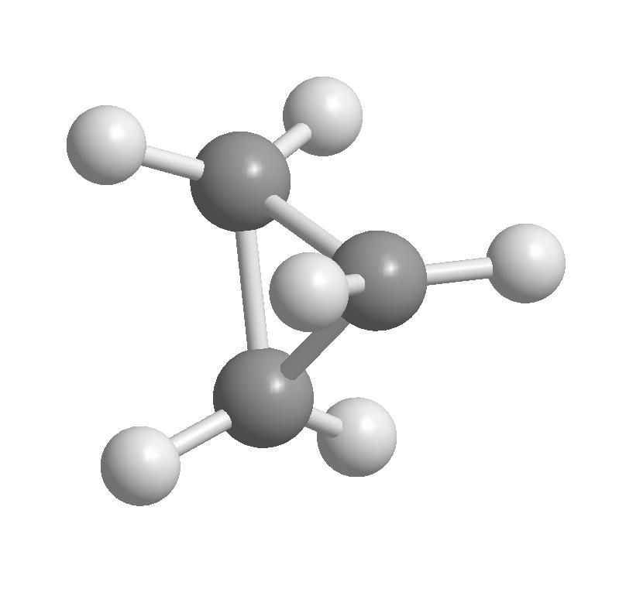DARKER BALLS = CARBON, LIGHTER BALLS = HYDROGEN

- CH ₃CH₂CH₂CH₂CH₂CH₂OH + ONE ISOMER (your choice)

- CH ₃COOH

- CH ₃CH₂CH₂COOCH ₃

DRAW THE FOLLOWING COMPOUNDS:

- BENZENE

- CYCLOHEXANE

- 3,3,4,4-TETRAMETHYL-1-NONENE

- ETHYL ACETATE

- 3,3-DIETHYL-1-HEXYNOL

- How do the number of carbon bonds affect the shape of the molecule?
- Write the chemical equation showing both the reactants and products of combining ethanoic acid with n-propanol

- What is different or special about the peptide bond?

- Show the protein that forms when the following amino acids join in a peptide bond,
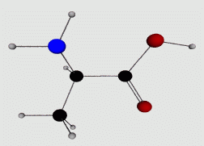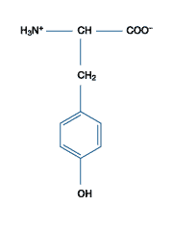

ANSWER KEY: To be guarded with your life or at least file cabinet.

MODEL BUILDING LAB:
Questions:
- The more bonds between carbon atoms the closer the atoms are to each other.
- The more bonds the stronger the bond and the carbon atoms loose the ability to rotate.
- Acetylene, C₂H₂, has a triple bond between the carbon atoms and methane has no carbon-carbon bond so there is much more energy that can be released.
- Look at the structural differences between single and double bonds and the shape instead of being linear becomes bent so it is more difficult for it to pack into layers on the sides of arteries. More energy has to be removed so it will form a solid because of the shape difference.

ISOMER AND FUNCTIONAL GROUP MODEL BUILDING LAB
Questions:
- The root and then change the ending, naming the positions of the functional groups.
- The more C-C bonds the straighter the structure became.
- An alcohol or an organic acid are both miscible because the oxygen atoms in both cases have unbonded electron pairs that make the molecule polar, like water.
- The unbonded electron pairs are buried by the rest of the ester atoms so it is more difficult form polar bonds.

AMINO ACID BUILDING LAB:
Questions:
- The larger side chain is bulky so it makes it more difficult for the protein (amino acid chain) to fold into its native (folded) state.
- If the phe is pointing towards the inside of the α-helix(slinky) then it is harder to fold but if it is facing outwards it interferes less.
- The ala and gly are more flexible so they fold more easily.

ORGANIC QUIZ:
- pentane
- 1-heptene
- cyclopropane
- heptanol, heptan-2-ol or 2-methyl-pentanol or other choices
- acetic or ethanoic acid
- methyl butyrate
- C₆H₆

- C₆H₁₂, cyclo, CYCLOHEXANE

- 3,3,4,4-TETRAMETHYL-1-NONENE

- ETHYL ACETATE

- 3,3-DIETHYL-HEXYNOL

- A number of different answers

- It has partial double bond character so it is rigid.

15.

