Name:
Date: Period:
Flame Test Part 1: Pre-Lab

Introduction: In this lab you will conduct a flame test of 3 unknown solutions. You will measure wavelengths of each sample and then use the speed of light equation to determine the unknown chemical. However, in order to complete this lab you will need to understand several mathematical equations and vocabulary. Before completing Parts 2-4, you MUST complete the pre-lab so you are able to complete this assignment correctly and on time.

Vocabulary and Key Concepts: Explain these big ideas in complete sentences.

- What do wavelength and frequency measure? How are these two ideas mathematically related?

- How can you find the energy of a wave?

- What is a flame test? What does the Law of Conservation of Energy have to do with this type of experiment?

Electromagnetic Spectrum: Use color pencils or markers to shade and label the complete visible spectrum.

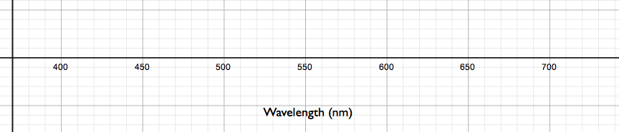

Flame Test Basics: Complete the table below showing the Before, During and After steps of a flame test.

 | Before Flame Test  Ground State Li Atom | During Flame Test  Excited Li Atom | After Flame Test  Ground State Li Atom
Draw the Bohr diagram for each step of the Flame Test
What is happening to the electrons in the atom?

Wavelength and Frequency: Find the wavelength and frequency of the four waves shown below.

 | Line 1 | Line 2 | Line 3 | Line 4
Wavelength
Frequency

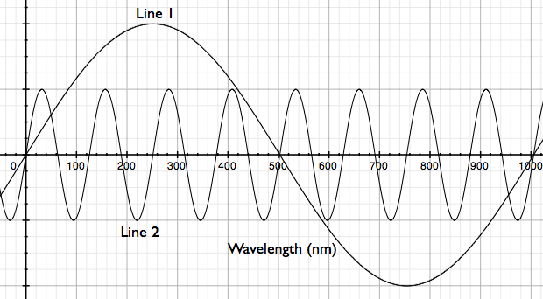
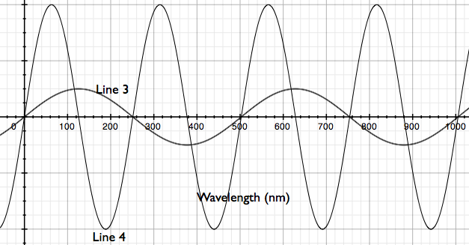
Name:
Date: Period:

Flame Test Part 2: Data Collection

Flame Test Part 2 Objective:

Materials:

- 3 Flame Test Solutions
- 3 100 mL Beakers
- 3 Watch Glasses
- 3 Matches
- Candle
- 10 mL Graduated Cylinder

Experimental Procedure:

- Put on safety goggles
- Place watch glass on top of 100 mL beaker
- Measure 5 mL of your first Flame Test Solution in graduated cylinder
- Carefully pour 5 mL Flame Test Solution 1 into the watch glass
- Light a match using the candle at your lab bench and CAREFULLY touch the edge of the Flame Test Solution in the watch glass
- Observe the color of the flame and estimate the wavelength using the laminated Visible Light Spectrum Card
- Write down the color and estimated wavelength in Data Table 1
- Repeat steps 2-7 for the other two Flame Test Solutions using the remaining beakers and watch glasses
- Let glass cool down while you work on the Wavelength Comparison questions
- Clean up your station (put all materials neatly back into the bin and return Flame Test Solutions to the front counter)

Data Table 1:

Flame Test Solution # | Color Description | Estimated Wavelength (nm)
 |  | λ =
 |  | λ =
 |  | λ =

Wavelength Comparison:

- Draw each observed wavelength below.

Flame Test Solution # | Color | Estimated Wavelength (nm)
 |  | λ =
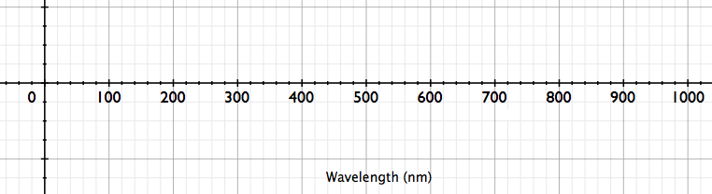

Flame Test Solution # | Color | Estimated Wavelength (nm)
 |  | λ =

Flame Test Solution # | Color | Estimated Wavelength (nm)
 |  | λ =

Name:
Date: Period:
Flame Test Part 3: Data Analysis

Flame Test Part 3 Objective:

Frequency Equation: Starting with the Speed of Light Equation, rearrange the equation to isolate frequency (ν). Then define each variable, including units.

Speed of Light Equation | Frequency Equation | Define Variables
- ν =
- c =
- λ =

Energy Equation: Write the Wave Energy Equation, then define each variable, including units.

Wave Energy Equation | Define Variables
E =
h =
ν =

Calculations: Use your wavelength data from Part 2 to solve for frequency and energy of each sample. Make sure to show ALL of your work.

Flame Test Solution # | Wavelength (nm) λ =
Frequency Calculation | Wave Energy Calculation
Frequency = | Wave Energy =

Flame Test Solution # | Wavelength (nm) λ =
Frequency Calculation | Wave Energy Calculation
Frequency = | Wave Energy =

Flame Test Solution # | Wavelength (nm) λ =
Frequency Calculation | Wave Energy Calculation
Frequency = | Wave Energy =

Graph Analysis:

- Graph Wavelength (nm) vs. Energy (kJ/mol).
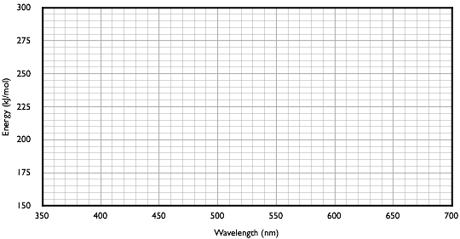
- What do you notice about the graph?

- What does this say about the electromagnetic spectrum? What end of the spectrum has high energy? Which end has low energy?

Element Identification:

- Determine the element is in sample by comparing your calculated energies to the known energy values given on the Visible Light Spectrum Card.

Flame Test Solution | Calculated Energy Values (kJ/mol) | Known Energy Values  (kJ/mol) | Element Responsible
#
#
#

Name:
Date: Period:

Flame Test Part 4: Fireworks and Flaming Pickles

Flame Test Part 4 Objective:

Fireworks! Reading:

- What is the difference between incandescence and luminescence?

- How do the atoms in a firework produce light?

Flaming Pickles: Watch the Flaming Pickles demonstration and answer the following questions?

- How is the flaming pickle similar to a firework?

- Unlike a firework, which has a double fuse system, where is the energy for the flaming pickles come from?

- What happens to the atoms when energy is added?

- How can you use information you learned in the Flame Test Lab and Fireworks! reading to determine the type of chemical used in each pickle?

Firework Design: Design your own firework, including the shape, color, chemicals needed and the calculated frequency and energy of each.

- Describe your firework using at two colors.

- Determine what chemicals you will need to make your firework.

- What wavelength will these chemical produce?

- Calculate the frequency and energy each chemical will produce

Chemical 1:
Frequency Calculation | Wave Energy Calculation

Chemical 2:
Frequency Calculation | Wave Energy Calculation

