Student Activity Pages
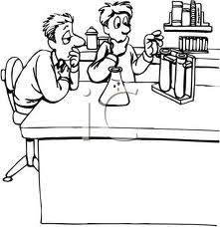
Name ______________________________ Date _____________ Class Period ____

Wacky Wire
Student Version
Demonstrating Change
What makes the wire special? What causes the wire to change shape?
Observations from teacher demonstration:

Part One: Inquiry Into Wacky Wire
You will now embark on an independent experiment to understand how the wacky wire works. You will need to explain in detail how you will set up experiments to test your

Question or Problem: What causes the wacky wire to behave as observed?

You will now suggest a hypothesis to explain the observed behavior of the wire.
Hypothesis:

Procedure:
Explain how you plan to test your hypothesis. Remember to include speciﬁc details
about how you will conduct this experiment. All measurements must be exact and
metric. Remember to include a control experiment and write in complete sentences. What materials do you plan to use? What quantities of each material do you need?

Create a data table to record you data.

Conclusion:
- What was the control?

- Summarize your data. Describe what variable you tested and how the wire responded to that variable.

- What were the independent and dependent variables?

- Explain any sources of error while you were experimenting.

- What do you think is causing the wire to change shape?

- What experiment would you test in the future that relates to the ideas in this lab?
How It Works:

Nitinol is called a shape memory alloy (SMA) because it can “remember” its original shape under certain conditions after being bent, twisted, or stretched out of shape. A shape-memory material is a type of smart material that can be programmed to return to a previously set shape when exposed to certain change in its environment. The Nitinol wire display their shape-shifting properties when exposed to heat. Other shape-memory materials respond to certain wavelengths of light, changes in the magnetic field, electrical currents, or chemical solutions. All materials change in response to their environment. Most expand when heated, for example. Smart materials are designed by materials scientists and engineers to respond to changes in their environments—often in unusual or dramatic ways to achieve a specific purpose. Scientists are developing new airplane wings that will one day be able to change their shape smoothly in mid-flight, as birds do. (Nature, a master of response and change, inspires the design of many smart materials.)

Shape-Memory Alloys
An alloy is a blend of metals. The alloy in the first part of this demonstration is a nickel (Ni) and titanium (Ti) alloy named Nitinol (pronounced “night-in-all”) whose shape-memory properties were discovered at the Naval Ordnance Laboratory (NOL) in White Oak, Maryland, in 1961 (hence the name NiTiNOL). It has a crystal structure, meaning the molecules are arranged in a rigid and regular structure, like a military marching band locked in formation. Most common materials undergo a phase change at specific transition temperatures. For example, they change from solid to liquid at their melting points, like ice to water, or from liquid to gas at their boiling points, like water to steam. Nitinol, however, when heated, undergoes a phase change while remaining solid. This causes its atoms to shift to a new arrangement, changing its outward shape, while remaining solid.

Below that transition temperature, the wire can be deformed because atoms shear past each other. It will hold that deformed shape until it is heated back above the transition temperature, at which point the molecules revert to their previous state. Training the wire to a new memorized shape requires a blast of thermal energy on the order of 500°C (about 900°F) and for the new shape to be temporarily maintained with applied force (such as pliers) until the wire sets and relaxes. Cooling the material ensures that the new shape becomes fixed.

Some other shape-memory alloys are copper-aluminum-nickel, copper-zinc- aluminum, and iron-manganese-silicon.

SHAPE-MEMORY POLYMER
All plastics are polymers, which are long chains of molecules. Shape-memory polymers, however, are combinations of two polymers, each of which has a different melting point. One polymer sets the permanent memorized shape at the polymer’s melting point while the other polymer creates the temporary shape at a different, transition temperature. Heat softens this temporary shape (by breaking the crosslinks between polymer strands), and the shape-memory polymer reverts to its permanent shape. Some shape-memory polymers have up to three memorized shapes, each triggered at a different temperature.

What are some uses for a material that operates this way?

How Do Shape – Memory Alloys Work?

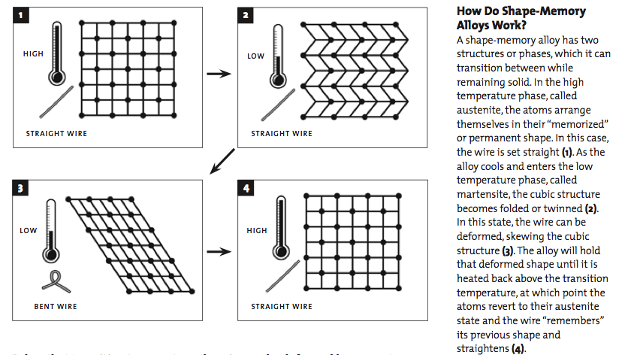

Checking for Understanding:
- Draw a graph for Nitinol wire with temperature on the y axis and rigidity on the x axis (flexible moving to rigid).

- If we imagine your arm is the nitinol wire, what can you do with your arm when it is at a low temperature or the martensite phase? Draw a picture of your arm.

- Now imagine your arm is the nitinol wire at a high temperature or in the austenite phase. Draw a picture of your arm.
How Do We Use Shape Memory Alloys?

Though many Nitinol applications are invisible to the general public, some are quite familiar.1 Shape memory materials can either be metal alloys or plastic polymers. Many of the current applications of Nitinol have been in the field of medicine. Tweezers to remove foreign objects through small incisions were invented by NASA. Anchors with Nitinol hooks to attach tendons to bone were used for Orel Hershiser's shoulder surgery.2 Nitinol needle wire localizers "used to locate and mark breast tumors so that subsequent surgery can be more exact and less invasive" utilize the metal's shape memory property. Eyeglass frames made from Nitinol can be bent severely out of shape, but then return perfectly to normal.1 Also, some years ago, when cell phones had pullout antennas, many of the antennas were made from Nitinol, allowing them to flex without breaking or permanently bending.

Another superelastic application, where you may have experienced Nitinol, is in arch wires used for orthodontistry. The orthodontist takes a Nitinol wire and bends it, attaching it to the teeth. Because the wire is superelastic, it tries to return to its straight condition, and continually exerts a force on the teeth. This allows less frequent visits to the orthodontist to have braces tightened.

A number of lesser-known applications use Nitinol’s shape memory capability. A well-known computer manufacturer used a Nitinol device to eject PCMCIA cards. Also, Nitinol is used in couplings that join the ends of hydraulic tubing in aircraft. In a less serious application, Nitinol enables spoons from the magic shop to bend when placed in hot water.

The superelastic quality of Nitinol, along with its biocompatability, makes it ideal for making many types of medical devices that are implanted in the body. An application familiar to many of us is the stent, a device that supports blood vessels and keeps them open. Nitinol’s superelasticity allows a medical device, such as a stent or a heart valve, to be compressed into a shape that fits inside a catheter. The catheter is positioned at the correct location in the body, the device is released, and it returns to its original shape.

This same superelasticity makes Nitinol the only material suitable for stents used in the carotid artery in the neck, or blood vessels in the legs, said Hrouda. In these vulnerable locations, a blow to the area of a stent will cause it to deflect, but a Nitinol stent will return to its intended shape. Stents made of other materials would be subject to crushing or permanent bending by such an impact.

Surgical instruments and components made from Nitinol fill many needs, especially in minimally invasive or arthroscopic surgery. These may take advantage of the superelasticity and fatigue resistance of Nitinol. A tool that has a bend in it can be straightened and introduced through a cannula, a rigid tube. When it emerges from the cannula, the tool returns to its original shape. The surgeon performs the procedure, and then the tool is retracted back into the cannula where it straightens out again for easy removal.

There are examples of SMAs used in safety devices, which will save lives in the future. 2Anti-scalding devices and fire-sprinklers utilizing SMAs are already on the market. The anti-scalding valves can be used in water faucets and showerheads. After a certain temperature, the device automatically shuts off the water flow. The main advantage of Nitinol-based fire sprinklers is the decrease in response time. (Kauffman and Mayo, 7)

Nitinol is being used in robotics actuators and micromanipulators to simulate human muscle motion. The main advantage of Nitinol is the smooth, controlled force it exerts upon activation. (Rogers, 156)

Other miscellaneous applications of shape memory alloys include use in household appliances, in clothing, and in structures. A deep fryer utilizes the thermal sensitivity by lowering the basket into the oil at the correct temperature. (Falcioni, 114) According to Stoeckel and Yu, "one of the most unique and successful applications is the Ni-Ti underwire brassiere" (11). These bras, which were engineered to be both comfortable and durable, are already extremely successful in Japan (Stoeckel and Yu, 11). Nitinol actuators as engine mounts and suspensions can also control vibration. These actuators can helpful prevent the destruction of such structures as buildings and bridges. (Rogers, 156)

Can you think of any new uses for shape memory materials?

The Story of Nitinol

A reading taken with permission from Kauffman, G. B. and Mayo, I. Chemistry and History: The Story of Nitinol: The Serendipitous Discovery of the Memory Metal and Its Applications. Chem. Educator 1997, 2(2): S1430-4171 (97) 02111-0, 21 pp., DOI 10.1007/s00897970111a, Electronic Journal.

In January 1958 William J. Buehler, a metallurgist at the Naval Ordnance Laboratory (NOL) had completed research on a series of iron-aluminum alloys. Buehler, born in Detroit, Michigan on October 25, 1923, had received his Bachelor of Science degree in chemical engineering (1944) and his Master of Science degree in metallurgical engineering (1948) from Michigan State University at East Lansing.
The “between-projects boredom” began to set in for Buehler after completing the iron-aluminum alloy project:

It was at this point that lady luck played a key role. I found within the U.S. Naval Ordnance Laboratory an ongoing materials project, which had the goal of developing metallic materials for the nose cone of the U.S. Navy Polaris reentry vehicle. The in-house project was under the direction of Mr. Jerry Persh, an aerodynamicist. I was able to attach myself to this project, and my initial task was to provide physical and mechanical property data on existing metals and alloys for computer-assisted boundary layer calculations. These calculations were to simulate the heating, etc. of a reentry body through the earth’s atmosphere. My informational role in this project very quickly became somewhat boring, and I almost immediately began to think in terms of possibly tailoring newly developed alloys that might better satisfy the drastic thermal requirements of the reentry body.

My first wife and I separated, and I spent a tremendous amount of time working in the laboratory...you might say it’s a good feature that came out of a disastrous situation. I had lots of time at that point...in the state of Maryland the law required a three-year waiting period of separation before formal divorce could be handled. During that three-year period I literally worked day and night. Many days I would get up at 4 o’clock in the morning, go to the lab, and not go home until 11 o’clock at night. Between working at the laboratory and playing, I really didn’t do anything other than eat or sleep.

Buehler selected approximately sixty...alloys [to] study. This number was then reduced, for various logical reasons, to twelve alloy systems. One of the systems, [a] nickel-titanium alloy, immediately exhibited considerably more [fatigue-, impact-, and heat-resistance] than the other eleven alloys. In 1953 Dr. Harold Margolin of New York University and his associates had carried out some studies on phase changes of nickel-titanium alloys but had sensed no uniqueness among them.

In 1959 Buehler...named [this nickel-titanium alloy] NITINOL (Nickel Titanium Naval Ordnance Laboratory). That same year he made an observation about [NITINOL] that hinted at the extraordinary, but still undiscovered, property of Nitinol.

I distinctly remember my very exciting discovery of the acoustic damping change with temperature change near room temperature. This unusual event unfolded when my...assistant...and I were melting a number of [Nitinol] bars in the arc-melting furnace. On the day in question (circa 1959), six arc-cast bars were made. While cooling on the...table, the first bars arc-cast into bar form had cooled to near room temperature, while the last bars to be cast were still too hot...to be handled with bare hands. Between the cool (first bar) and the very warm bar (last bar) were four...bars possessing a broad spectrum of temperatures...My “hands-on” approach caused me to take the cooler bars to the shop grinder to manually grind away any surface irregularities that might produce a subsequent scaly or bad....surface. In going from the table to the bench grinder, I purposely dropped the cool (near room temperature) bar on the concrete laboratory floor [a quick test to determine roughly the damping capacity of an alloy]. It produced a very dull “thud,” very much like what one would expect from a similar size and shape lead bar.

My immediate concern was that the arc-casting process may have in some way produced a multitude of micro cracks within the bar—thus producing the unexpected damping phenomena. With this possibly discouraging development in mind, I decided to drop the others on the concrete floor. To my amazement, the warmer bars rang with bell-like quality.

Following this I literally ran with one of the warmer bars (that rang) to the closest source of cold water—the drinking fountain—and chilled the warm bar. After thorough cooling the bar was again dropped on the floor. To my continued amazement it now exhibited the leaden-like acoustic response. To confirm this unique change, the cooled bars were heated through in boiling water—they now rang brilliantly when dropped upon the concrete floor.

Subsequent discussions with my melter assistant revealed that he had in no way mixed or altered the alloy compositions during repeated melting. This immediately alerted me to the fact that the marked acoustic damping change was related to a major atomic structural change, related only to minor temperature variation.

Following the startling acoustic damping discovery, other seemingly related unique changes were observed. More interestingly, these changes also occurred in about the same temperature range as the acoustic damping change.1

In the early 1960s Buehler prepared a long, thin (0.010-inch thick) strip of Nitinol to use in demonstrations of the material’s unique fatigue-resistant properties. He bent the strip into short folds longitudinally, forming a sort of metallic accordion. The strip was then compressed and stretched (as an accordion) repeatedly and rapidly at room temperature without breaking. In 1961 a laboratory management meeting was scheduled to review ongoing projects. Unable to attend, Buehler sent... his assistant to the meeting to present [their] work. As one of their “props” for the review, [the assistant] took the accordion folded fatigue-resistant strip. During the presentation, it was passed around the conference table and flexed repeatedly by all present. One of the Associate Technical Directors, Dr. David S. Muzzey, who was a pipe smoker, applied heat from his pipe lighter to the compressed strip. To everyone’s amazement, the Nitinol stretched out longitudinally. The mechanical memory discovery, while not made in Buehler’s metallurgical laboratory, was the missing piece of the puzzle... [and] became the ultimate payoff for Nitinol.

In 1962 Dr. Frederick E. Wang joined Buehler’s group at the Naval Ordnance Laboratory, his expertise in crystal physics being vitally needed. Wang, born on August 1, 1932 in Su-Tou, Formosa (now Taiwan), emigrated to the United States and did his undergraduate work in chemistry and physics at the University of Tennessee at Knoxville. After receiving his doctorate in physical chemistry from Syracuse University in 1960, he worked as a postdoctoral associate for future (1976) Nobel chemistry laureate William Nunn Lipscomb, Jr. at Harvard University, until he left to join Buehler at NOL. The commercial applications of Nitinol that were to come would not have been possible without Wang’s discovery of how the shape memory property of Nitinol works.
National Nanotechnology Infrastructure Network www.nnin.org Copyright Georgia Institute of Technology 2006 Permission granted for printing and copying for local classroom use without modification Developed by Joyce Palmer
Development and distribution partially funded by the National Science Foundation

NNIN Document: NNIN-1123 Rev: 03/08

Name ___________________________ Date _______________ Class Period_______

The Story of Nitinol

Answer the following questions, after reading the story of Nitinol. Answer in complete sentences.

- What two metals make up Nitinol?

- What is NITINOL an acronym for?

- What larger project was William J. Buehler working on when he discovered something unique about nickel-titanium alloys?

- What initially compelled Buehler to drop one of the cooled bars on the concrete floor?

- Why did Dr. Muzzey heat the demo wire with his pipe lighter?

- How do your answers in questions in d and e show that doing science involves curiosity, imagination, and creativity?

- Provide evidence from the reading that shows how science is NOT a solitary activity.
Part 2
Name ___________________________ Date _______________ Class Period_______

The Force of Nitinol


Objective:
May the force be with you!
Measure the force of Nitinol wire.

Background:
Nitinol wire is a shape memory alloy (blend of metals) that can remember a rigid shape while as having the possibility of being manipulated. Nitinol is an alloy of nearly equal numbers of nickel and titanium atoms, with the exact amounts varied to match the temperature of the phase change to the application. The alloy can exist in either of two structures (phase s) at room temperature, depending on the exact ratio of nickel to titanium atoms. The structure found above the temperature of the phase change possesses the high symmetry of a cube and is called austenite; the structure found below the temperature of the phase change is much less symmetric and is called martensite. In the martensite phase the material is very elastic, while in the austenite phase the material is comparatively rigid.
From: https://www.mrsec.wisc.edu/Edetc/background/memmetal/index.html

Materials:
Mass set
Nitinol Wire
Hair Dryer

Procedure:
- We are going to calculate the force of the memory wire. You will take a lab stool and flip it over. Place the upside down lab stool on the table with the seat resting on the table.
- Take your piece of Nitinol wire and a mass set. Then you will bend your Nitinol wire over the rung of the stool closest to the tabletop.
- You will hold one end of the Nitinol wire against the table. Make sure you have a good grip because it may move. The other end of the wire should be bent into a hook shape.
- You want a small hook at the end of the wire, as achieved when you take a pencil and wrap the last centimeter of the wire over the pencil.
- Starting with the smallest mass (10 g), you will then hook your mass to the wire (you may use an additional centimeter of tape to tape the mass and the wire together). The mass should be resting on the stool with the hook rising above it.
- Take your hair dryer and set it to high heat. Direct the hair dryer so the heat hits the part of the wire bent over the rung of the stool. Hold the hair dryer in a way so it is directed down (be sure to not be directing the heat at yourself or others). Heat the wire for no more than 25 seconds.
- Observe whether the wire is able to lift the mass and record data in the data table.

Data/Results:

Conclusion:
- What was the largest mass the Nitinol wire was able to lift?

- What sources of error occurred during this lab?

- What applications for Nitinol wire can you imagine that we have not discussed?
Part 3
Name ___________________________ Date _______________ Class Period_______

Inventing With Nitinol Wire

Objective:
Create a game with Nitinol wire.

Background:
Nitinol wire is a shape memory alloy (blend of metals) that can remember a rigid shape while as having the possibility of being manipulated. Nitinol is an alloy of nearly equal numbers of nickel and titanium atoms, with the exact amounts varied to match the temperature of the phase change to the application. The alloy can exist in either of two structures (phase s) at room temperature, depending on the exact ratio of nickel to titanium atoms. The structure found above the temperature of the phase change possesses the high symmetry of a cube and is called austenite; the structure found below the temperature of the phase change is much less symmetric and is called martensite. In the martensite phase the material is very elastic, while in the austenite phase the material is comparatively rigid.
From: https://www.mrsec.wisc.edu/Edetc/background/memmetal/index.html

Your job is to invent a game that utilizes Nitinol wire’s unique shape memory effect. You must write down the rules, goal and directions for playing your game. You and your partner will challenge another lab group to the game. You will need to be able to play the game in a total of five minutes.

Goal of Game:

Rules:

Directions:

Diagram of how to play:

Inventing With Nitinol Wire Rubric

Points
Part One: 20 points
- Hypothesis 1 point
- Procedure 5 points
- Data Table 2 points
- Conclusion Questions 12 Points

Part Two 20 points
- How it works reading and check for understanding 6 points
- Story of Nitinol questions thoughtfully answered 14 points

Part Three 20 points
Force of Nitinol Lab
- Data Table titled and clearly labeled 8 points
- Conclusion Questions Thoughtfully answered 12 points

Part Four 40 points
Game 5 points
- Original and creative
- Game can be played in 5 minutes
Rules for game 15 points
- Clearly outlined, easy to follow and legible
Directions for Game 15 points
- Clear, thoughtful and reflects effort
- Objective or goal of game is clear
- Legibly written and provide enough detail to play game
Diagram 5 points
- Drawing of how to play game is labeled, helpful, clear and legible

Name __________________________ Total Points ______/100 points
States of Matter
Matter exists in several different forms, which we call phases or states of matter. We are familiar with solids, liquids and gases. Less commonly discussed but incredibly important phase is the plasma phase. The energy in the atomic forces holding the particles together, pressure, and the energy of the particle motions determine which phase matter exists in.

Amorphous Solids
A solid substance with its atoms held apart at equilibrium spacing, but with no long-range periodicity in atom location in its structure is an amorphous solid. Examples of amorphous solids are glass and some types of plastic. They are sometimes described as supercooled liquids because their molecules are arranged in a random manner somewhat as in the liquid state. For example, glass is commonly made from silicon dioxide or quartz sand, which has a crystalline structure. When the sand is melted and the liquid is cooled rapidly enough to avoid crystallization, an amorphous solid called a glass is formed. Amorphous solids do not show a sharp phase change from solid to liquid at a definite melting point, but rather soften gradually when they are heated.

Crystalline Solids
More than 90% of naturally occurring and artificially prepared solids are crystalline. Minerals, sand, clay, limestone, metals, carbon (diamond and graphite), salts (NaCl, KCl etc.), all have crystalline structures. A crystal is a regular, repeating arrangement of atoms or molecules. The majority of solids, including all metals, adopt a crystalline arrangement because the amount of stabilization achieved by anchoring interactions between neighboring particles is at its greatest when the particles adopt regular (rather than random) arrangements. In the crystalline arrangement, the particles pack efficiently together to minimize the total intermolecular energy.

Within the solid state, matter can have different phases or internal arrangements. As we change the temperature of the Nitinol wire, what makes up Nitinol does not change; it is still Nickel and Titanium. The spacing or rather the angles between these atoms change and gives Nitinol its unique shape memory capability. Nitinol wire is a type of crystalline solid that arranges atoms in two structures. One is called austenite, which is a square lattice shape consisting of 90° angles. The other is a hexagonal structure called a martensite structure where the atoms are more closely packed. The austenite structure occurs at the high temperatures while the martensite structure occurs at lower temperatures. Other crystals such as rock salt or sugar simply break when you attempt to bend the structure or bring atoms of the crystal closer together (because of the like charge of atoms getting closer together).Nitinol wire's ability to closely pack atoms in the martensite structure allow it to be flexible and with the addition of energy those atoms jump back to the memorized austenite structure.
Austenite Martensite
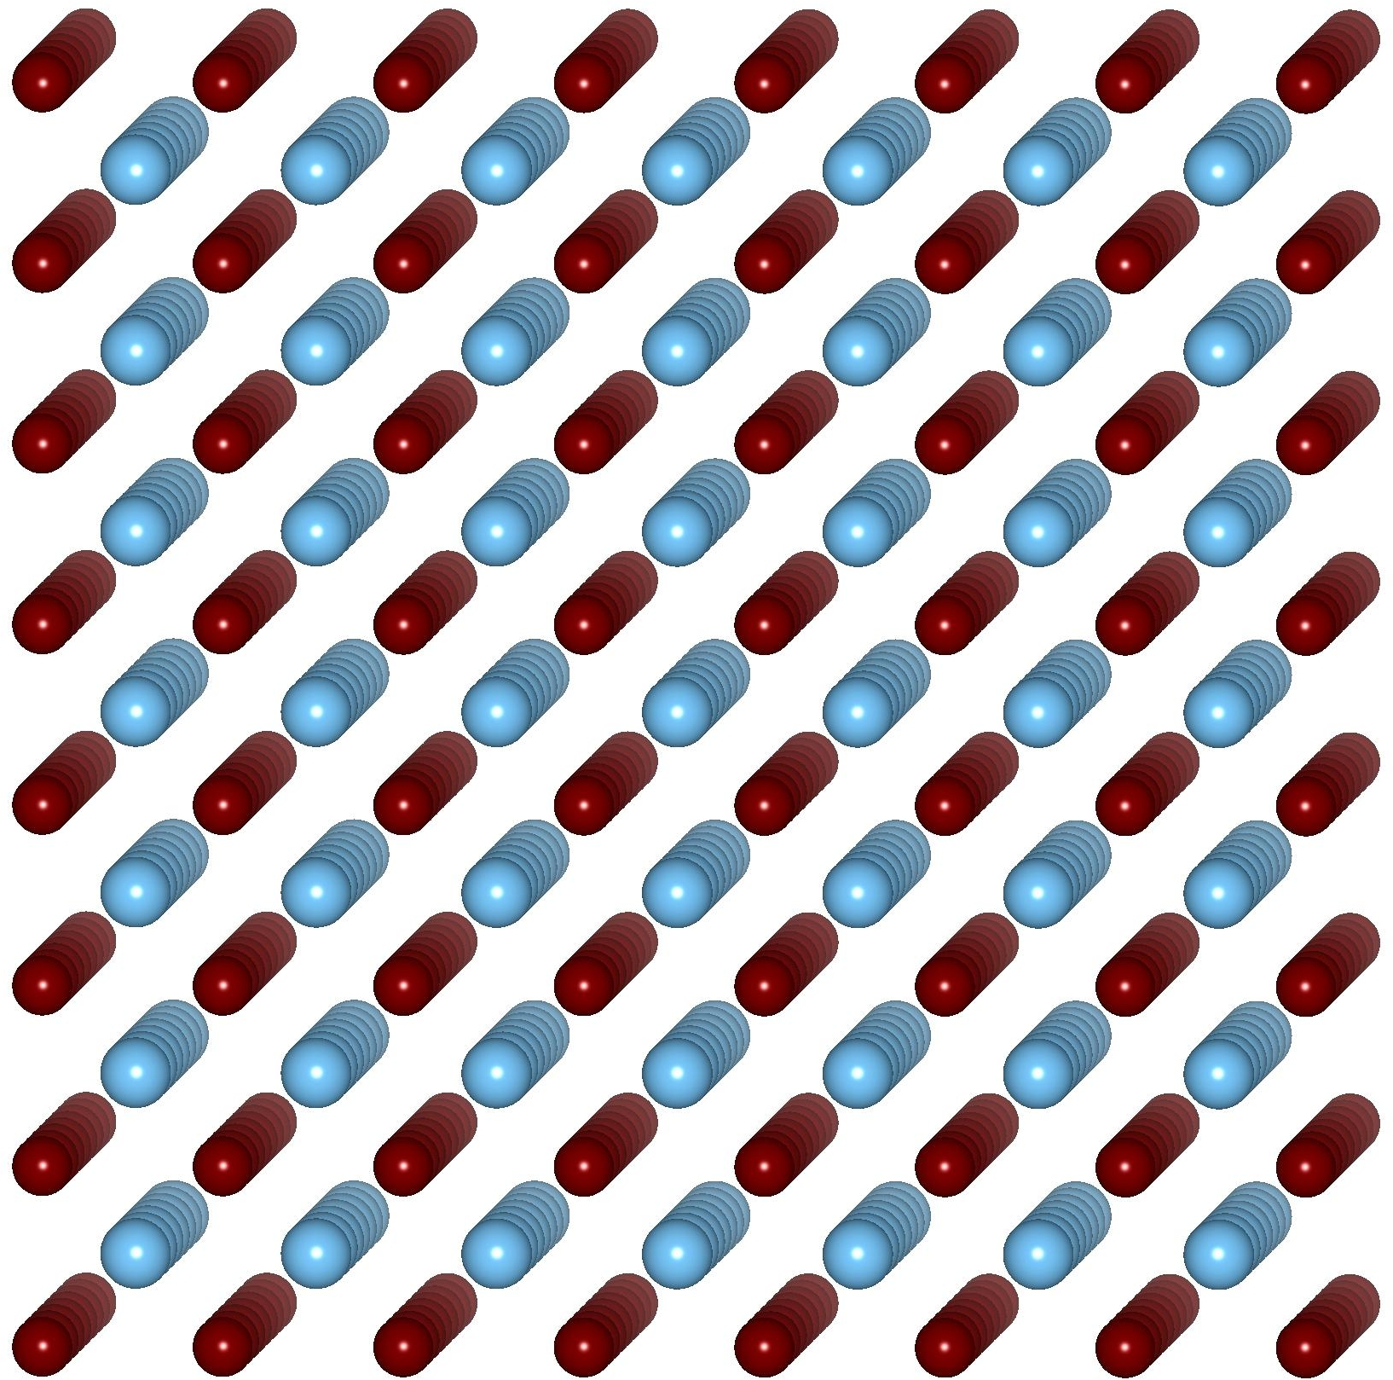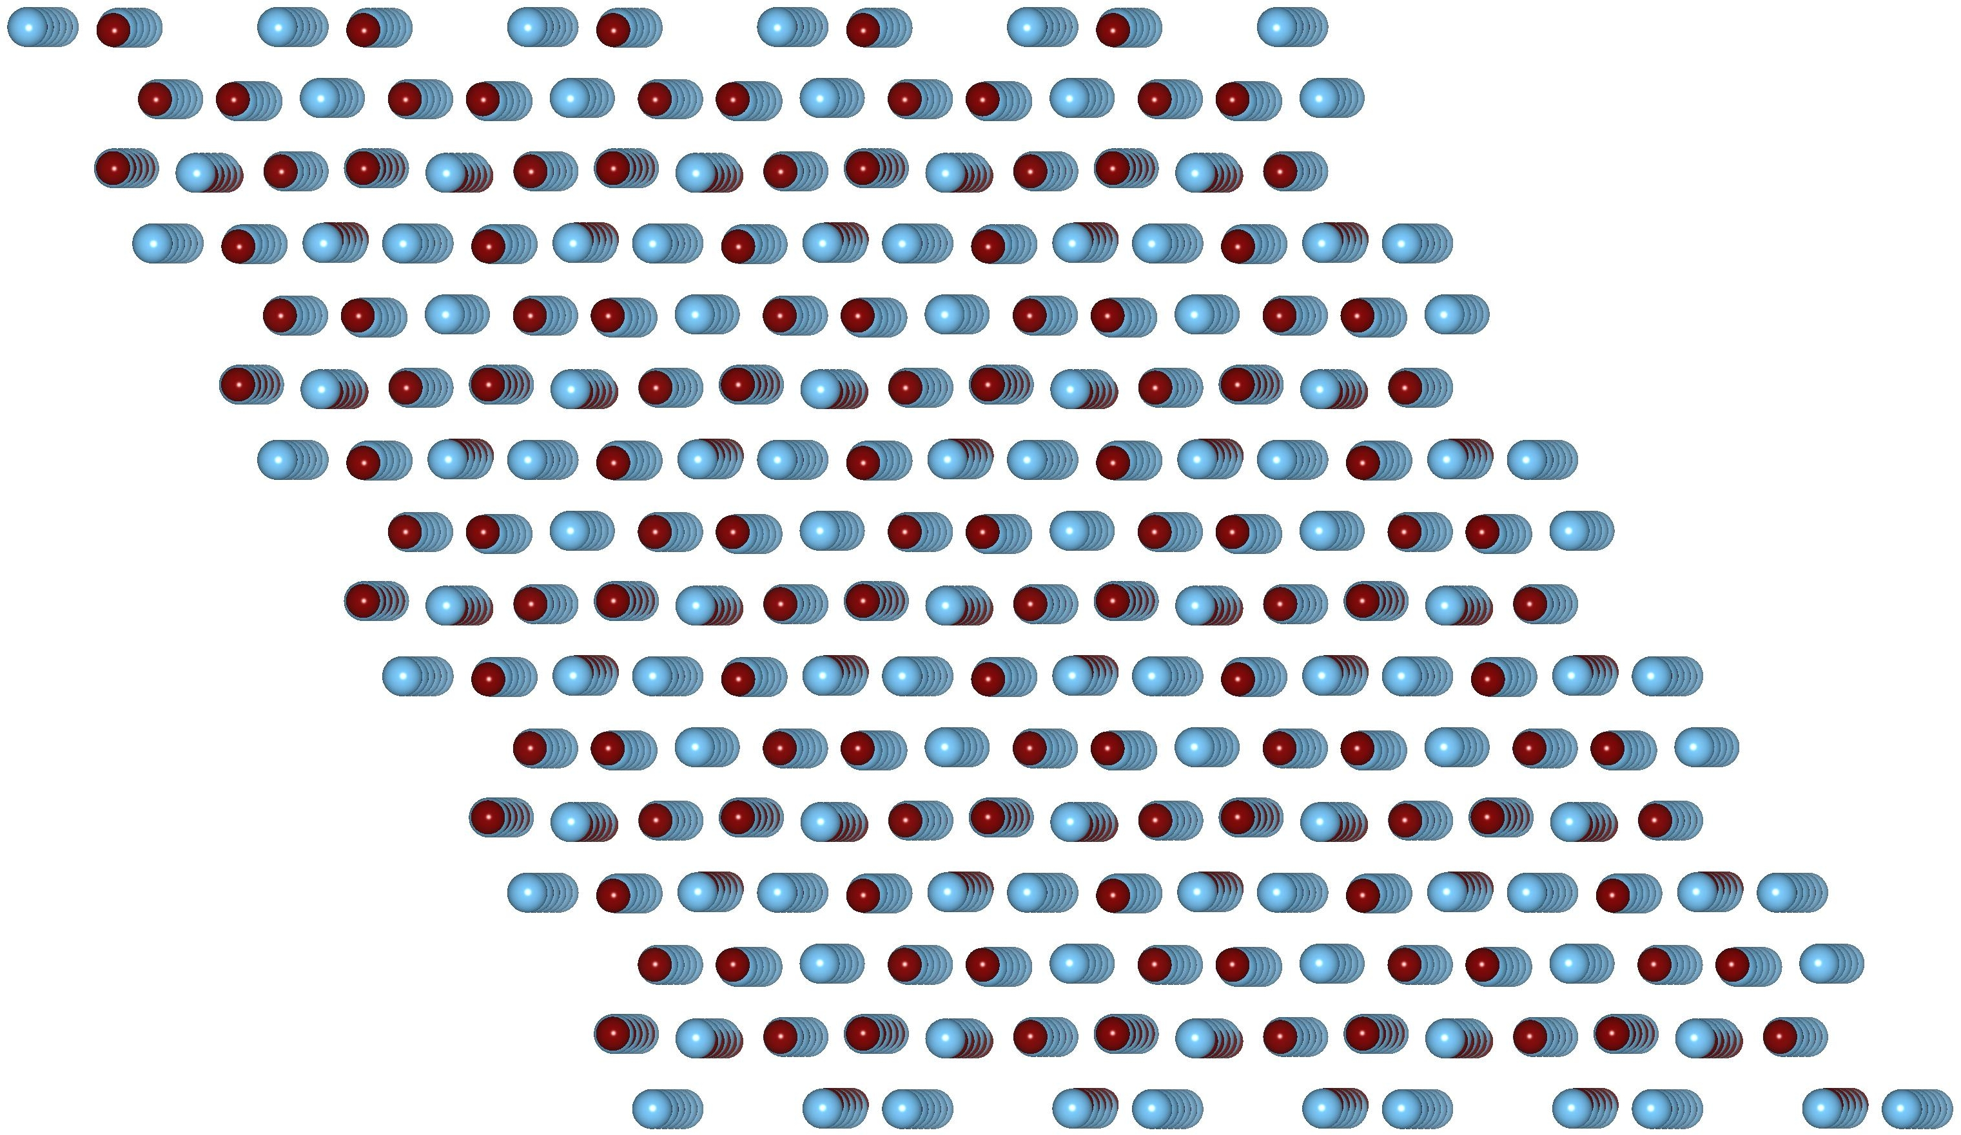

http://www.google.com/imgres?imgurl=http://www.clipartguide.com/_named_clipart_images/0511-0908-2515-5721_Chemistry_Lab_clipart_image.jpg&imgrefurl=http://www.clipartguide.com/_pages/0511-0908-2515-5721.html&usg=__FpQiK3lYLxgacy0MIzydkvFU2Gk=&h=350&w=340&sz=26&hl=en&start=0&sig2=r89E7jyFCKnPxS6n_Cpk3Q&zoom=1&tbnid=_g82aXCDYzba0M:&tbnh=139&tbnw=135&ei=LZocTpn-LIKqsAPUmfiSBQ&prev=/search%3Fq%3Dscience%2Blab%2Bcartoon%26hl%3Den%26client%3Dfirefox-a%26rls%3Dorg.mozilla:enUS:official%26biw%3D1280%26bih%3D595%26tbm%3Disch&itbs=1&iact=hc&vpx=362&vpy=258&dur=32&hovh=228&hovw=221&tx=121&ty=252&page=1&ndsp=21&ved=1t:429,r:16,s:0
www.pbs.org/wgbh/nova/assets/.../making-stuff/stuff-toolkit-cleaner-app.pdf
www.pbs.org/wgbh/nova/assets/.../making-stuff/making-stuff-toolkit.pdf
1 http://www.todaysmachiningworld.com/how-it-works-developing-a-good-memorynitinol-shape-memory-alloy/
2 http://www.stanford.edu/~richlin1/sma/sma.html
1
21 http://www.todaysmachiningworld.com/how-it-works-developing-a-good-memorynitinol-shape-memory-alloy/ 2 http://www.stanford.edu/~richlin1/sma/sma.html
http://www.ndt-ed.org/EducationResources/CommunityCollege/Materials/Structure/solidstate.htm
Images courtesy of Ram Seshadri Professor, Materials and Chemistry & Biochemistry and Associate Director, Materials Research Laboratory at UCSB

