Student Activity Pages
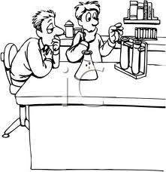
Name _______________________________ Date ____________________ Period_____
Cell Membrane Lab
Student Version
Background Information:
The cell membrane or also called the plasma membrane is a remarkable film so thin that you would have to stack 8,000 of them to equal the thickness of the page you are reading. The plasma membrane is a flexible, nonrigid structure made of two layers of phospholipid molecules, with each molecule having a hydrophilic (water-loving) “head” and a hydrophobic “tails” of the phospholipids point inward; the hydrophilic “heads” point outward, in contact with the watery environments inside and outside of the cell. This lipid bilayer structure is studded with proteins. The proteins move laterally within the membrane forming what is called a fluid mosaic. These proteins serve an important role of allowing substances to enter the cell that may not otherwise be able to cross the lipid bilayer of the plasma membrane. Because of its molecular composition, the plasma membrane is selective about what passes through it. It allows nutrients to enter the cell but keeps out undesirable substances. By the same token, valuable cell proteins and other substances are kept within the cell, and wastes pass to the exterior. This property is known as selectively permeable. Nutrients, respiratory gases, wastes and inorganic ions must all pass through the membrane on their way into or out of the cell. The unique structure of the plasma membrane allows some substances to easily enter and exit the cell while others must pass with the assistance of embedded proteins. Transport through the plasma membrane occurs in two basics ways. In passive processes, concentration or pressure differences drive the movement. In active processes, the cell provides energy (ATP) to power the transport process.
PreLab Questions:
- Where is the cell membrane located?

- What is the function of the cell membrane?

- What is another name for the cell membrane?

- What does selectively permeable mean?

- What is the difference between active and passive transport?

Part One: Cell Membrane Lab
Procedure:2
- Make your soapy solution by adding 50 ml of dish soap to your pan.
- Then add two drops of glycerin to the soap.
- Now we must construct the frame with straws and string. Cut a straw in half with scissors.
- Thread the 45 cm long string through the two pieces of straw. Tie the ends of the string in a knot to form a loop.
- Move the string so the knot is hidden inside one of the straws.
- Now create a handle by threading another piece of string (20 cm) through one of the pieces of straw. Tie the ends of the 20 cm piece of string together in a knot. If you are having trouble, you can tie one end of the shorter 15 cm long piece of string to the frame, then pull the string through one of the straws. Then untie the knot of the shorter string and make the handle.
- Fill the pan with the 50 ml of dish soap.
- Shape the frame into a rectangle. Hold the frame by the handle and immerse the entire frame in the soapy solution.
- Lift the frame by the handle until the bottom of the frame is out of the soapy solution. You should have a rectangular soap film between the two half-straws. If there is no soap film, try immersing and lifting the frame again. Now we are going to poke the film with various things. If the film pops or stays intake make sure to try poking the film two more times with the same substance to confirm your results.
- Have one partner hold the frame that molds the cell membrane while the other partner acts like materials trying to get into the cell. Try poking your finger through the soap film. Record what happens. If your film breaks in between trials immerse it in the soapy solution again.
- Now wet your finger with water and poke it through the film. Then gently move it around the frame in a circular motion. Record what happens.
- Now dip your finger in the soapy solution and poke it through the film. Record what happens.
- Take the condiment cup with the bottom removed and grab it near one end. Now try to poke it through the film. Be sure to put the uncut end of the condiment cup in first.
- Now, immerse the condiment cup in the soapy solution and poke it through the soapy solution. When you can successfully insert a bubble-solution-coated cup through the soapy film, leave the can in this position and have your partner pass you can object through the opening in the cup.
- Answer the conclusion questions and move on to part two.

Data/Results
Substance | Result
Dry finger
Wet finger
Soapy finger
Dry condiment Cup
Soapy condiment cup
Explanation:
The soapy film creates a water sandwich that has two layers of soap with a layer of water in the middle. The hydrophilic heads of the soap molecules point inward toward the water layer, and the hydrophobic tails of the soap molecules point toward the outside of the film, in contact with the air.

The surface tension that causes the soapy film is due to the tendency of water, through hydrogen bonding, to minimize its surface area. When a finger, condiment cup, or other object is wetted with the soapy solution and inserted through the film, the film remains in contact with a like solution, and doesn’t burst because it continues to minimize its surface area. The water-coated finger also causes the film to stretch at the point of entry rather than burst because water wants to minimize its surface area. A dry object simply sheers the film.

Plasma membranes are similar to soap films in many respects. They are both bilayered structures with hydrophobic and hydrophilic ends. They both allow objects to move laterally within them and they are both flexible. Plasma membranes do not burst like soap films though. Both are selectively permeable and allow hydrophobic substances to pass through them like the condiment cup coated in soap.

Part One Conclusion Questions:
- What part of the cell does the soapy solution in the frame represent?

- What does your finger represent in this demonstration?

- What does the condiment cup allow you to do?

- What does the condiment cup represent in a real plasma membrane?

- How does the soap film demonstrate the selectively permeable nature of the plasma membrane?
Bonus Extension Question:

All of the chemical reactions inside the cell take place in water. Additionally, water surrounds the cells. 46% of your body’s mass is comprised of water located inside cells, with another 23% comprised of water located outside of the cells. Add it up...and your body consists of approximately 70% water!

Water is a molecule that consists of two atoms of hydrogen and one atom of oxygen – its chemical formula is H20. Water is considered to be a polar molecule because it has a slightly positive charge near the hydrogen atoms and a slightly negative charge near the oxygen atom. The ends of polar molecules attract opposite charges and repel like charges, just like a magnet. Because of its polarity, many substances dissolve easily in water. However,
not all molecules dissolve in water.....

Most lipids do not dissolve in water. A cell’s membrane is composed of a type of lipid that has two parts: a water-loving (“hydrophyllic”) head and a water-hating (“hydrophobic”) tail. The cell membrane is called the phospholipid bilayer because it is made of two layers of lipid molecules, with the nonpolar tails meeting each other in the middle.

Why is it important that the cell membranes are composed of lipids?
Part Two: Exploring Hydrophobic and Hydrophilic
Now we will experiment with various substances and see how they affect the soapy film.
Try dipping your finger in various substances and seeing how the film reacts. Remember to repeat your test for each substance at least three times to confirm your results. Record your observations in a data table you create.

Use the blank lab report form to record this portion of the lab.

Materials Available:
Olive Oil
Vegetable Oil
Sugar
Salt
Distilled Water
Tap Water
Isopropyl Alcohol
Baking Soda

Remember you can dissolve substances in water to create a solution.

Part Two Conclusion:
- What substances were you able to poke through the film without popping it? What do these substances have in common? Use your class data to answer this question.

- What substances popped the film? What do these substances have in common? Use your class data to answer this question.

- What is the difference between hydrophilic and hydrophobic?

- Why is the cell membrane called a lipid bilayer?

- If the soapy film was actually the cell membrane, what substances you tested would need assistance being transported into the cell?
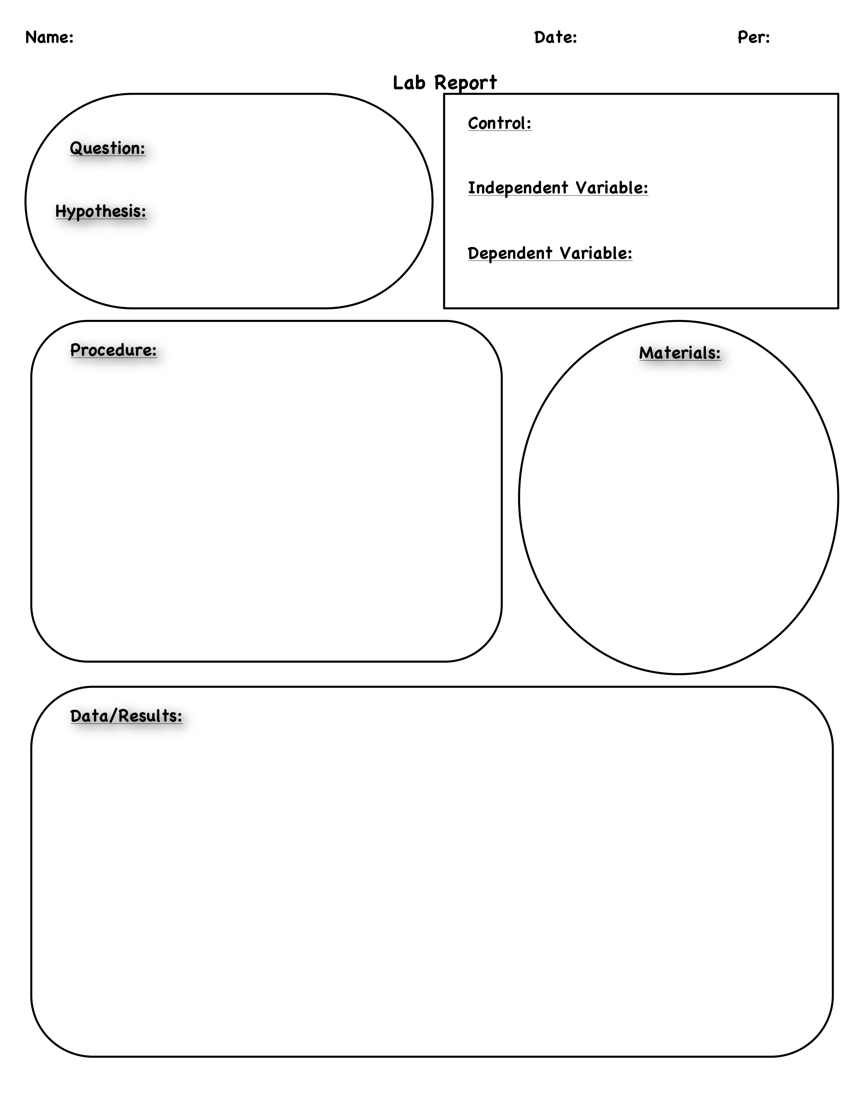
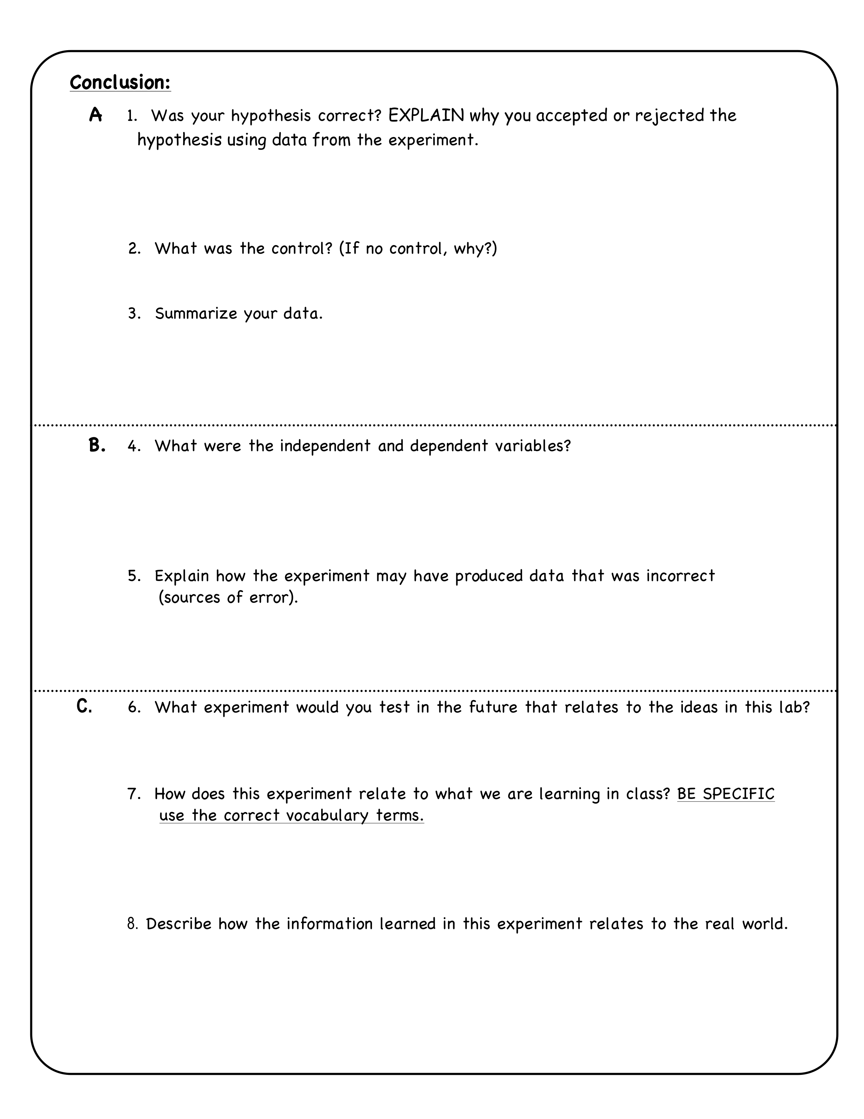

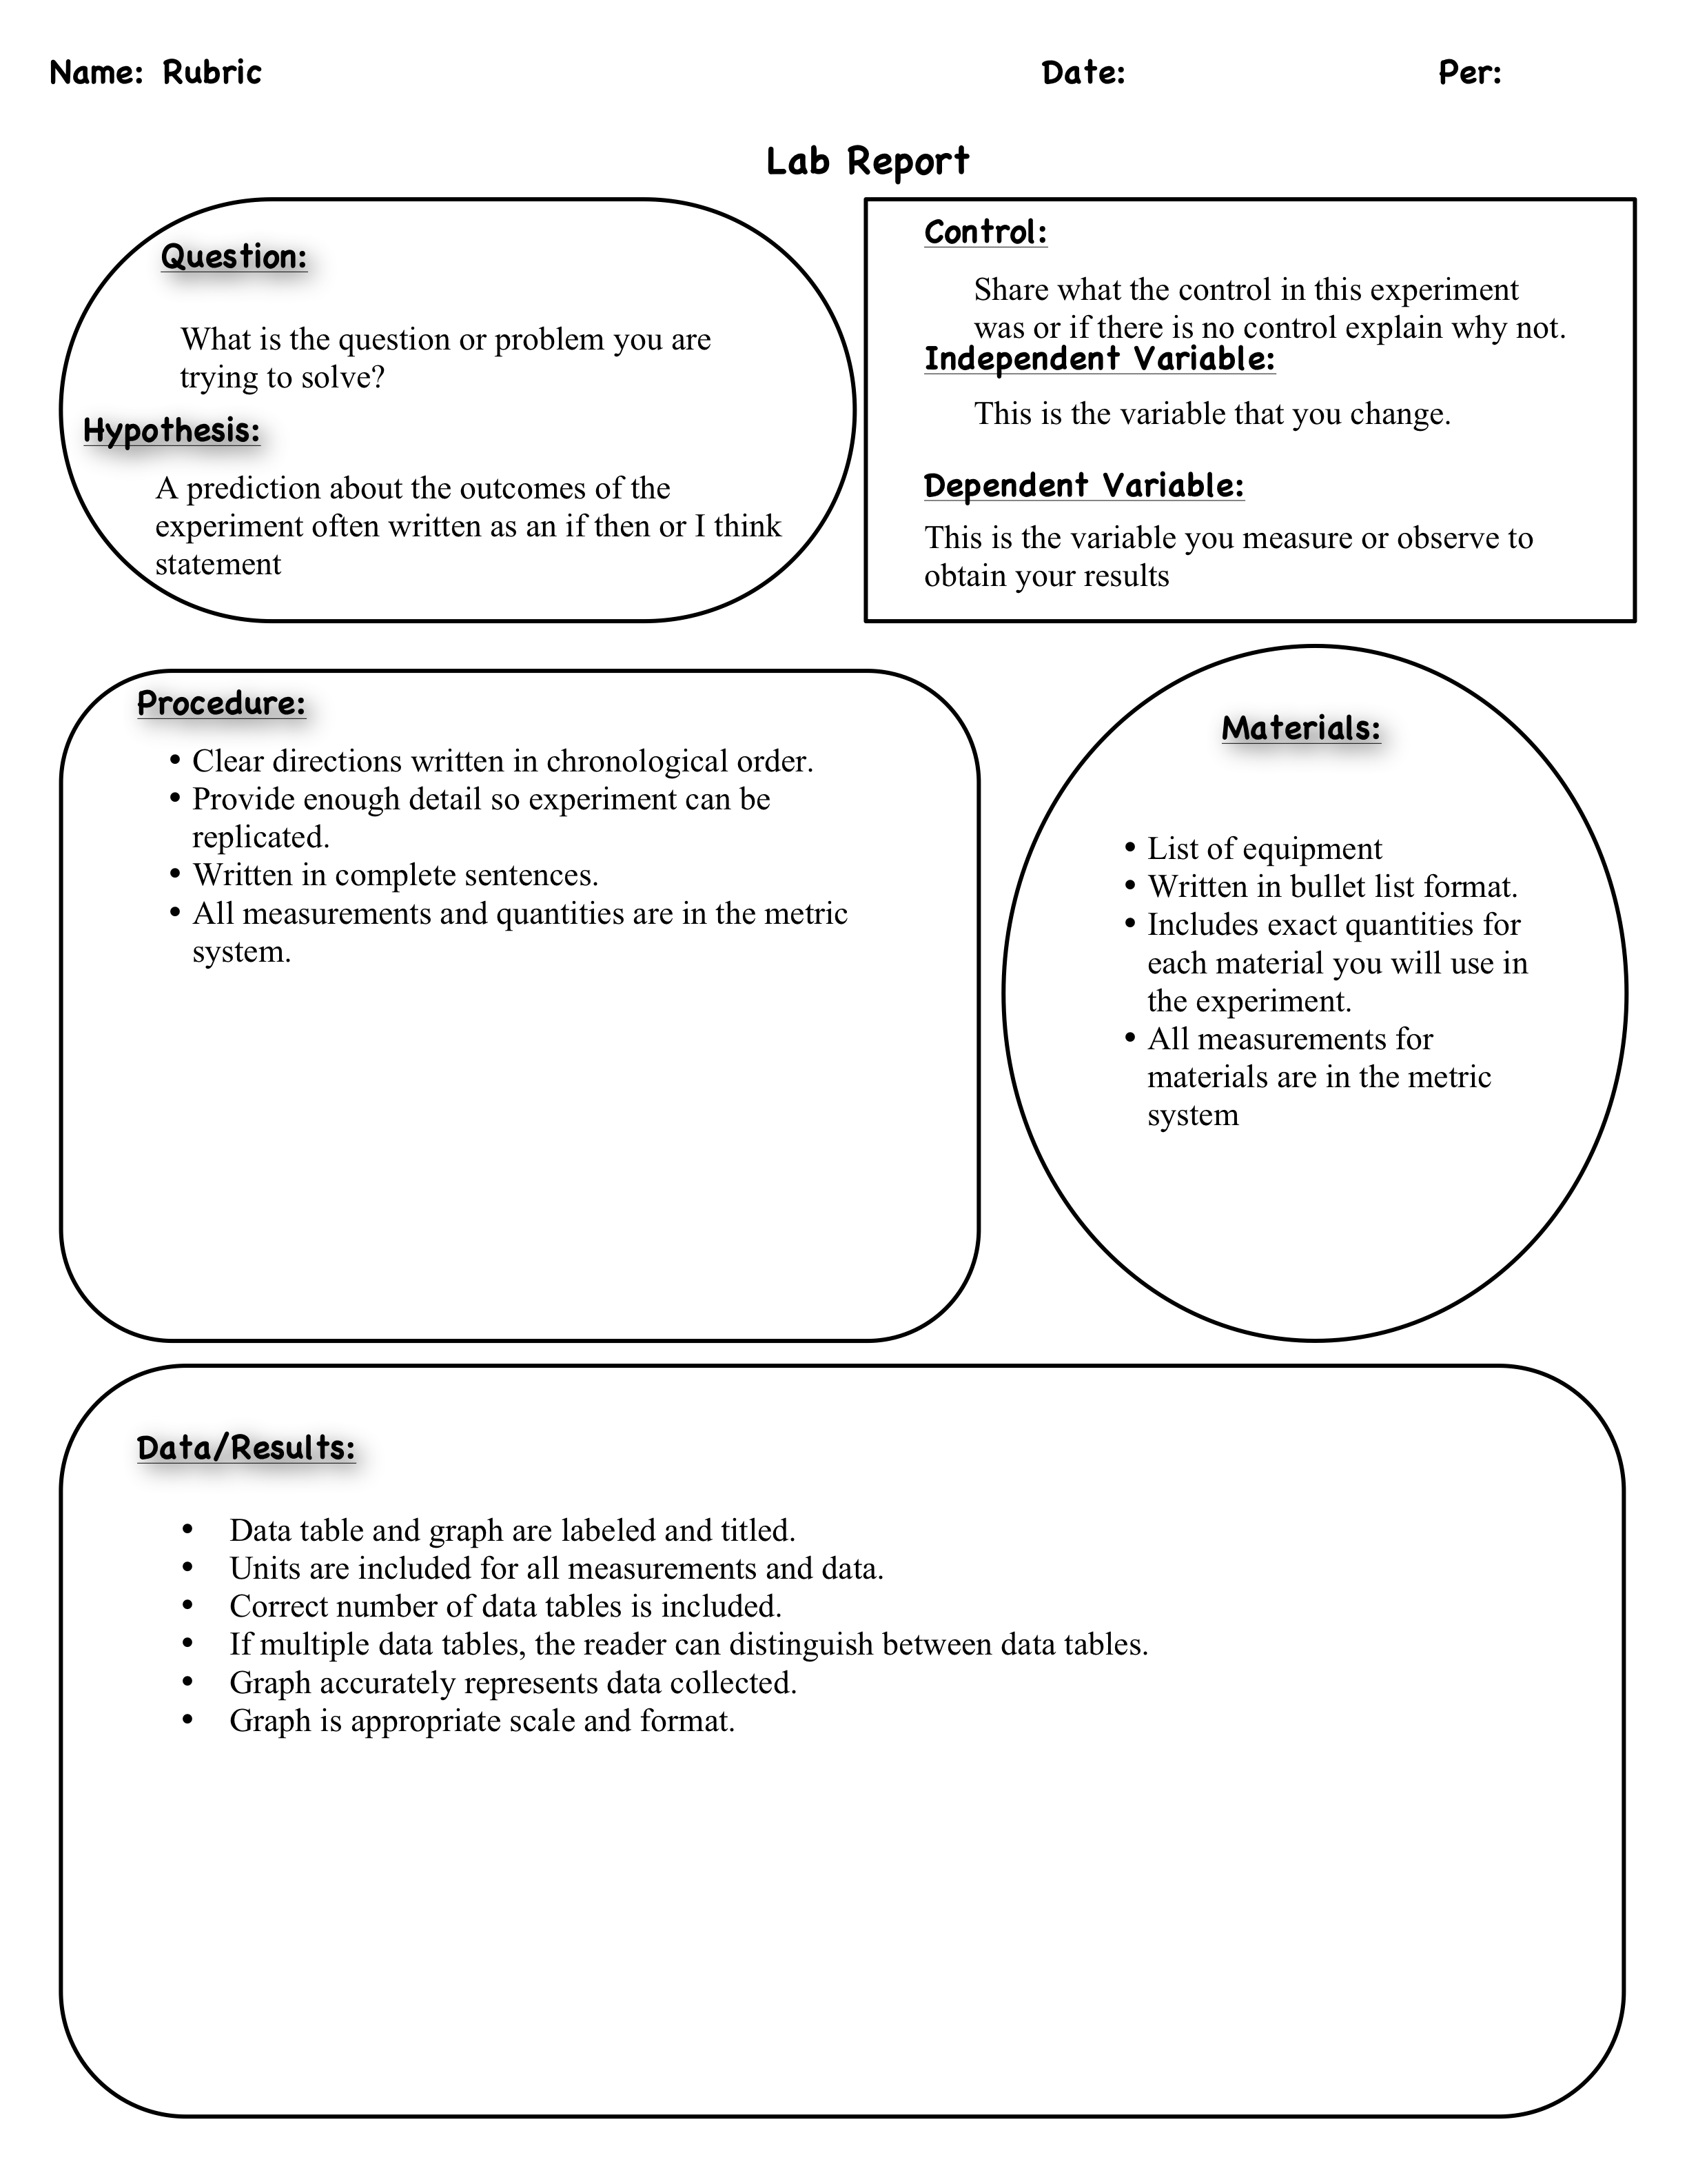Part Three: Passive Transport Demonstrations
Demonstration #1
Take a colander and pour 50 g of salt and 50 g of dried black or lima beans in the colander.

- The colander represents what organelle of a cell?

- The salt is _______________ enough to pass through, but the beans are too ___________________. In a cell, water, carbon dioxide, and oxygen are small enough to cross the cell membrane but larger particles cannot cross. The cell membrane is ______________________ permeable, which means that some substances pass though while others do cannot.
- The movement of water molecules through a selectively permeable membrane is called __________________.

Demonstration #2
Take 200ml of water and add a drop of food coloring. Watch the food coloring for 2 minutes.

- What happened to the food coloring after it entered the beaker?
- __________________ is the movement of particles (like the food _______________) from areas of __________ concentration to an area of low concentration until the concentration in both areas is uniform.
- How does this idea of diffusion relate to the smell when you spray perfume in a room?

- How is osmosis related to diffusion?

Name _________________________________ Date __________________ Period ____
The Egg-Citing Egg-Speriment!

Introduction:
Our bodies are made up of cells that are responsible for every job our body does. But for our cells to perform all these jobs properly, they need to bring in certain particles from outside the cell (just the way that an individual person usually needs help from other people to do a big project). One way for particles to enter the cell and help it do its job is to simply pass through the cell membrane or also called the plasma membrane. All living cells are surrounded by a membrane, which separates the stuff inside the cell (water, nucleus, etc.) from the stuff outside the cell (water, other cells, nutrients, etc.) This membrane decides what can enter the cell and what should stay outside. One way that it prevents certain particles from entering is by having holes only large enough to allow small particles to enter. It is therefore called a semipermeable membrane. An analogy could be made to a basketball net. Only certain size balls will get through. That is, a tennis ball will go through the hoop, a basketball will go through the hoop, but a big beach ball will not. The same holds true with cell membranes. Many particles, such as sugars and salts that are dissolved in the water surrounding the cell try to enter the cell, but they are too big and therefore cannot pass through the membrane.

Egg-Speriment:
Materials:
- (3) 250 ml beakers or big clear cups
- 1 egg (be careful handling the egg!)
- 250 ml vinegar
- 250 ml liquid or mixture of choice
- 250 ml water approximately
- 30 cm piece of string ruler paper and pencil to record observations
- Balance and mass set to record mass

Procedure:
Day One:
- Record observations. Measure the circumference of the egg. Measure the circumference of the egg by wrapping the string gently around the middle of the egg. Hold your finger on the spot where the end of the string meets the rest of the string. Measure the distance between the end of the string and your finger with the ruler. How does the egg feel? ___________________________________________
- Find the mass of your egg.
- Place egg into one of the beakers. (Be careful -- do not drop the egg in.)
- Fill beaker with 200 ml of vinegar. The egg should be submerged.
- Record observations immediately. What do you notice? How does the egg feel? What does the egg look like?

- Remember to record egg number. Your egg is egg number one. If something should happen to your egg your experiment is now faulty because you are comparing data from different eggs and we want to record the new egg’s number, which would be 2.
- Each day we will do the same circumference and mass measurements for a control egg. The control egg data will be posted on the board.
- What is your hypothesis for what will happen to your egg as it soaks in vinegar overnight? Describe what you think the egg will feel like (texture), look like, and smell like. Also include in your hypothesis what you think will happen to the mass and circumference of the egg. Remember to be specific.
Day Two:
- Record the mass and the circumference of your egg each day. Be sure to note how the egg feels when you touch it each day. Don't squeeze too hard! It may seem disgusting to touch, but it actually feels quite amazing! Remember when measuring mass that you need to record the mass of whatever is holding your egg. It is a good idea to place your egg in an empty petri dish or beaker when measuring mass so that it does not roll off the balance.
- Record control egg data.
- What is your hypothesis for what will happen to the egg over the next 24 hours? Describe what you think the egg will feel like (texture), look like, and smell like. Also include in your hypothesis what you think will happen to the mass and circumference of the egg. Remember to be specific.

Day Three:
- Record observations. Record circumference and mass measurement. Once the shell is removed on the third day (i.e. the egg is soft), gently rinse off the egg. Also record how the egg feels at this point. Transfer the egg to a new beaker with water. Fill beaker with 200 ml of water.
- Record control egg data.
- What is your hypothesis for what will happen to the egg over the next 24 hours? Describe what you think the egg will feel like (texture), look like, and smell like. Also include in your hypothesis what you think will happen to the mass and circumference of the egg. Remember to be specific.

Day Four:
- Record observations. Measure circumference and mass.
- Soak egg a substance of your choice. Be sure the egg is covered in your substance. You will need at least 200 ml of the liquid of your choice.
The substance or liquid our group will use is _____________.
- Record control egg data.
- What is your hypothesis for what will happen to the egg during the remainder of the lab? Describe what you think the egg will feel like (texture), look like, and smell like. Also include in your hypothesis what you think will happen to the mass and circumference of the egg. Remember to be specific.

Day Five, Six, Seven
- Each day record observations for circumference and mass.
- Record control egg data.

Data/Results: CONTROL EGG DATA
Day | Liquid | Circumference  (millimeters) | Mass (grams)
1
2
3
4
5
6
7

Data/Results: Experimental Egg

Egg # | Day | Liquid | Circumference  (millimeters) | Mass (grams) | Texture | Other Observations
 | 1
 | 2
 | 3
 | 4
 | 5
 | 6
 | 7

Conclusion:
- Why did we remove the eggshell first?

- What happened to the egg when it was placed in vinegar? Explain why this happened or what process occurred?

- What do you think would happen if you placed the egg in syrup? Explain your answer.

- How did your egg’s appearance change over the past week? (color, texture etc)

- How did your egg’s mass and circumference change when placed in the liquid or substance of your choice? What process occurred?

- If you placed an indoor plant in a high concentration of salt water, what would happen? Why?

- Were your hypotheses correct for how the egg would change over the course of the experiment? Use data from the experiment to support your answer.

- Draw a graph of your results (time on the x axis and circumference or mass on the y axis).

- Red blood cells (RBCs) are good examples to use for an osmosis experiment because their shape changes dramatically when they are exposed to hypotonic or hypertonic solutions. Their normal shape is a round biconcave disk with a smooth plasma membrane. Under the microscope, they look two-toned, with the center being lighter because of the concavity and thinness of the center. If the cell loses most of its water by osmosis when put in a hypertonic solution, it becomes crenated or shriveled with spiked edges. If the cell gains a significant amount of water by being placed in a hypotonic solution, it swells and may eventually burst – a process called hemolysis (hemo- = blood; -lysis = break down).

The red blood cells labeled A are normal cells. Label the B and C cells as either being in hypertonic or hypotonic solutions.
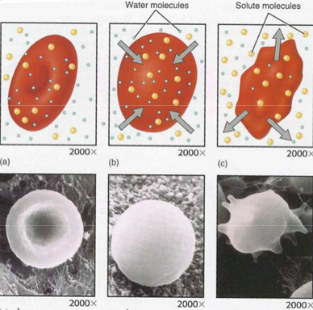
from ourse1.winona.edu/mgarbrecht/Membrane%20Lab.pdf
Egg-Citing Egg-Speriment Rubric

Points
Day One: 2 points
Questions 5 and hypothesis are complete, thoughtful and legible

Day Two: 1 point
Hypothesis is thoughtful and legible

Day Three: 1 point
Hypothesis is thoughtful and legible

Day Four:
Substance 3 points
- recorded on lab sheet
- appropriate
- correct quantity (at least 200 ml)
- brought to class on time
Hypothesis is thoughtful and legible 3 points
Control Data
- thorough
- legible
- labeled
Experimental Egg Data 3 points
- thorough
- legible
- labeled
Conclusion Questions 16 points
Graph (labeled, titled, and neatly drawn) 5 points

Name________________________ Total Points ______/35 points

http://www.google.com/imgres?imgurl=http://www.clipartguide.com/_named_clipart_images/0511-0908-2515-5721_Chemistry_Lab_clipart_image.jpg&imgrefurl=http://www.clipartguide.com/_pages/0511-0908-2515-5721.html&usg=__FpQiK3lYLxgacy0MIzydkvFU2Gk=&h=350&w=340&sz=26&hl=en&start=0&sig2=r89E7jyFCKnPxS6n_Cpk3Q&zoom=1&tbnid=_g82aXCDYzba0M:&tbnh=139&tbnw=135&ei=LZocTpn-LIKqsAPUmfiSBQ&prev=/search%3Fq%3Dscience%2Blab%2Bcartoon%26hl%3Den%26client%3Dfirefox-a%26rls%3Dorg.mozilla:enUS:official%26biw%3D1280%26bih%3D595%26tbm%3Disch&itbs=1&iact=hc&vpx=362&vpy=258&dur=32&hovh=228&hovw=221&tx=121&ty=252&page=1&ndsp=21&ved=1t:429,r:16,s:0
http://knight.noble-hs.sad60.k12.me.us/content/exploringLife/text/chapter6/concept6.2.html
Human Body Explorations Soap Opera Experiment published by Exploratorium
www.harford.edu/faculty/wrappazzo/.../Laboratory/CellMembraneLab.pdf
2 Adapted from Human Body Explorations Soap Opera Experiment published by Exploratorium
www.shellyssciencespot.com
Adapted from sciencephiles.com/files/doc/Labs/Egg-speriment%20Lab.doc

