Analyzing Earth History Data
Student Activity Pages

Name ____________________________Date _____________Period_____
Understanding Mass Extinctions:
Graphing Diversity Data
Student Version

Part One: Understanding Mass Extinctions
Objective:
We are going to look at diversity of specific genera to see what patterns we see over time and develop our understanding of how scientists determine when mass extinctions occur by using data from the fossil record. Genera is plural for genus. All life is organized into kingdom, phylum, class, order, family, genus, species. Kingdom being the most broad while species is the most specific. We will investigate three coral building organisms and see how their diversity has changed throughout geologic time. Through our analysis of this limited set of data we see trends. This gives us a basis for understanding how scientists take data from thousands of fossils and draw conclusions about mass extinction events.

Background Information:
Mass extinctions have sometimes accelerated the evolution of life on Earth. When dominance of particular ecological niches passes from one group of organisms to another, it is rarely because the new dominant group is "superior" to the old and usually because an extinction event eliminates the old dominant group and makes way for the new one. For example mammaliformes ("almost mammals") and then mammals existed throughout the reign of the dinosaurs, but could not compete for the large terrestrial vertebrate niches, which dinosaurs monopolized. The end-Cretaceous mass extinction removed the non-avian dinosaurs and made it possible for mammals to expand into the large terrestrial vertebrate niches. Ironically, the dinosaurs themselves had been beneficiaries of a previous mass extinction, the end-Triassic, which eliminated most of their chief rivals, the crurotarsans.

Another point of view put forward in the Escalation hypothesis predicts that species in ecological niches with more organism-to-organism conflict will be less likely to survive extinctions. This is because the very traits that keep a species numerous and viable under fairly static conditions become a burden once population levels fall among competing organisms during the dynamics of an extinction event. One prediction of the Escalation Hypothesis is that individual species having fewer adaptations that enable them to compete with other life forms are more likely to survive a mass extinction event such as one of The Big Five. This is because there is more flexibility to fit into new ecological niches that arduous adaptations such as heavy shells or energy consuming venom production would hinder.

Furthermore, many groups, which survive mass extinctions do not recover in numbers or diversity, and many of these go into long-term decline, and these are often referred to as "Dead Clades Walking". So analyzing extinctions in terms of "what died and what survived" often fails to tell the full story.
PreLab Questions:
- Historically mass extinctions have allowed certain species to fill the niches of extinct species. Scientist propose that the species filling the niches of the extinct species are not dominant in anyway but rather utilizing resources made available through the extinction of a species. What species have benefited from the extinction of other species?

- Why would it be a disadvantage of a mass extinction survivor species to be extremely adapted to a certain environment?

- At a mass extinction event, do all species go extinct immediately or do some species gradually die out? Explain your answer.

Procedure: Graphing Diversity Data

Your objective is to graph the diversity data from the Paleobiology database. The Paleobiology database is a collection of data relating to the fossil record obtained from the research of hundreds of scientists.

Take the data from the attached data tables and create a graph with all organisms on one graph. The Paleobiology database provides a lot of information about the fossil record but we will only graph the range through genera column, which refers to the number of genera present in that division of time. Additionally, we will graph the interval, which refers to the time period. Each time period is divided into equal sections to give a more detailed despersion of diversity during that time period.
Rugosa Data
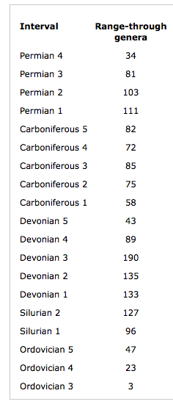
Archaeocyatha Data Tabulata Data

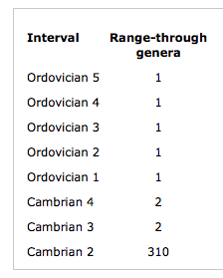
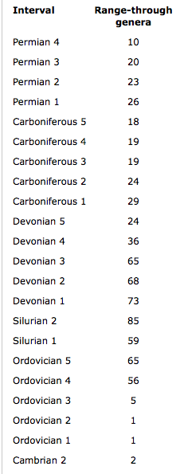

Diversity Curve Data Analysis
- Looking at the graph, what do you notice happened to the diversity of these genera at the end of the Ordovician?

- What happens to the reef building genera at the end of the Devonian?

- Was the decline of the Tabulata gradual or sudden?

- How does the decline of Tabulata compare to the decline of Rugosa?

- What trend do you notice when looking at the three different types of corals or reef building organisms? When do they originate versus go extinct? Give a general overview of what the fossil record looks like for corals represented in this graph?

- Why do we not find many fossils before the Cambrian?

Scientists take the data sets from these organisms and thousands of others. From analyzing all of these data sets together scientists have determined when mass extinctions have occurred. We have looked at a very narrow range of results in our graph but if we expanded this to a very large range of organisms we will see some more trends.

Now we will look at the graph provided.

All Genera Through Time Graph
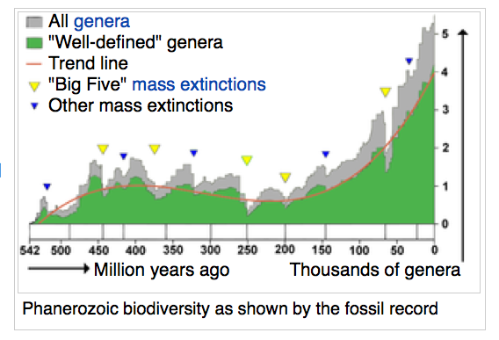
image from: http://en.wikipedia.org/wiki/Extinction_event
Analysis:
- Following the trend line, what is the general trend of the graph? What is happening to biodiversity over geologic time?

- What are some reasons why scientists would observe an increase in diversity of organisms throughout the history of the Earth?

- Find the end of the Paleozoic (251 ma) and Mesozoic (65.5 ma) on the graph. What do you notice happens to the graph? What does this indicate happened?

- How does diversity today compare to diversity at the early Cambrian?

- What guess do you have for why this graph starts at 542 million years and not further back in Earth’s history?

Part Two: Sampling Inquiry

Evaluating what information we do have
Scientists who evaluate the fossil record and draw conclusions from it must be mindful of the data that is present and the lack of certain data. The fossil record has a relative abundance of certain organisms that are favorable to being preserved and lacks the presence of other organisms that are more difficult to preserve. We know organisms with a hard shell or calcium carbonate will preserve better and be more numerous in the fossil record than soft bodied animals that has tissue that is easily damaged by decay and environmental conditions surrounding where the organism dies. Additionally, when scientists analyze data such as the diversity curve data that we just graphed, scientists must be sure they have a large enough sample size that is statistically significant or unlikely to have occurred by chance.

You already understand that you need a certain sample size to get a representative sampling of a population. If I asked you to find out what the favorite ice cream flavor of students in your class is you would not go out and ask two students in order to draw your conclusion.

This activity helps us understand and experience how scientist must evaluate how much data in a sample provides enough evidence to draw accurate conclusion. Scientists refer to this as confidence intervals, which refer to how scientists use statistics to confirm the conclusions they are making.

Objective:
Your goal is to collect a sample of data from your classmates regarding what sport is the easiest to play. You have two minutes to sample your classmates to obtain your data regarding your question.

Question:

Hypothesis:

Procedure: How will you sample the class to collect a representative amount of data?

Data/Results:

Conclusion:
- Do you feel you got an accurate sampling of the class? Explain why or why not.

- What would be the most accurate way to collect a 100% accurate sampling?
Paleontologists and geologists do not have fossils from all organisms that have ever existed. This is because some organisms have bodies that do not preserve well, conditions for fossils to form are somewhat rare, environmental conditions can make it difficult for organisms to be preserved, and fossils can be preserved in rock that is weathered and destroyed during the rock cycle. Understanding the factors that reduce the number of available fossils, scientists must be aware of the numerous factors affecting sample sizes of fossils they do have.

Now take the four envelopes and make a hypothesis for what image is inside the envelope. The same image is in each envelope. Each envelope represents a different sample size.

Hypothesis Envelope #1

Hypothesis Envelope #2

Hypothesis Envelope #3

Hypothesis Envelope #4

Analysis:
- Did your hypothesis change as you gathered more information?

- Were all envelopes and their respective samples of equal value? Explain why or why not. Were any of the samples (associated with an envelope) misleading? Explain why or why not.

- Was there a point at which you were confident that you had enough information?

- We will never have a fossil for each organism that has ever existed or even created a fossil. How does this activity relate to our collections of fossils in the fossil record?

- Are there other factors in addition to number of samples that would affect the distribution or abundance of fossils created at a particular time in history?
Part Three: Taphonomy Lab

The field of taphonomy in paleontology was born out of a discovery in the 1950ʼs by scientists named Knoll and Barghoorn. They looked at the decay of algae to see what changes occurred to the algae over time. They discovered that the protoplasmic (stuff inside a cell membrane) material decay in such a way that it looked like a nucleus. This disproved many of the early images of eukaryotic cells that were found in chert (rock like charcoal) prior to their discovery. While scientists have a lot of confidence in their findings in the fossil record, this discovery challenged the early evidence of eukaryotic cells. This study introduced the importance of a field called taphonomy. Taphonomy studies the role of decay in changing an organism’s appearance and how they become fossils. This has extended into our study of forensics in a field called forensic taphonomy where we look at decay in human bodies to help solve mysteries about a crime. The new discoveries by Knoll and Barghoorn and the emerging field of taphonomy challenged scientist to reevaluate the fossil record and potential biases it held. The goal of taphonomy is to see what bias exists in the fossil record regarding the relative abundances of organisms. Since we know organisms with a hard shell or calcium carbonate will preserve better and be more numerous in the fossil record than soft bodied animals that has tissue that is easily damaged by decay and environmental conditions surrounding where the organism dies. Experimental taphonomy testing usually consists of exposing the remains of organisms to various altering processes, and then examining the effects of the exposure.
Prelab Questions:
- What is the study of taphonomy?

- Why is it important that scientists understand taphonomy as it relates to the fossil record?

Now we will conduct our own taphonomy study using paramecium. We are using paramecium, a single celled eukaryotic cell, because they are large enough to see in a compound light microscope and their long unique body shape makes them easy to identify. We will compare the paramecium under normal circumstances and alter the environmental conditions to see how it affects the rate of decay or appearance of organism.
- What will you do for your control experiment?

- What variable or environmental condition are you altering?

- What environmental condition in the real world is this analogous to?

Complete the lab report form. Record what you plan to do for the experiment.

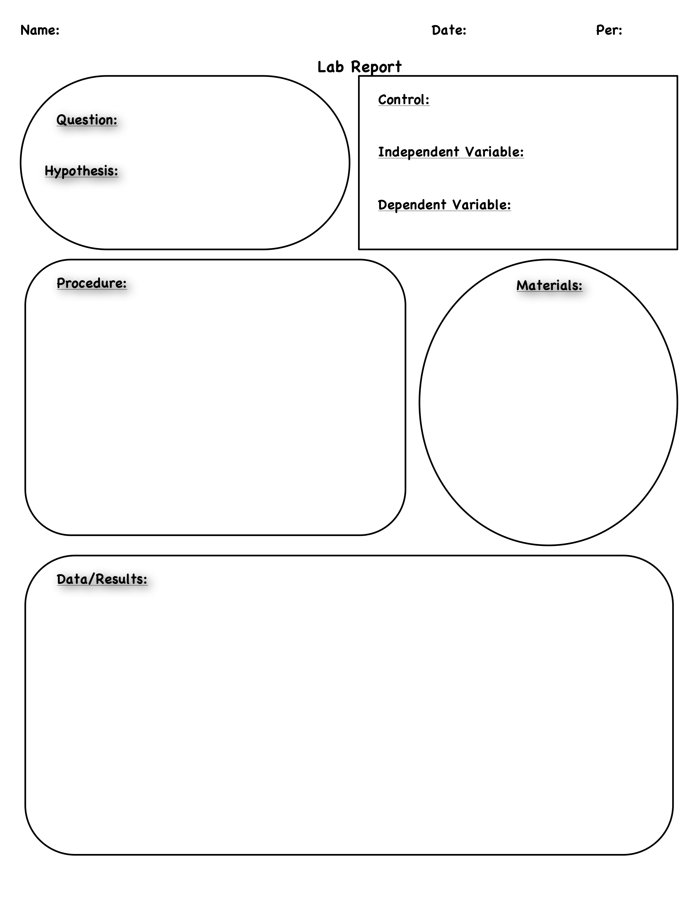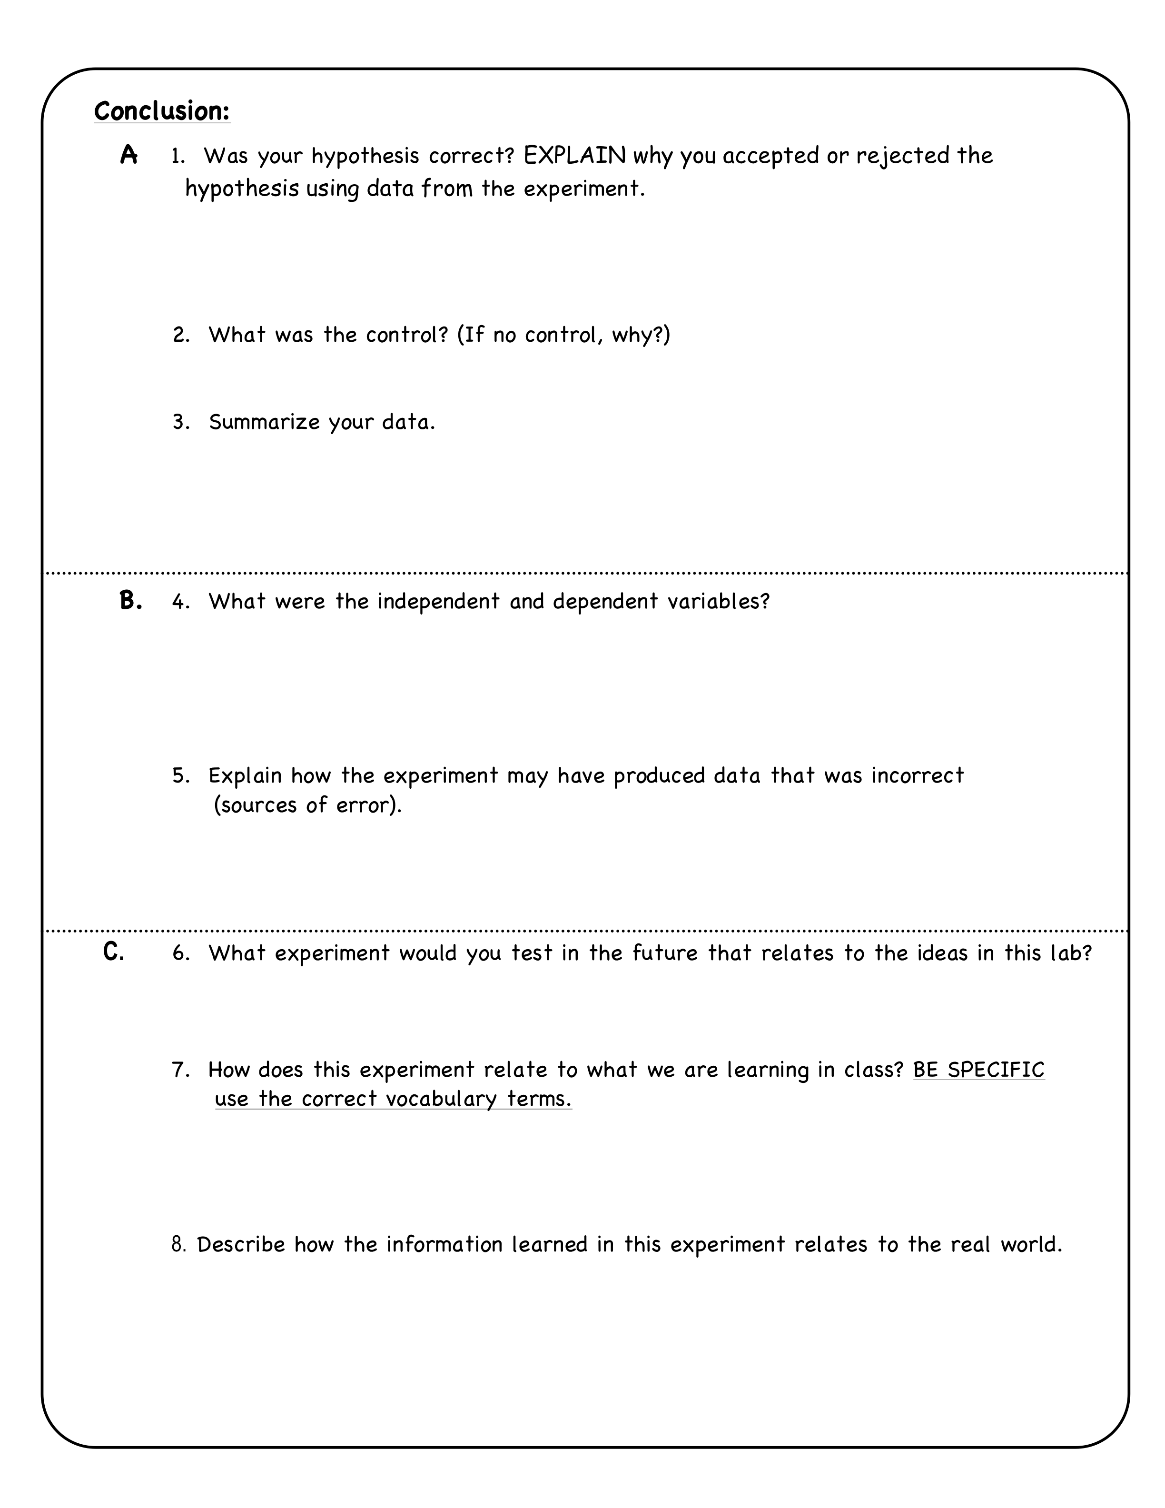

The Current Mass Extinction

Is the biosphere today on the verge of anything like the mass extinctions of the geological past? Could some equivalent of meteorite impacts or dramatic climate change be underway, as humankind's rapid destruction of natural habitats forces animals and plants out of existence?

Increasingly, researchers are doing the numbers, and saying, yes, if present trends continue, a mass extinction is very likely underway. The evidence is pieced together from details drawn from all over the world, but it adds up to a disturbing picture. This time, unlike the past, it's not a chance asteroid collision, nor a chain of climatic circumstances alone that's at fault. Instead, it is chiefly the activities of an ever-growing human population, in concert with long-term environmental change.

The background level of extinction known from the fossil record is about one species per million species per year, or between 10 and 100 species per year (counting all organisms such as insects, bacteria, and fungi, not just the large vertebrates we are most familiar with). In contrast, estimates based on the rate at which the area of tropical forests is being reduced, and their large numbers of specialized species, are that we may now be losing 27,000 species per year to extinction from those habitats alone.

The typical rate of extinction differs for different groups of organisms. Mammals, for instance, have an average species "lifespan" from origination to extinction of about 1 million years, although some species persist for as long as 10 million years. There are about 5,000 known mammalian species alive at present. Given the average species lifespan for mammals, the background extinction rate for this group would be approximately one species lost every 200 years. Of course, this is an average rate -- the actual pattern of mammalian extinctions is likely to be somewhat uneven. Some centuries might see more than one mammalian extinction, and conversely, sometimes several centuries might pass without the loss of any mammal species. Yet the past 400 years have seen 89 mammalian extinctions, almost 45 times the predicted rate, and another 169 mammal species are listed as critically endangered.

Therein lies the concern biologists have for many of today's species. While the number of actual documented extinctions may not seem that high, they know that many more species are "living dead" -- populations so critically small that they have little hope of survival. Other species are among the living dead because of their interrelationships -- for example, the loss of a pollinator can doom the plant it pollinates, and a prey species can take its predator with it into extinction. By some estimates, as much as 30 percent of the world's animals and plants could be on a path to extinction within 100 years. These losses are likely to be unevenly distributed, as some geographic areas and some groups of organisms are more vulnerable to extinction than others. Tropical rainforest species are at especially high risk, as are top carnivores, species with small geographic ranges, and marine reef species.

Humanity's main impact on the extinction rate is landscape modification, an impact greatly increased by the burgeoning human population. Now standing at 5.7 billion and growing at a rate of 1.6 percent per year, the population of the world will double in 43 years if growth continues at this pace. By draining wetlands, plowing prairies, logging forests, paving, and building, we are altering the landscape on an unprecedented scale. Some organisms do well under the conditions we've created: They tend to cope well with change, tolerate a broad range of habitats, disperse widely, and reproduce rapidly, and they can quickly crowd out more specialized local species. City pigeons, zebra mussels, rats, and kudzu and tamarisk trees -- these are examples of what biologists call "weedy" species, both animals and plants. Many weedy species will probably survive, and even thrive, in the face of the current mass extinction. But thousands of others, many never known to science, are likely to perish.

And what is the fate of our own species likely to be, if we really are in the midst of a sixth mass extinction? One possibility is that as diversity and abundance wither, the species causing it all -- Homo sapiens, the most dominant species in history -- could also be on the road to oblivion. But another possibility is that Homo sapiens, which has proved to be a very effective weedy species itself, will persist. That's the view of paleobiologist David Jablonski, who sees us as one of the survivors, "sort of picking through the rubble" of a world that has lost much of its biodiversity -- and much of its comfort. For along with that species richness, the ecosystem is likely to loose much of its ability to provide many of the valuable services that we take for granted, from cleaning and recirculating air and water, to pollinating crops and providing a source for new pharmaceuticals. And while the fossil record tells us that biodiversity has always recovered, it also tells us that the recovery will be unbearably slow in human terms -- 5 to 10 million years after the mass extinctions of the past. That's more than 200,000 generations of humankind before levels of biodiversity comparable to those we inherited might be restored.

Conclusion Questions:
- How does the rate of extinction today compare to historically?

- Why is it important to understand how the Earth has changed geologically and biologically?

- The article says that while the number of actual documented extinctions may no seem that high, they know that many more species are “living dead.” What are the “living dead” that many biologists are concerned about?

- According to the article, what are humanity’s main impacts on the extinction rate of species today?

- What environmental challenges are happening to habitat in your local area.

http://www.google.com/imgres?imgurl=http://www.clipartguide.com/_named_clipart_images/0511-0908-2515-5721_Chemistry_Lab_clipart_image.jpg&imgrefurl=http://www.clipartguide.com/_pages/0511-0908-2515-5721.html&usg=__FpQiK3lYLxgacy0MIzydkvFU2Gk=&h=350&w=340&sz=26&hl=en&start=0&sig2=r89E7jyFCKnPxS6n_Cpk3Q&zoom=1&tbnid=_g82aXCDYzba0M:&tbnh=139&tbnw=135&ei=LZocTpn-LIKqsAPUmfiSBQ&prev=/search%3Fq%3Dscience%2Blab%2Bcartoon%26hl%3Den%26client%3Dfirefox-a%26rls%3Dorg.mozilla:enUS:official%26biw%3D1280%26bih%3D595%26tbm%3Disch&itbs=1&iact=hc&vpx=362&vpy=258&dur=32&hovh=228&hovw=221&tx=121&ty=252&page=1&ndsp=21&ved=1t:429,r:16,s:0
http://en.wikipedia.org/wiki/Extinction_event
Lesson adapted from Learning to take scientific samples: holey card activity presented by Miriam Polne
Precambrian Eukaryotic Organisms: A Reassessment of the Evidence. Andrew H. Knoll; Elso S. Barghoor Science, New Series, Vol. 190, No. 4209. (Oct. 3, 1975), pp. 52-54.
http://en.wikipedia.org/wiki/Taphonomy
http://www.pbs.org/wgbh/evolution/library/03/2/l_032_04.html

