Student Activity Pages
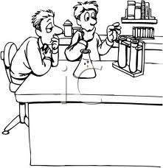
Name ___________________________________ Date ____________ Period________

Electrolysis Lab
Background Information:
Water is an example of a "molecular compound." Atoms in a molecular compound are bound together by shared electrons (i.e., covalent bonds). Water can be split into its constituent elements through electrolysis. In chemistry, electrolysis is a method of separating bonded elements and compounds by passing an electric current through them. An ionic compound, in this case salt, is dissolved with an appropriate solvent, such as water, so that its ions are available in the liquid. Ions are atoms or molecules where the amount of protons does not equal the number of electrons. An ionic compound is a compound where the ions are held together by electrical attraction (or ionic bonds). Ions or electrolytes (substance with free ions that make the substance electrically conductive) are needed to make the water conductive. The solid form of table salt has the sodium and chloride ions strongly bonded but once they are dissolved in water the ions freely move. An electrical current is applied between a pair of inert (not reactive) electrodes (transition points from an electrical conductor to an ionic conductor) immersed in the liquid. The negatively charged electrode is called the cathode, and the positively charged one the anode. Each electrode attracts ions, which are of the opposite charge.

Therefore, positively charged ions (called cations) move towards the cathode, while negatively charged ions (termed anions) move toward the anode. Elements in group one have a tendency to lose a single electron to form a single positively charged ion. Elements in group 16 have six electrons in their outermost shell and thus have a tendency to gain two electrons to form a doubly negatively charged ion. The molecules of salt dissociate into ions of opposite charges. It is the ions of sodium chloride that render the water conductive to electricity when they dissolve in water. In table salt, the Na+ and Cl- ions make it possible for the distilled water to conduct electricity.

The energy required to separate the ions, and cause them to gather at the respective electrodes, is provided by an electrical power supply. At the electrodes, electrons are absorbed or released by the ions, forming a collection of the desired element or compound.

One important use of electrolysis is to produce hydrogen. The reaction that occurs is 2H2O(aq) → 2H2(g) + O2(g). This has been suggested as a way of shifting society towards using hydrogen as an energy carrier for powering electric motors and internal combustion engines.

PreLab Questions:
- What is electrolysis?

- What is an ion?

- How do we use electrolysis in the real world?

- Which ions will move towards the cathode or positively charged electrode?

- Would solid NaCl conduct electricity?

Part One: Splitting Water
Materials:
2 Strips of Aluminum Foil (6cm by 10 cm)
10 cm by 10 cm glass container or 250 ml Beaker
60 ml NaCl salt
400 ml of water
Stirring Rod
Timer
Falcon Tube or Test Tube (check with teacher which is available)
Goggles
Power source ( 9V battery or solar panel)

Procedure:
- Create nearly identical electrodes by folding the strip of aluminum foil on themselves so they are longer than they are wide. You should have two strips of aluminum foil.
- Fill the glass container with 400 ml of water.
- Dissolve 90 ml of salt in the water. Stir vigorously until the salt has dissolved.
- Place the two electrodes on the edge of the beaker. Leave at least 5 cm in between each electrode. Fold the aluminum foil over the lip of the beaker with at least 7 cm of the aluminum foil submerged in the water. Pinch the ends of the aluminum foil that will be submerged in the water so they make a point. It is best to have the aluminum foil parallel with the side of the beaker.
- Completely submerge the falcon tube with the opening facing the electrodes. Make sure the cathode aluminum foil tip is directing into the falcon tube to capture the gas bubbles. The falcon tube must be completely full of water. If your container is larger and part of the tube is not submerge simply add more water and salt.

- Have your partner take the leads (red and black wires) from the power source and place one on each piece of aluminum foil. You will need to hold the wires on the aluminum foil the entire experiment.
- Do not let the wires or pieces of aluminum foil touch each other.
- Once you have placed the leads on the aluminum foil start the timer. Record how much gas is formed at the black wire or anode. Take a measurement every 2 minutes.
- Stop recording the gas volume after 20 minutes or until the falcon tube is full (which ever occurs first).

Data/Results:
Hydrogen Gas Formation Data
Time | Volume of Hydrogen Gas
2
4
6
8
10
12
14
16
18
20

Conclusion:
- Where did the hydrogen gas come from?

- What would happen if you did not connect one of the electrodes from the power source to the aluminum foil? If you do not know, try this now.

- Why do the hydrogen gas bubbles rise in the water?

- What are some sources of error in this experiment?

- Without the presence of salt in the water, would it be possible to go through this process of electrolysis?
Name ___________________________ Date____________ Period _____

Exploring Electrolysis

Part Two:
Now we will explore what variables affect the rate of hydrogen gas formation.

Objective:
You and your partner must alter one variable from the previous experiment. We will treat your data from the Splitting Water lab as your control data.

Possible questions you can explore are
- See how the amount of salt impacts the production of hydrogen gas
- See if a sports drink will impact the production of hydrogen gas
- What would happen if we change the solute in water. Dissolve sugar or baking soda instead of salt in the water

What variable are you changing?

Record your information on the provided lab report form.
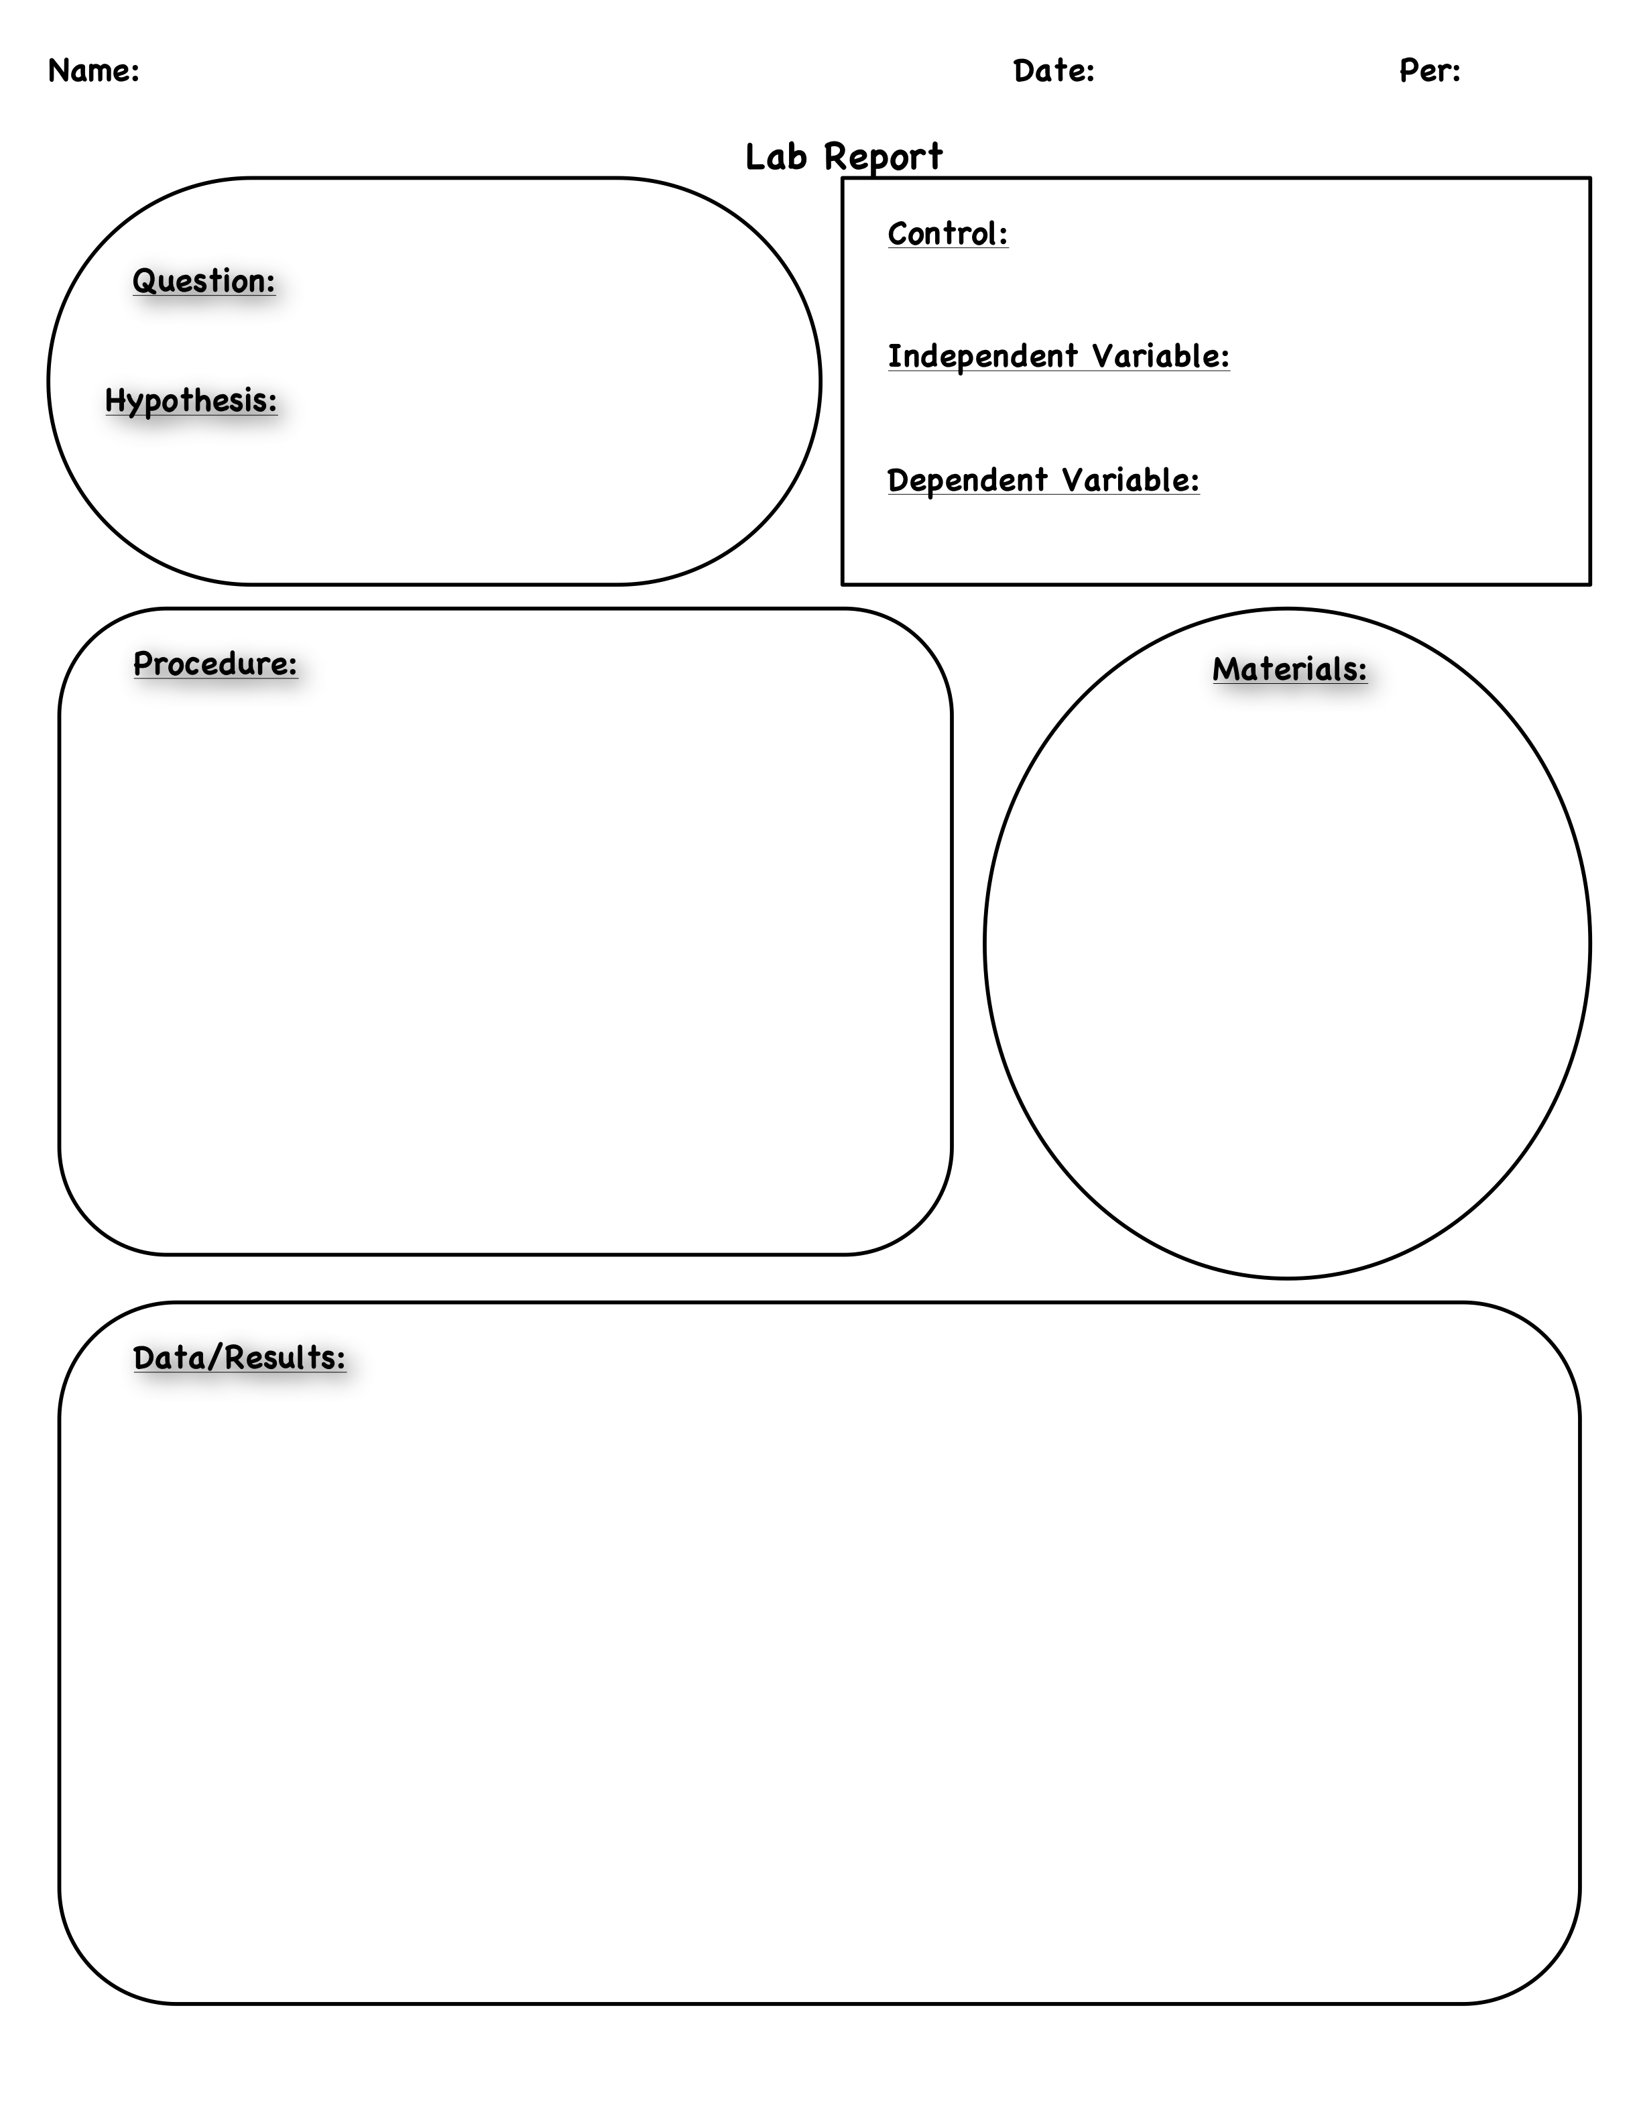

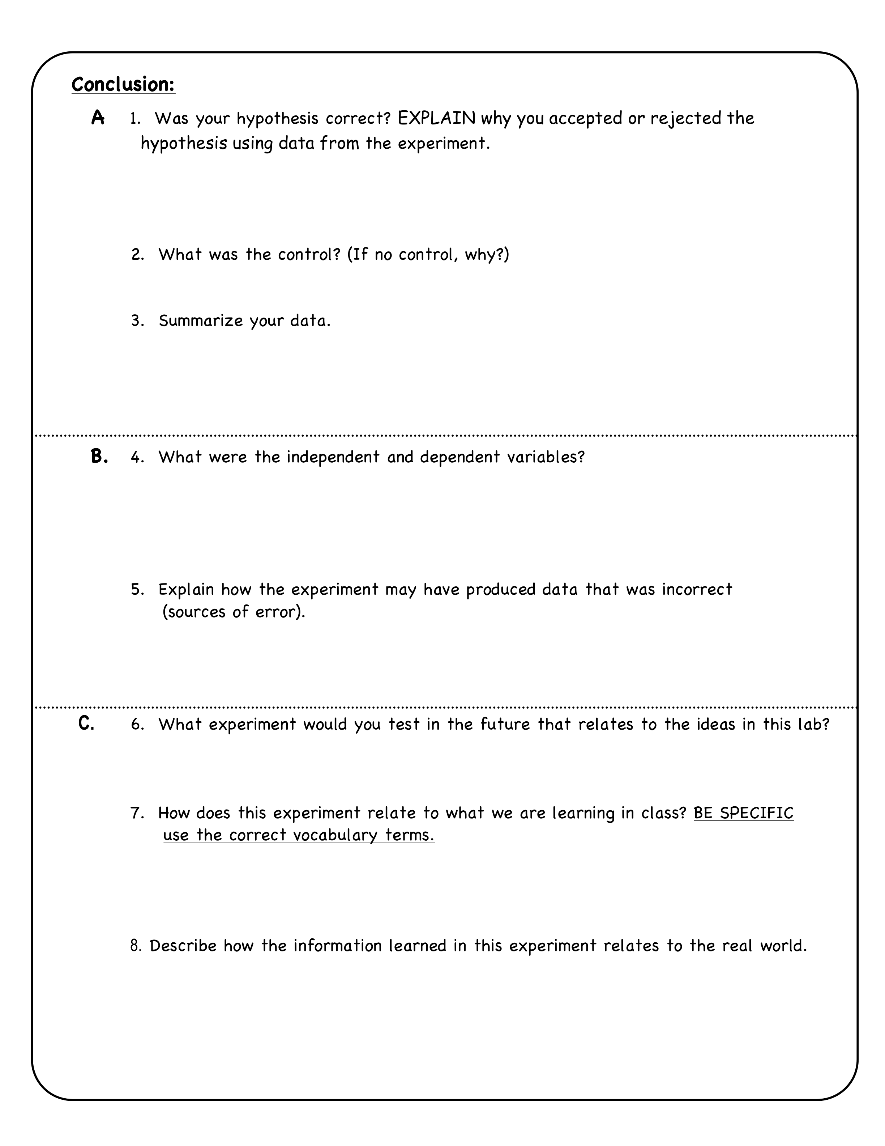
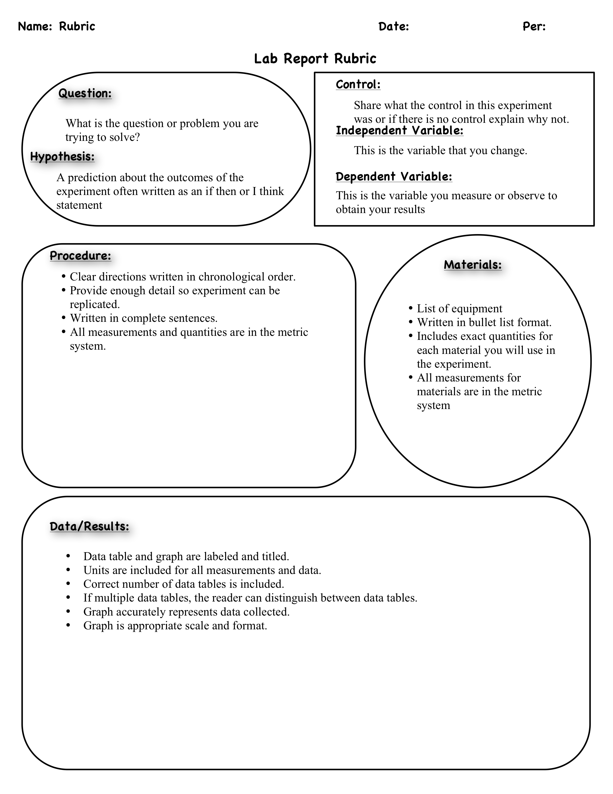

http://www.google.com/imgres?imgurl=http://www.clipartguide.com/_named_clipart_images/0511-0908-2515-5721_Chemistry_Lab_clipart_image.jpg&imgrefurl=http://www.clipartguide.com/_pages/0511-0908-2515-5721.html&usg=__FpQiK3lYLxgacy0MIzydkvFU2Gk=&h=350&w=340&sz=26&hl=en&start=0&sig2=r89E7jyFCKnPxS6n_Cpk3Q&zoom=1&tbnid=_g82aXCDYzba0M:&tbnh=139&tbnw=135&ei=LZocTpn-LIKqsAPUmfiSBQ&prev=/search%3Fq%3Dscience%2Blab%2Bcartoon%26hl%3Den%26client%3Dfirefox-a%26rls%3Dorg.mozilla:enUS:official%26biw%3D1280%26bih%3D595%26tbm%3Disch&itbs=1&iact=hc&vpx=362&vpy=258&dur=32&hovh=228&hovw=221&tx=121&ty=252&page=1&ndsp=21&ved=1t:429,r:16,s:0
aquarius.nasa.gov/pdfs/electrolysis.pdf
Adapted from Thames and Kosmos Fuel Cell Car and Experiment Kit

