Analyzing Earth History
Teacher Activity Guide

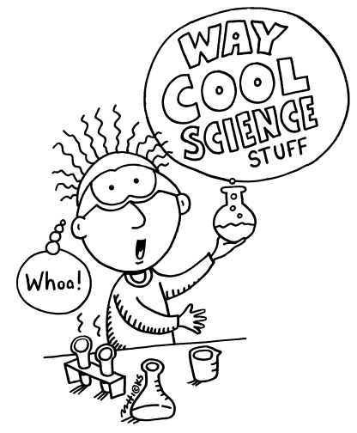

Analyzing Earth History
Part One
Students are going to look at diversity of specific genera to see what patterns appear over time and develop an understanding of how scientists determine when mass extinctions occur. They will graph the diversity of three coral building genera and see how their diversity has changed throughout geologic time. Through the analysis of this limited set of data we are able to see trends. This gives us a basis for understanding how scientists take data from thousands of fossils and draw conclusions about mass extinction events.

Teacher Background Information
What is biodiversity? Biodiversity is the simply the variation of life forms. By today’s standards, generally greater diversity means the greater health of the ecosystem. We are going to look at diversity of specific genera to see what patterns we see over time and develop our understanding of how scientists determine when mass extinctions occur.
Genera is plural for genus. All life is organized into kingdom, phylum, class, order, family, genus, species. Kingdom being the most broad while species is the most specific.

We will investigate three coral building organisms and see how their diversity has changed throughout geologic time. Rugose corals have corrugations or rugosities in portions of their skeletons. Rugosans are most common as single horn or tube shaped forms that may be up to several centimeters in diameter. Less commonly, they may be colonial. Tabulate corals are exclusively colonial. Colonies are commonly globose or massive, although encrusting or branching forms also occur. Tabulates are characterized by horizontal tabulae or partitions within the colony. Individual chambers are typically hexagonal or some other polygonal shape in horizontal section. This tends to give tabulates a "honeycomb" appearance. Both rugose and tabulate corals are extinct. Modern corals belong to a group known as scleractinians. The Archaeocyatha was generally a shallow water tropical group. Fossils are nearly always found with photosynthesizing cyanobacteria, possibly symbiotically, and thus the group is thought to have lived within the photic zone. The distribution of archaeocyath fossils and the characteristics of the strata that contain them suggest that the group was largely restricted to warm shallow waters near the equator. Although not as massive as reefs known later in the Phanerozoic, substantial carbonate buildups comprised largely of archaeocyath skeletal remains formed the earliest known reefs.

Sample Graph
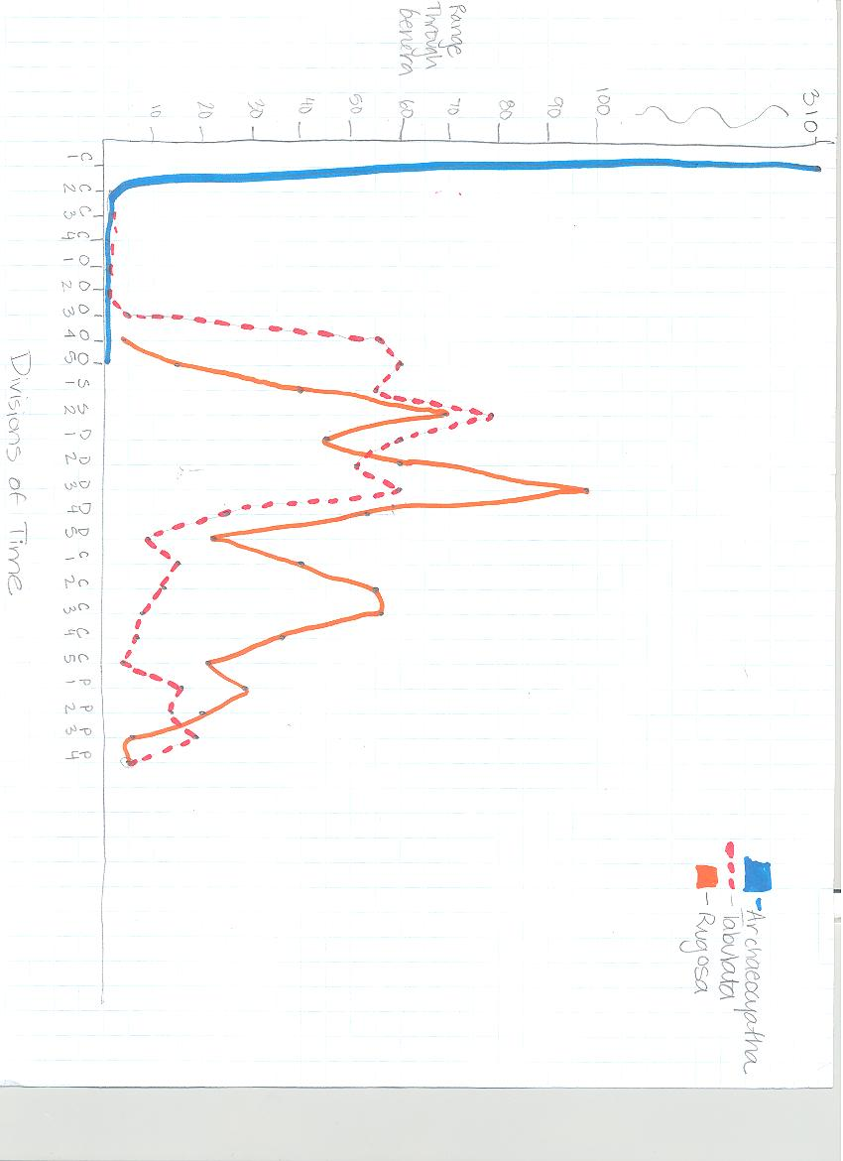
Part Two
Students are given 4 copies of the same image. The images are placed inside an envelope labeled 1-4. The envelopes have varying amounts of holes. The envelope can represent a trial while the holes in the envelope represent a sample. Each hole in the envelope or sample is the same size but the number of samples or holes varies from envelope to envelope. A sample template for how many holes to create in each envelope is provided below. The image and size of holes does not matter. I used a hole punch to create the holes in the envelope. The arrangement of the holes is not significant but it is important to have the placement of the holes be as similar as possible. It is important that as students move from envelope 1 to 2 they are seeing the same pieces of the image they saw in envelope 2 as they did in 1. Envelope 2 is different in that it has additional holes which provide additional new information.

Students will experience how sample size affects conclusions and make connections from this activity to the evidence provided in the fossil record. This activity helps students understand and experience how samples should be selected, how many samples would be enough, when to trust a result that represents the “truth” and helps critical assess what samples mean. This gives students an introduction into how scientist take data from sources like the paleobiology database and evaluate the significance of the data.
Envelope 1

○

Envelope 2

○
○
○
○

Envelope 3

○   
○

○ 

Envelope 4
        
 
Part Three:
Students will conduct their own taphonomy study using paramecium. We will compare the paramecium under normal circumstances and alter an environmental condition to see how it affects the rate of decay or appearance of organism.

Teacher Notes:
Environmental conditions that could be altered include:
- Temperature of water
- Specimen placed in vinegar or other acidic liquids
- Salt added to water and paramecium

Materials:
You will need to purchase live paramecium from a science supply store. I purchased the paramecium from Carolina Biological. It makes for a better experiment if the paramecium are still alive when students are performing this experiment. The movement of the paramecium makes them easily identifiable. Paramecium worked best for this lab because of their relatively large size as compared to cyanobacteria or euglena. I used concave microscope slides but flat or deep well slides will work as well. I used compound light micrcoscopes because that is what is available in my classroom but if you have dissecting microscopes available they may be preferable depending on what slide you choose to work with.

Timing
Results are apparent after 2 hours for most conditions. This lab could be extended for how ever long you wish. I did not see any significant differences from day 1 to day 2 so I kept this experiment to a 24 hour time frame.

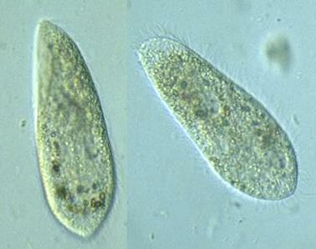
Part Four:
After students have had time to learn about the biological and geological changes and events throughout the geological time scale, students should understand why they are learning about Earth history. The reading titled The Current Mass Extinction, provides a good summary of some challenges we face today.

It is important to present students with examples of how human’s actions can harm species diversity but humans do have the opportunity to reverse some of those potentially damaging actions. One positive example of this is the introduction of the national park system, education and monetary incentives in Costa Rica have reversed the degradation of rain forest habitat. A more local example here is Santa Barbara would be the role in DDT decreasing Bald Eagle populations at the Channel Islands. The decreased bald eagle populations allowed golden eagles to populate the islands and consume wild pig and foxes. The endemic fox population became endangered. Through a series of human actions like captive breeding programs for foxes and bald eagles, banning DDT, and habitat restoration projects the fox and bald eagle populations have been able to increase in number.

California State Standards
Earth and Life History (Earth Sciences)
4. Evidence from rocks allows us to understand the evolution of life on Earth. As a basis for understanding this concept:
a. Students know Earth processes today are similar to those that occurred in the past and slow geologic processes have large cumulative effects over long periods of time.
b. Students know the history of life on Earth has been disrupted by major cata strophic events, such as major volcanic eruptions or the impacts of asteroids.
d. Students know that evidence from geologic layers and radioactive dating indicates Earth is approximately 4.6 billion years old and that life on this planet has existed for more than 3 billion years.
e.Students know fossils provide evidence of how life and environmental conditions have changed.
f.Students know how movements of Earth’s continental and oceanic plates through time, with associated changes in climate and geographic connections, have affected the past and present distribution of organisms.
g. Students know how to explain significant developments and extinctions of plant and animal life on the geologic time scale.
Investigation and Experimentation
7. Scientific progress is made by asking meaningful questions and conducting careful investigations. As a basis for understanding this concept and addressing the content in the other three strands, students should develop their own questions and perform investigations. Students will:
a. Select and use appropriate tools and technology to perform tests, collect data, and display data.
c. Communicate the logical connection among hypotheses, science concepts, tests conducted, data collected, and conclusions drawn from the scientific evidence.
d. Construct scale models, maps, and appropriately labeled diagrams to communicate scientific knowledge (e.g., motion of Earth’s plates and cell structure).
e. Communicate the steps and results from an investigation in written reports and oral presentations.

http://www.google.com/imgres?imgurl=http://www.clevelandhs.org/ourpages/client/library/curric_areas/cool_science_disc2.gif&imgrefurl=http://www.clevelandhs.org/ourpages/client/library/curric_areas/index.html&usg=__dMZodJXz4DFCU-GYdzTyOeZwK0=&h=504&w=416&sz=21&hl=en&start=21&sig2=9G1VHGL64crnOVrXpmoxEQ&zoom=1&tbnid=vlQhcjH27LxDbM:&tbnh=139&tbnw=115&ei=LZocTpnLIKqsAPUmfiSBQ&prev=/search%3Fq%3Dscience%2Blab%2Bcartoon%26hl%3Den%26client%3Dfirefox-a%26rls%3Dorg.mozilla:en-US:official%26biw%3D1280%26bih%3D595%26tbm%3Disch&itbs=1&iact=hc&vpx=309&vpy=239&dur=5946&hovh=247&hovw=204&tx=72&ty=168&page=2&ndsp=21&ved=1t:429,r:1,s:21
http://www.ucmp.berkeley.edu/porifera/archaeocyathalh.html
http://www.google.com/imgres?imgurl=http://www.fcps.edu/islandcreekes/ecology/Miscellaneous/Paramecium/paramecium3.jpg&imgrefurl=http://www.fcps.edu/islandcreekes/ecology/paramecium.htm&h=298&w=378&sz=18&tbnid=Euk58AO3RhZvuM:&tbnh=90&tbnw=114&prev=/search%3Fq%3Dparamecium%26tbm%3Disch%26tbo%3Du&zoom=1&q=paramecium&hl=en&usg=__Q1Vu5rqfv0UynOWk9Y8if1pdjSs=&sa=X&ei=QTodTrmrHIi_gQf9zJnmCQ&ved=0CDoQ9QEwAw&dur=255

