Using Yeast to Enhance a
Cell Unit

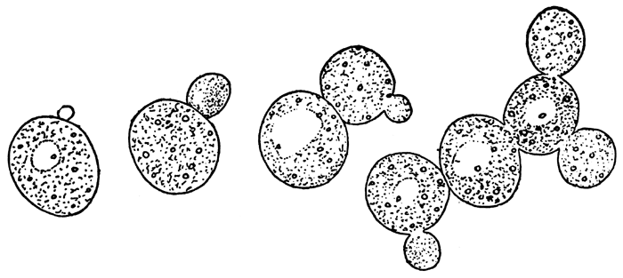

Jenny Willis
Balboa Middle School
Ventura, CA
UCSB RET II

Abstract: The goal of this project was to enhance my 7th grade curriculum by developing hands-on activities to make it more relevant and meaningful to the students. These supplemental lessons using yeast were designed to help students gain a better understanding of the cell biology and genetics standards. Fundamental topics include asexual reproduction, chemical reactions, respiration, fermentation, genetics and cancer. Three of the four labs may be considered inquiry-based activities and feature a lab report template to establish consistent lab activity practices by the students.

Project Overview: During my RET 1 research we synthesized a small, trackable molecule called a dendrimer, loaded with cargo, that went into cells through endocytosis and then released the cargo (drug, dye, etc.). This innovative molecule has possible future applications as therapeutic agents for cancer. Therefore, the focus of this project was on cells and developing an inquiry based lab activity around UV and skin cancer. Yeast was used throughout this unit because it is commonly available, similar to human cells, economical and easy to work with.

Table of Contents:

Activity 1. Asexual Reproduction

  - Lab: Looking at Yeast…a Wee Little Beast

Activity 2. Chemical Reactions in Cellular Respiration

- Elephant Toothpaste

Activity 3/4. Respiration/Fermentation

  - Lab: Yeast Respiration
  - Inquiry Lab: Yeast Taste Test

Activity 5. Genetics/DNA/UV Light/Skin Cancer

- Inquiry Lab: Sun-Screen Your Genes

