Name_________________________________________Date_________________Per.______
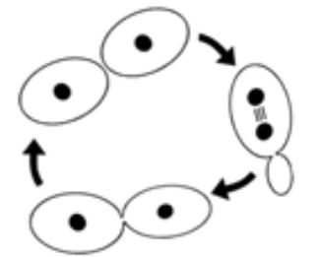
Looking at Yeast…a Wee Little Beast

Objective: To look at common bread yeast Saccharomyces cerevisiae (sack-roe-MY-seas sair-a-VIS-e-eye) under the microscope. You will observe and sketch several yeast cells in different stages of budding.
What is asexual reproduction?
Asexual reproduction is a form of reproduction, which requires only one parent. Unlike sexual reproduction, there is no exchange of genetic material or fertilization. Therefore, organisms that result from asexual reproduction will have the exact same DNA as their parent. Asexual reproduction is the simplest form of reproduction, since organisms are only making genetically identical copies of themselves.
Asexual reproduction can be very advantageous to certain animals. Animals that remain in one particular place and are unable to look for mates would need to reproduce asexually. Another advantage of asexual reproduction is that numerous offspring can be produced without "costing" the parent a great amount of energy or time. Large colonies can form that can out-compete other organisms for nutrients and water. Large numbers of organisms mean that species may survive when conditions or the number of predators change. Environments that are stable and experience very little change are the best places for organisms that reproduce asexually.
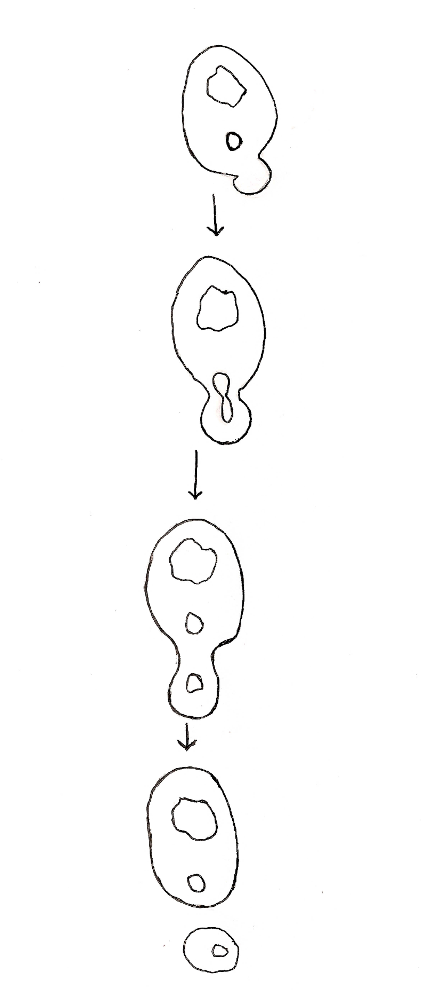
A disadvantage of this type of reproduction is the lack of genetic variation. All of the organisms are genetically identical and therefore share the same weaknesses. A negative mutation can make asexually produced organisms susceptible to disease and can destroy large numbers of offspring. Unfavorable conditions such as extreme temperatures can wipe out entire colonies. Some methods of asexual reproduction produce offspring that are close together and compete for food and space. Yeast are single-celled fungi that produce asexually by budding. In budding the cell wall pushes out, beginning the bud. The cell nucleus moves toward the bud and divides, with one nucleus moving into the bud and the other remaining in the parent cell. The bud grows, and eventually a cell wall grows between the parent cell and the bud. Finally, the bud breaks away and develops into a mature cell.

Describe what is happening to the yeast cell under each picture:

Procedure:
- Get a slide and cover slip
- Place 1 drop of the yeast solution onto the slide
- Hold the cover slip at a 45⁰ angle to the slide and lower the coverslip slowly to avoid any air bubbles.
- Starting on low power, carefully focus the microscope.
- Remember, you may need to adjust the diaphragm and the amount of light coming in.
- Look for various yeast cells in different stages of budding. Accurately draw them in the space provided on the other side.
- Remember you will need to slowly move the slide around while continually adjusting the fine focus knob.

Draw an accurate picture with color of yeast cells in at least 3 different stages of budding :
Total Magnification_________

Questions:

- Describe the appearance of yeast cells that are budding. How many cells are produced?

- What is the difference between sexual and asexual reproduction?

- What are three advantages of asexual reproduction?

- What are three disadvantages of asexual reproduction?

