Yeast Respiration Lab
Teacher Activity Guide

Topic: Cellular Respiration/Fermentation

Subject/grade: 7th grade Life Science

Standards: 1. All living organisms are composed of cells, from one to many trillions whose details usually are visible only through a microscope.
a. cells function similarly in all living organisms
b. that mitochondria liberate energy for the work that cells do and that
chloroplasts capture sunlight energy for photosynthesis
7. Scientific progress is made by asking meaningful questions and conducting careful investigations. As a basis for understanding this concept and addressing the content in the other three strands, students should develop their own questions and perform investigations.
a. Select and use appropriate tools and technology to perform tests, collect data and display data.
c. Communicate the logical connection among hypothesis, science concepts, tests conducted, data collected, and conclusions drawn from the scientific evidence.
e. Communicate the steps and results from an investigation in written reports and oral presentations.

Duration: 2 class periods.

Learning objectives:

The purpose of this laboratory is to explore factors that might affect the rate of respiration in yeast. Students carry out an experiment to investigate and quantify the effect of sugar on yeast respiration. They will do this by observing yeast producing carbon dioxide gas.

Materials needed per Student Group:
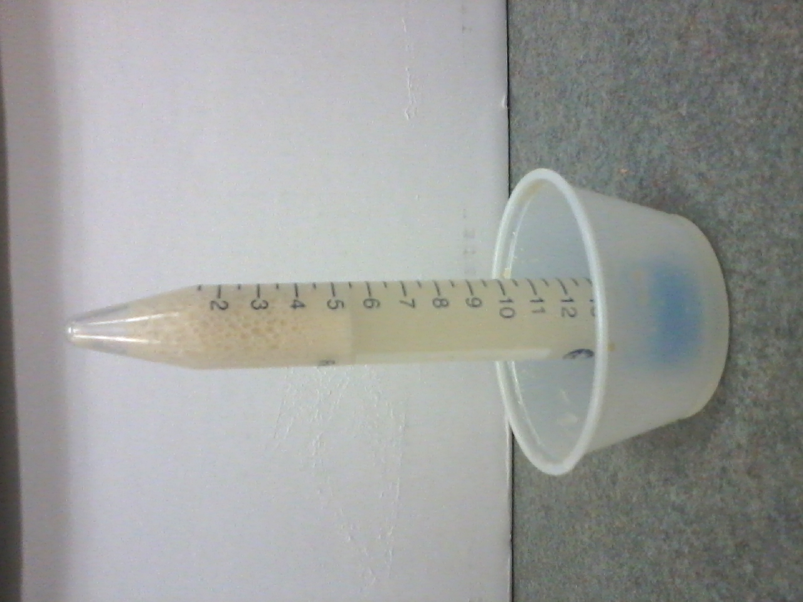
- 2 Graduated tubes/ 15ml centrifuge tubes
(with pinhole in lid)
- 4 small clear plastic cups
- warm water
- table sugar
- stir sticks
- ¼ tsp measurement
- 1tsp measurement
- tape to label tube
- stop watch

Teacher Activities:

Students set up a simple way to indirectly observe and quantify the amount of respiration/fermentation occurring in yeast-sugar and yeast without sugar cultures. Each student adds a small amount of baking yeast to a graduated tube filled with sugar, and one without.

*I used centrifuge tubes I got from UCSB- Falcon 15ml (352097). They are cheap to purchase online, but only come in bulk(500). I did find one place that sells them in packs of 50 for $27.25
http://www.dynamicaqua.com/tubes.html (product # 21008-103A)

Set-up:
- Have a beaker(s)of warm water available for the students. It should be like bath water, between 105-115 ⁰F. A waterbath helps if you have one available.
- Use fresh yeast packets, or dry active yeast (most economical is from Smart and Final)
- Place a pinhole in the top of each graduated tube, this alleviates some of the pressure build up. To do this I lit a tea candle and held the end of a pin in the flame and then pushed it through the top of the cap.
- I used the 15ml graduated tubes. It is helpful if you mark the 1 ml line for the students with a sharpie, the markings start at 1.5 ml
- If you plan on doing the extension and letting them make bread, have paper plates, flour and muffin cups available for them to use.

Pre-lab discussion questions: Put up on overhead
1. Humans use yeast every day. What is yeast, and what are some common uses of yeast?

2. You can buy yeast to make bread in the grocery store. This yeast consists of little brown grains. Do you think that these little brown grains of yeast are alive? Why or why not?

3. To find out whether yeast is alive, we first need to think about what makes something alive. What are some of the Characteristics of living organisms?

Hopefully one of the answers will be they go through respiration or elicit this response if they said they need food. Why do they need food etc?
Review respiration with the students: When yeast, humans, and other living organisms use energy, they break down energy molecules like sugar to get the energy they need and give off gas (metabolism).
Remind the class that yeast cells are microscopic, and ask them if we can actually see respiration occur in yeasts. Some students may suggest that with a good microscope someone might be able to see it. Can these be seen with a microscope? Make sure students understand that molecules are too small to be seen with a microscope.
Then ask the class, "If molecules are too small to be seen, how could we tell if a beaker full of well-fed yeasts living in some nice, warm, water were respiring or not?" Give students some time to figure out that carbon dioxide is produced by respiring yeasts, and since it is a gas, it should bubble up to the surface of the water.
Then tell the class that that is just what they will do: try to determine if yeast cells are respiring or not.

Then ask what else respiring yeast cells produce, and remind them about the answers to #1 and what products are made with yeast? Discuss that yeast can actually respire anaerobically (fermentation). What does that mean? Pointing out that in the process of observing yeast respiration, the class will actually be making a "forbidden" substance -- ethyl alcohol. Mention that if the experiment works, i.e., students are able to provide the conditions necessary for yeast respiration.

*Ask the question, “Do you expect yeast to produce a gas when no sugar or other food is available?”
Activity: Guide students through the Yeast Respiration Lab.

Assessment: Worksheet answers and graph can be graded. See Rubric.

Extensions:
- The next activity: “Taste Test: Can yeast tell the difference?” uses gas production as a measure of rate of yeast metabolism with different sugars. They will compare the results of this lab with different sugars they choose to experiment with.
- After the experiment the students can use the yeast solution tubes to produce a small loaf of bread. For the students to be able to eat their bread after they bake it, it will be necessary to make sure the tubes are clean and that students wash their hands before they start. To make bread they will 1) Put 4 Tbsp of flour and 1 Tbsp of warm water into a bowl. 2) Add the yeast/sugar solution from the tubes. 3) Mix the contents. 4) Knead the dough on a paper plate, add flour as needed. 5) Form a ball and place in a labeled tin muffin cup. 6) Cover with a warm paper towel. Allow at least an hour for the dough to rise. If you need to leave the bread overnight without baking you should store it in a refrigerator so it doesn’t rise too much. You can bake in a preheated toaster oven or as your cafeteria staff to bake them at once, and eat the next day.
- Test for CO₂ by placing a lit match into the tube an it should go out.

Sources: This lesson was adapted from-
- http://serendip.brynmawr.edu/sci_edu/waldron/#fermentation
- www.newark.k12.ny.us/7432082022543997/lib/7432082022543997/Lab_12_Cell_Respiration_in_Yeast_Lab.pdf
Discussion Questions:

- Humans use yeast every day. What is yeast, and what are some common uses of yeast?

- You can buy yeast to make bread in the grocery store. This yeast consists of little brown grains. Do you think that these little brown grains of yeast are alive? Why or why not?

- To find out whether yeast is alive, we first need to think about what makes something alive. What are some of the Characteristics of living organisms?

- Will we be able to see respiration occurring in the yeast? If not, how can we tell?

- What else might they produce?

