Looking at Yeast…Wee Little Beasts
Teacher Activity Guide

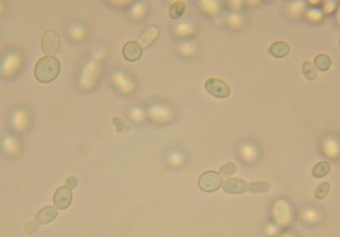
Topic: Asexual reproduction

Subject/grade: 7th grade Life Science

Duration: 1 class period

Materials:
- Yeast (active dry baker’s yeast)
- Warm water
- Sugar
- Slides and cover slips (1 per student group)
- Dropper
- Microscopes (1 per student group)
- Colored pencils

Standards:
1. All living organisms are composed of cells, from just one to many trillions, whose details usually are visible only through a microscope. As a basis for understanding this concept:
a. Students know cells function similarly in all living organisms.
b. Students know the characteristics that distinguish plant cells from animal cells, including chloroplasts and cell walls.
e. Students know cells divide to increase their numbers through a process of mitosis, which results in two daughter cells with identical sets of chromosomes.
2. A typical cell of any organism contains genetic instructions that specify its traits. Those traits may be modified by environmental influences. As a basis for understanding this concept:
a. Students know the differences between the life cycles and reproduction methods of sexual and asexual organisms.

Learning objectives:
- Students will investigate asexual reproduction in fungi (yeast), by looking at common bread yeast (Saccharomyces cerevisiae) under the microscope.
- Students will observe and sketch several yeast cells in different stages of budding.

Prior Knowledge:
Students should have a basic understanding of the differences between sexual and asexual reproduction. Students should have an understanding of the structure and function of cells and organelles.

Background Information:

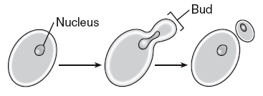
Yeasts reproduce asexually by budding. In the budding process, a bulge forms on the outer edge of the yeast cell as nuclear division takes place. One of these nuclei moves into the bud, which eventually breaks off completely from the parent cell. Budding also occurs in flatworms, which divide into two and then regenerate to form two new flatworms.

Yeast can also reproduce sexually, and usually do so under starvation conditions. Most yeast have two mating types. In the most commonly studied species, Saccharomyces cerevisiae, these are designated a and alpha. When yeast of opposite mating types meet, the cells fuse (plasmogamy), followed by the fusion of their nuclei (karyogamy). This diploid cell can produce more diploid cells by budding. Eventually, a diploid cell will become and ascus and enter meiosis. This produces four haploid nuclei that are then surrounded by thick protective coats and become spores. These spores are released and become new haploid cells.
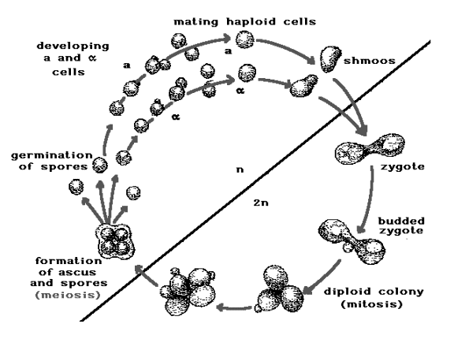

The life cycle of yeast. Yeast cells alternate between budding and mating, as well as mitosis and meiosis. (With permission from Tom Manney)
http://www.phys.ksu.edu/gene/Mating4.html

Bees, ants, wasps, and other insects can reproduce sexually or asexually. In asexual reproduction, eggs develop without fertilization, a process called parthenogenesis. In some species the eggs may or may not be fertilized; fertilized eggs produce females, while unfertilized eggs produce males. There are a number of crop plants, which are propagated asexually. The advantage of asexual propagation to farmers is that the crops will be more uniform than those produced from seed. Some plants are difficult to cultivate from seed and asexual reproduction in these plants makes it possible to produce crops that would otherwise not be available for commercial marketing. The process of producing plants asexually is called vegetative propagation and is used for such crops as potatoes, bananas, raspberries, pineapples, and some flowering plants used as ornamentals. Farmers plant the so-called " eyes" of potatoes to produce duplicates of the parent. With banana plants, the suckers that grow from the root of the plant are separated and then planted as new ones. With raspberry bushes, branches are bent and covered with soil. They then grow into a separate plant with their own root system and can eventually be detached from the parent plant.

Preparation:
At least 2 hours before the activity- Combine 1tablespoon of sugar, one packet of yeast and 1/3 cup (80ml) of warm water, to make yeast solution. Stir well. I usually split this up into a few containers for students to access around the room. You can also make it the day before, and let it sit overnight. You should be able to see a lot of budding cells.

Introductory Teacher Activity:

- Review with students the difference between sexual and asexual reproduction. Elicit responses about what organisms reproduce each way.

- Draw on the board the lifecycle of yeast budding

- If you choose, you can show pictures of budding yeast cells from internet:
http://users.rcn.com/jkimball.ma.ultranet/BiologyPages/Y/Yeast010.jpg
http://studydroid.com/imageCards/card-1661208-front.jpg

- You can also show some short video clips from you tube on yeast budding:
This video clip shows how the quick lab is set up and a picture of the yeast-
http://www.youtube.com/watch?v=D12SXrelgOU or you can go directly to the Tutor Vista site to see this same video http://www.tutorvista.com/content/biology/diversity-in-living-world/budding-in- yeast.php
http://www.youtube.com/watch?v=5ruXdbUl_TE
http://faculty.ccbcmd.edu/courses/bio141/lecguide/unit3/fungi/images/yeastgrowt h.mov

- Read Introduction from lab handout with students.

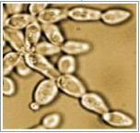
Student Activities:
- Students will read Introduction on lab handout.
- Prepare their slides.
- Label diagram of yeast cells budding.
- Observe and make a detailed sketch of budding yeast cells.
- Answer lab questions

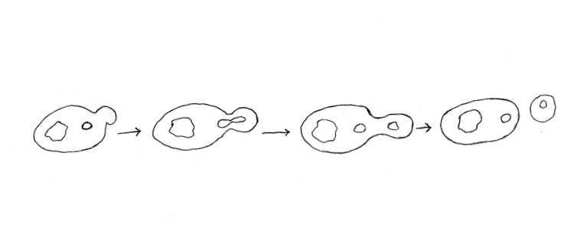
Assessments:
Lab worksheet drawings and answers will be graded.

Key to graphic:

The cell nucleus moves toward the bud and divides.

the cell wall pushes out, beginning the bud.

one nucleus moves into the bud and the other remains in the parent cell.

the bud breaks away and develops into a mature cell.

Other Resources:
http://www.phys.ksu.edu/gene/index.html
http://www.bookrags.com/research/asexual-reproduction-wog/
http://bioweb.uwlax.edu/bio203/s2007/nelson_andr/
http://www.devbio.biology.gatech.edu/?page_id=1226

