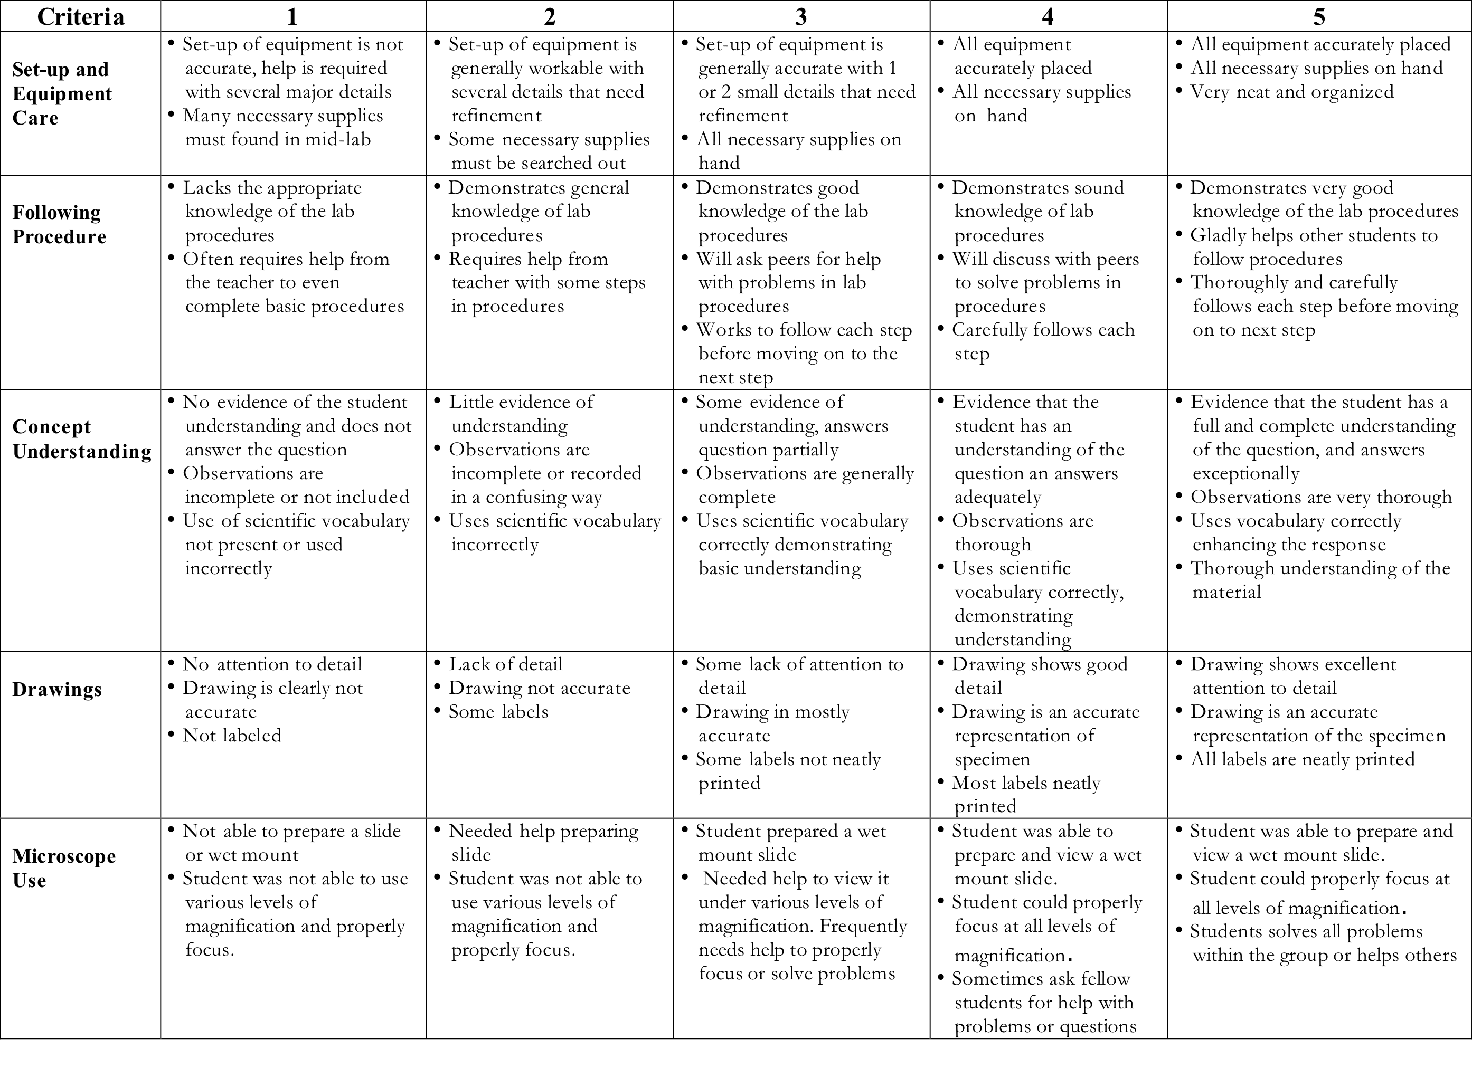
Rubric For Laboratory Activities With Microscope

CA High School Standards:

Although these activities were designed for a middle school life science class, many High School standards are also addressed. These lessons can be adapted to accommodate the H.S. curriculum.

Waves
4. Waves have characteristic properties that do not depend on the type of wave. As a basis for understanding this concept:

a. Students know waves carry energy from one place to another.
e. Students know radio waves, light, and X-rays are different wavelength bands in the spectrum of electromagnetic waves whose speed in a vacuum is approximately 3x10 ⁸ m/s (186,000 miles/second).

Acids and Bases
5. Acids, bases, and salts are three classes of compounds that form ions in water solutions. As a basis for understanding this concept:
a. Students know the observable properties of acids, bases, and salt solutions.
d. Students know how to use the pH scale to characterize acid and base solutions.

Cell Biology
1. The fundamental life processes of plants and animals depend on a variety of chemical reactions that occur in specialized areas of the organism’s cells. As a basis for understanding this concept:
a. Students know cells are enclosed within semipermeable membranes that regulate their interaction with their surroundings.
g. Students know the role of the mitochondria in making stored chemical-bond energy available to cells by completing the breakdown of glucose to carbon dioxide.
4. Genes are a set of instructions encoded in the DNA sequence of each organism that specify the sequence of amino acids in proteins characteristic of that organism. As a basis for understanding this concept:
c. Students know how mutations in the DNA sequence of a gene may or may not affect the expression of the gene or the sequence of amino acids in an encoded protein.
5. The genetic composition of cells can be altered by incorporation of exogenous DNA into the cells. As a basis for understanding this concept:
a. Students know the general structures and functions of DNA, RNA, and protein.

Investigation and Experimentation
1. Scientific progress is made by asking meaningful questions and conducting careful investigations. As a basis for understanding this concept and addressing the content in the other four strands, students should develop their own questions and perform investigations. Students will:
a. Select and use appropriate tools and technology (such as computer-linked probes, spreadsheets, and graphing calculators) to perform tests, collect data, analyze relationships, and display data.
b. Identify and communicate sources of unavoidable experimental error.
c. Identify possible reasons for inconsistent results, such as sources of error or uncontrolled conditions.
d. Formulate explanations by using logic and evidence.

