Name:
Date: Period:

Electromagnetic Spectrum: Introduction to Radiation

  - What is the electromagnetic radiation?

  - Fill in the table with information about each type of electromagnetic radiation.
Spectrum | Wave Type | Wavelength | Properties and Uses
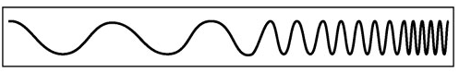 | Radio
 | Microwave
 | Infrared
 | Visible
 | Ultraviolet
 | X-Ray
 | Gamma

- Describe and draw the observed spectrum of the following forms of radiation.
Type of Radiation | Description of Radiation | Observed Spectrum
Sunlight
Incandescent Lightbulb
Fluorescent Lightbulb
Black Light
Glow Stick

- Why do you think incandescent bulbs have a different emission spectrum than fluorescent bulbs?

- What is the main difference you saw in the absorption spectrum between sunlight and the other types of light?

Name:
Date: Period:

Exploring Planets with Absorption Spectroscopy

Objective: Identify the wavelength of each peak and the chemical responsible for each of the labeled peaks using the INFRARED absorption spectrum on the Earth, Venus and Mars Reference Card.

 | Wavelength | Chemical
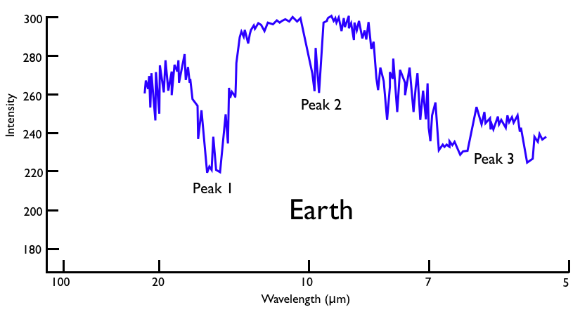 | Peak 1  Peak 2  Peak 3 | Peak 1  Peak 2  Peak 3
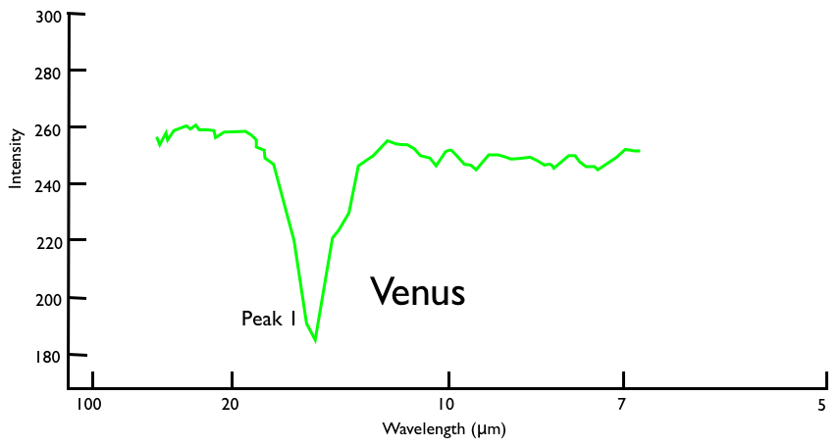 | Peak 1 | Peak 1
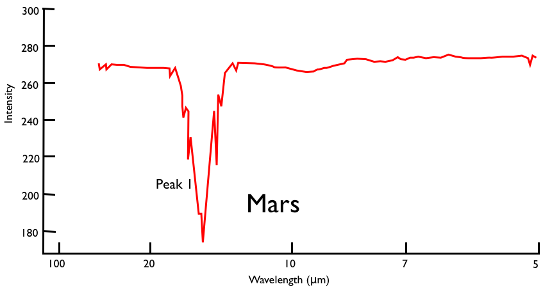 | Peak 1 | Peak 1

Objective: Identify the wavelength of each peak and the chemical responsible for each of the labeled peaks using the ULTRAVIOLET absorption spectrum on the Saturn and Titan Reference Card.

 | Wavelength | Chemical
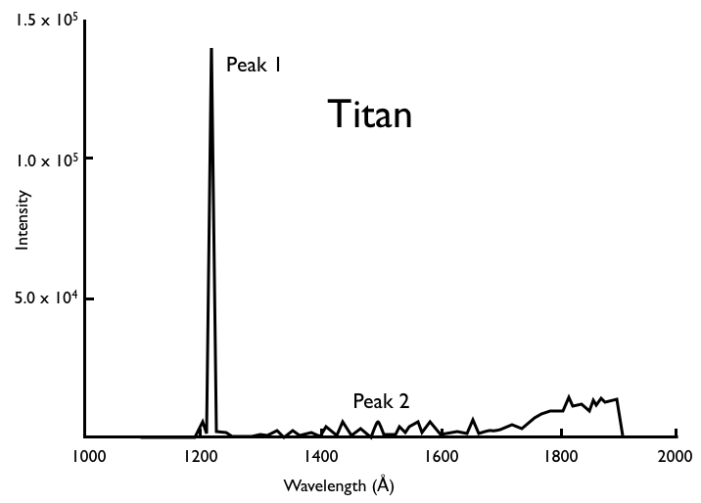 | Peak 1  Peak 2 | Peak 1  Peak 2
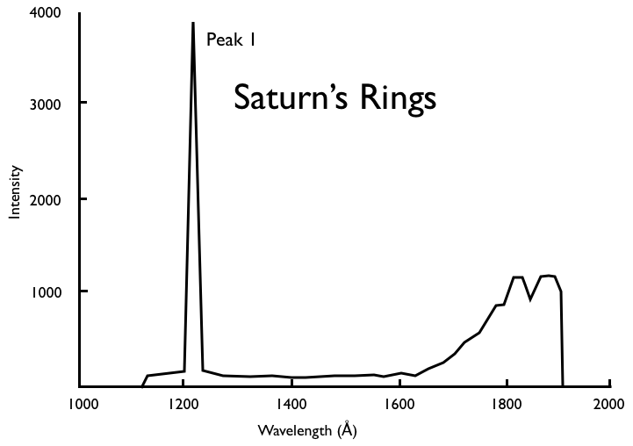 | Peak 1 | Peak 1

Analysis:

Why is Peak 2 so small on Titan and Saturn’s spectra compared to the reference card peak for that chemical?

Name:
Date: Period:

Searching for Life in the Universe Using Spectroscopy

Questions: Use your notes to answer each question thoroughly and in complete sentences.
- What gases does life require? What does does life product?

- What is the difference between a terrestrial and gaseous planet?

- What does it mean for a planet to be in the “habitable zone”? What planets are in the habitable zone?

- Why is it important to look at Archean Earth when trying to understanding life on our planet?

Planetary Spectral Analysis: The planet spectra data shown below represents the infrared portion of the electromagnetic spectrum, where planets re-emit the energy absorbed from their parent star. The dips in the curve result when gases in the planet’s atmosphere absorb certain wavelengths of energy. Because every element and compound has a characteristic pattern of absorption, the location of these absorption bands allow scientists to identify different the element or compound in the atmosphere that is absorbing the energy.

Instructions: Identify the wavelength and brightness for each peak.

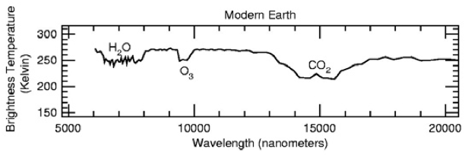 | Wavelength  H2O  CH4  CO2 | Brightness  H2O  CH4  CO2
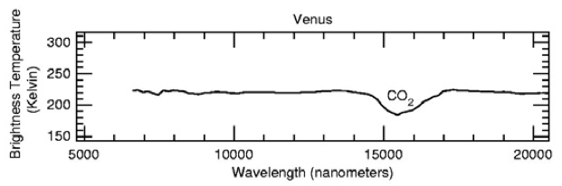 | Wavelength  CO2 | Brightness  CO2
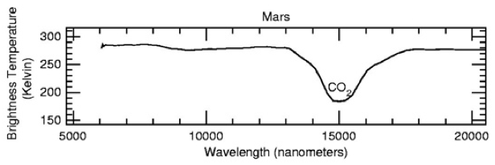 | Wavelength  CO2 | Brightness  CO2
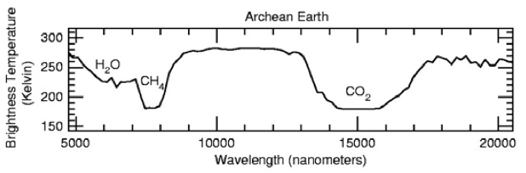 | Wavelength  H2O  O3  CO2 | Brightness  H2O  O3  CO2

Planetary Spectral Analysis Questions: Use the absorption spectrum to answer the following questions.

- What gases, if any, are common to all four planet spectra?

- How does your answer from Question 1 impact where scientists should be looking in order to find life on other planets?

- What gases are likely to be present in the atmosphere of a planet with life? Would your answer be different if it were primitive or complex life?

- Can the infrared portion of the spectrum be used to look for molecules important for life? What absorption peaks (USE NUMBERS) should scientists be looking for?

Instructions: Read Chemical Fingerprints, then answer the following questions using complete sentences.

- What is it difficult to study a planet using visible light?

- Explain the two methods will Terrestrial Planet Finder missions use to search for other planets?

- How does studying starlight tell you the chemical composition of an object?

- What chemicals are the Terrestrial Planet Finder missions looking for? What absorption peaks are scientists looking for? Why these chemicals?

- Since oxygen does not absorb in infrared, how can scientists test for atmospheres with oxygen?

- What is a greenhouse gas?

- Why are scientists looking for methane, even though there is very little methane in Earth’s atmosphere today?

Mystery Atmosphere: Now its time to apply what you learned...

- What four chemicals are scientists looking for on terrestrial planets?

- Identify the molecule responsible for each absorption peak using Chemical Fingerprints

- Label each absorption peak

- What do you think about the mystery atmosphere? Can this planet support life? Compare and contrast this spectrum to Earth, Venus, Mars and Archean Earth. Explain your answer using data from the absorption data.

