Teacher’s Guide to Nutrient Surplus and Algal Blooms

Making Connections:
Part 1: The Carbon Cycle and Upwelling
Part 2: Identifying Upwelling (graphing)
Part 3: Nutrient Surplus and Algal Blooms
Part 4: Predicting Agricultural Run-Off (graphing)

Grade: 10th, 11th

Prior Knowledge:
- Basic Marine Food Webs and Trophic Levels. For help, please visit: http://www.bigelow.org/edhab/fitting_algae.html
- Convection/Density
- The element carbon and how it is found in organic materials for life.

Objectives:
The Carbon Cycle and Upwelling:
- Describe the reservoirs of carbon on a global scale
- Outline the movement of carbon between natural reservoirs
- Define the steps phytoplankton undergoes to remove carbon from the atmosphere
- Diagram the natural process of upwelling
Agricultural Run-off and Nutrient Surplus:
- Read about harmful algal blooms and explain how excess nutrients can contribute to the frequency and intensity of blooms
- Describe the different hazards algal blooms can bring to a marine environment, such as eutrophication and toxic fish poisoning
Predicting Algal Blooms
- Analyze a data set from buoy measurements in Monterey, CA and make inferences about upwelling and phytoplankton growth.

Part 1: The Carbon Cycle and Upwelling (Teacher’s Edition)

Carbon can be stored in reservoirs on earth such as the ocean, atmosphere, biomass, fossil fuels and rocks. The carbon cycle describes the movement of the element carbon during processes such as weathering, erosion, photosynthesis, respiration, volcanic activities, decomposition, animal waste and combustion.

The carbon cycle is a key concept in biology when we teach about photosynthesis in phytoplankton, but it is also fundamental in regards to larger phenomena such as climate change and ocean acidification. To understand how nutrients affect algal growth, it is important for students to have an overall understanding of nutrient circulation on a global scale during natural processes such as the carbon cycle and upwelling.

More information about the importance of the carbon cycle can be found here: http://www.education.noaa.gov/Climate/Carbon_Cycle.html

More in-depth activities using the carbon cycle can be found here: http://www.esrl.noaa.gov/gmd/education/carbon_toolkit/teacher_reference.html

Diagram Activity: Explain to students what the carbon cycle is and how it moves throughout the planet.

Have students draw their own carbon cycle poster, including their own examples of carbon reservoirs.
A. Carbon Reservoirs
1. Ocean
2. Atmosphere
3. Fossil Fuels
4. Earth’s Crust (rock)
5. Biomass (plants and animals)

http://oceancolor.gsfc.nasa.gov/SeaWiFS/LIVING_OCEAN/carbon_cycle.png

Upwelling: Explain to students the basic idea of upwelling (you can remind them of density and convection here too); upwelling is a process in which deep, cold water rises toward the surface. Winds blowing across the ocean surface push water away. Water then rises up from beneath the surface to replace the water that was pushed away. Upwelling occurs in the open ocean and along coastlines. Water that rises to the surface as a result of upwelling is typically colder and is rich in nutrients. These nutrients “fertilize” surface waters, meaning that these surface waters often have high biological productivity. Therefore, good fishing grounds typically are found where upwelling is common. (http://oceanservice.noaa.gov/facts/upwelling.html)
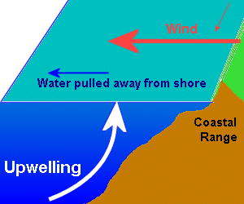
Apollo.lsc.vsc.edu

Making Connections: Link the concept of photosynthesis and algae to the global carbon cycle by helping students understand the role phytoplankton play in the uptake of carbon.

- On a projector or in a computer lab, visit the website: http://www.nwfsc.noaa.gov/hab/habs_toxins/phytoplankton/images/AlgalGrowth_Revised2.swf
- Before showing video, tell students that they will watch an animation that helps explain the role phytoplankton play in the carbon cycle. While they are watching it, they should be trying to identify which animation shows which step in photosynthesis. How many steps did they see? (They have the vocabulary needed for describing the steps within the formula on the animation, but you should also give them of the word “upwelling”.)
- Now have students sit in pairs and show the video again; during the animation, they will try to tell each other what is happening at each step.
- Now show it again, only this time, they will write each step as they see it- you can pause the video between each step and have them shout it out as a class and write is down together.

Answer Key:
- Phytoplankton receive energy from the sunlight
- Phytoplankton receive carbon dioxide from the atmosphere.
- Phytoplankton receive nutrients from the seafloor brought up during upwelling.
- Phytolankton grow
- Phytoplankton cells release oxygen back into the atmosphere during phytosynthesis

Check for understanding:
- How do plankton reduce carbon dioxide levels in the atmosphere? (They take it in during photosynthesis)
- How do plankton increase oxygen levels in the atmosphere? (They release it during photosynthesis)
- How are phytoplankton on the ocean different than plants on land? (They get nutrients from processes like upwelling or land runoff, whereas most plants get nutrients from soil.)

Extension: Read National Geographic article, “The Case of The Missing Carbon”: http://environment.nationalgeographic.com/environment/global-warming/missing-carbon/#page=1

Part 2: Predicting Upwelling (Teacher’s Edition)

Making Connections: Graphing Activity

The following activity is adapted from a ‘Teaching Box’ pilot program in Berkeley, CA.
http://www.teachingboxes.org/upwelling/index.jsp

The graph is attached, but can also be found at: http://www.teachingboxes.org/upwelling/lessons/lesson3_supplement/StudentDataforGraphing.pdf

Class Discussion:
The natural process of upwelling occurs when warm surface water is pushed by wind, allowing cooler, more nutrient rich water to rise to the surface. How can we determine if and when upwelling occurs? Scientists look at various sets of data to determine natural patterns (and sometimes unnatural patterns) in the ocean. Remind students that upwelling off the coast of California is caused by winds from the north.

Graphing:

- As a class, look at the data table for seasonal temperatures from 2002 and ask students what each measurement means. Help them navigate through the data table so they are familiar with the measurements and variables such as nitrates, etc.
- Ask the class if they see any patterns in the data? Are there any relationships between the values and the ocean temperature?
- Now draw their attention to May 2002* and have them look at the nutrient levels that correspond to the change in temperature. Have them create a hypothesis based on the data:
  - A decrease in temperature occurred as levels of nutrients, such as nitrate and phosphate, increased.
- Have all students graph the temperature fluctuation from January 2002 to December 2002.
  - Each student should have a MBARI data table* and a piece of graph paper.
  - The months in 2002 should be on the x-axis and the temperature should be on the y-axis. Be sure to remind them that the temperature only varies by about 7° F/4° C before they make their graph and suggest using a pencil.
  - Work as a class or have students work independently, depending on their ability level.
  - Have the students connect the points to create a graph and trace over line with red. Below graph in bottom corner, use red color to label the line as “temperature over time”.

- Divide class into groups of four. Have each student choose a different variable to graph on the y-axis (along with temperature):
  - Nitrates
  - Phosphates
  - Silicates
  - Iron

- Have students in groups label the variable they graphed in color (Green for nitrates, blue for phosphates, orange for silicates or black for iron, for example.) Make sure they use this color to add a key at the bottom of the page.

Results:

- Have students compare graphs with their group. Are there any patterns? (All nutrients increased in May as the ocean temperature decreased).
As you look at each graph with the students, ask questions such as:
- Do you see any changes through the year? Describe the pattern.
- In what months is this resource abundant?
- In what months is it scarce?
- How is this resource related to upwelling?
- How is it used in the food web?
- What organisms might be affected if this resource is abundant?
- How would these organisms be affected if this resource were scarce?
- What evidence do the graphs provide that tells us when upwelling is happening?

Conclusions:

- Have students create a written reflection of the discussion and graphing activity. “What inferences can you make from the data you graphed? Was your hypothesis correct? Why or why not? What could the data imply? [In May 2002, the temperature dropped, probably due to wind patterns and upwelling. With that cold water came an abundance of nutrients, such as nitrate, phosphate, silicate and iron.]
- What is the difference between upwelling and agricultural run-off? [Upwelling is a natural process that brings cooler water and nutrients from the bottom of the ocean to the surface. Run-off is fresh water often containing fertilizers that adds a surplus of nutrients to the shore.]
- What variable could scientists measure and add to the data chart to determine if agricultural run-off was present? [They could measure the salinity. Lower salinity could indicate more fresh water running into the ocean.]

[*Please Note: The data in the table created using buoy information from the Monterey Bay Aquarium has been modified for 5/2002 and data has been combined from a few different buoys to make a more simplistic chart for students to graph.]

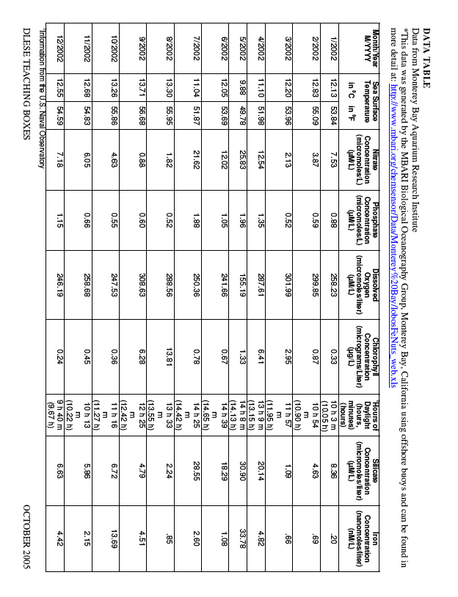

http://www.teachingboxes.org/upwelling/lessons/lesson3_supplement/StudentDataforGraphing.pdf

Part 3: Agricultural Run-off and Nutrient Surplus (Teacher’s Edition)

Reading Activity: Have students read the following passage, giving them a question* to focus on before the reading, such as:

“What makes marine algae grow so fast and why can it be a problem for marine environments?”

*This helps students distinguish what to focus on while reading, and helps them differentiate between the main ideas and the interesting details.

Reading:

What is an algal bloom? An algal bloom is a rapid increase in the number of algal cells that dominate the planktonic community. A “bloom” refers to a population of phytoplankton who’s population has suddenly exploded, often becoming visible to the naked eye.

What causes an algal bloom? Like land plants, algae need certain things to grow – water, carbon dioxide, sunlight and nutrients. Carbon dioxide is plentiful in the marine environment, but sunlight and nutrients can be scarce. Sunlight is available near the surface of the water, so algae grow readily when they can remain near the surface. Nutrients are abundant in areas of run-off where water flows over land and picks up minerals that are then carried to the sea. Nutrients are also plentiful in areas where cool, deep, nutrient-rich waters are brought to the surface due to upwelling, tides or wind-driven mixing. When the algal cells get everything they need to grow, they can divide very rapidly and potentially create a bloom.

Phytoplankton live in a very dynamic environment. The ocean is always moving and algae and nutrients move with it. Not only can regional circulation patterns affect the nutrient concentrations in the water, but also they can actually physically concentrate or disperse algal cells. In addition, many algal species thrive under only certain temperature and salinity conditions. And finally, for algae to bloom successfully, there must be a limited number of grazers (organisms that eat plankton) in the area. After all, if there were enough grazers to keep the algal population under control, there wouldn’t be a bloom. (http://www.bigelow.org/edhab/pdf/building_bloom.pdf)

Why are large algal blooms harmful? Harmful algal blooms (HABs) can negatively impact organisms in a variety of ways that can range from cell and tissue damage to organism death. Some HABs are not toxic; they do not produce actual toxins that kill animals, but instead, create an environment that is unhealthy for other organisms. For example, with an excess of nutrients, algae will grow a thick layer on the water’s surface, preventing the light penetration and oxygen absorption necessary for underwater life. This process is referred to as eutrophication. (http://www.bigelow.org/edhab/help_hab.html)

Algae that produce potent toxins can cause toxic blooms, massive fish kills, marine mammal deaths, and human illness. There are several types of toxins produced by these harmful algae. Commonly, the toxins affect the functioning of nerve and muscle cells. Toxic blooms have been responsible for causing respiratory irritation and distress, diarrhea, vomiting, numbness, dizziness, paralysis, and even death.

How can a toxin in phytoplankton cells cause such serious illnesses in so many different organisms? The key is how the toxins move through the food web.
Although a phytoplankton cell may only contain a tiny amount of toxin, imagine how
much toxin a copepod would contain if it ate dozens of phytoplankton cells a day! Now
imagine how much toxin a right whale would contain if it ate thousands of those
copepods a day!

An important component involved in our scenario above is bioaccumulation. Bioaccumulation is the process by which compounds accumulate or build up in an organism at a rate faster than they can be broken down. Several organisms, including copepods, krill, mussels, anchovies, and mackerel, have been found to retain toxins from phytoplankton in their bodies. These organisms are often not affected by the toxins, but act as vectors and transport the toxins up the food web. There have been several cases of whale and sea lion illness and death attributed to this process. In many cases the toxins can be transported through the food web to humans, often through contaminated shellfish. The toxins can impact humans in different ways leading to mild symptoms or even death. The toxins cause many illnesses, including Ciguatera Fish Poisoning, Diarrhetic Shellfish Poisoning, Neurotoxic Shellfish Poisoning, Paralytic Shellfish Poisoning, and Amnesic Shellfish Poisoning. (http://www.bigelow.org/edhab/pdf/tracing_toxins.pdf)

Questions from Reading:

- What are algal blooms? What causes an algal bloom to occur? (An algal bloom is a rapid increase in the number of algal cells that dominate the planktonic community. A “bloom” refers to a population of phytoplankton who’s population has suddenly exploded)
- How can large algal blooms be harmful? (They can produce toxins that move through the food chain and can also block sunlight, reducing photosynthesis)
- What is bioaccumulation? (Bioaccumulation is the process by which compounds accumulate or build up in an organism at a rate faster than they can be broken down.)

Part 4: Predicting Agricultural Run-Off (Teacher’s Edition)

Making Connections: Computer Graphing Activity

Background: Algal Blooms can occur naturally from a surplus of nutrients during the natural process of upwelling, but usually happen suddenly when agricultural waste and fertilizers drain into the oceans along the coasts from rivers and other freshwater drainages. Not all blooms are toxic, but can harm ecosystems by promoting a process called eutrophication, where the phytoplankton smother the surface and suffocate life below it.

Goal: In this activity, students will look at some REAL data collected from the Monterey Bay in California and predict where agricultural run-off is occurring.

1. Go to http://www.mbari.org
2. Click on the tab along the top called “Ocean Observatories” or type http://www.mbari.org/moos/ into your browser.
3. Click on the “Land/Ocean Biological Observatory (LOBO)” square on the upper right of the picture or type http://www.mbari.org/lobo/default.htm into your browser.
b. Drag the curser over the picture of Elkhorn Slough to uncover a graph. Examine the graph: what variables is the graph comparing over time? [salinity and nitrates] Where does the line spike? [nitrates] Where does is dip? [salinity]
c. Complete this sentence:
“As nitrates levels [increase], salinity levels appear to [decrease].”
4. Many answers are possible. Look at map and point to buoys off-shore- these will be more like a pier. Buoys near smaller, stagnant waters will be more like the estuary and buoys near more open water flow will be more like the harbor, depending on where you live.
d. Where do you think agricultural nutrient run-off could be a problem? Why? [near farmland]

5. Click on the “Real-Time” data tab from the list on the left-hand side of the screen.
6. Look at the top of the screen for the network status of the buoys. Currently, L1, L3 and M1 are online for data comparison. These buoys are similar enough to the pier (M1), harbor (L1) and Estuary (L3) that was sampled in a previous activity, as they have similar environmental conditions. If this is not the case when you are doing this activity, choose similar buoys that are online by referencing the maps.
a. At which of the three sites above would you expect to find higher nitrates (nutrients) and lower salinity (more fresh water from land)? [L3]

b. Why would higher nitrate levels and lower salinity levels indicate run-off? [More freshwater carrying farm waste and fertilizers]

7. Graphing: Select “real-time data” from the left-hand column of the page. Choose the following option on the tables to create a graph, comparing nitrate and salinity levels at the three different sites:
- “How many graphs” = One
- “What dates?” = month ending on end date
- “End date?” = today (this will give a graph for the last month)
- Graph 1 = Select L01
- X-variable = Date
- Y-variables = hold the shift key to select both nitrates and salinity.
- Look at the bottom, right-hand corner of the screen and hit “send”.
*It may take a minute or two for your graph to load. When viewing the graphs, peaks in nitrates and dips in salinity occurring at the same time indicate run-off.

8. Now change the number of graphs to 3.
- For graph 1, select L1, dates and select both nitrates and salinity
- For graph 2, select L03, dates and select both nitrates and salinity
- For graph 3, select M1, dates and select both nitrates and salinity
- Then hit “send”

Expected Results:

When students compare all three graphs, they should see a pattern where salinity level changes a lot near L03 due to tidal pumping and daily run-off from fields, M01 is fairly unvaried and L01 may have a few sharp spikes or dips depending on how much run-off and/or rainfall occurred at the time period it registered. If you have time, after looking at the past month, choosing a time period when you know a winter rain event occurred could also be useful in seeing a clear decrease in salinity and increase in nitrate for L01.

L03 is the most affected my agriculture and tidal run-off; visit these case studies for a more in-depth understanding:

http://www.mbari.org/lobo/results.htm

http://www.mbari.org/lobo/casestudy1.htm

For more advanced classes or if you have more time, students can also select and compare other variables such as oxygen, chlorophyll and turbidity. See power point in “Teacher Resources” on ‘abiotic factors affecting plankton growth’ for help interpreting any results.

