Teacher/Student Version

Shell-Shocked

How does lowered ocean pH affect the exoskeletons of calcifying organisms?

Key Concept
Ocean acidification lowers the pH and disrupts the carbonate chemistry in the ocean, and calcifying organisms need carbonate to build their shells.

What you should know
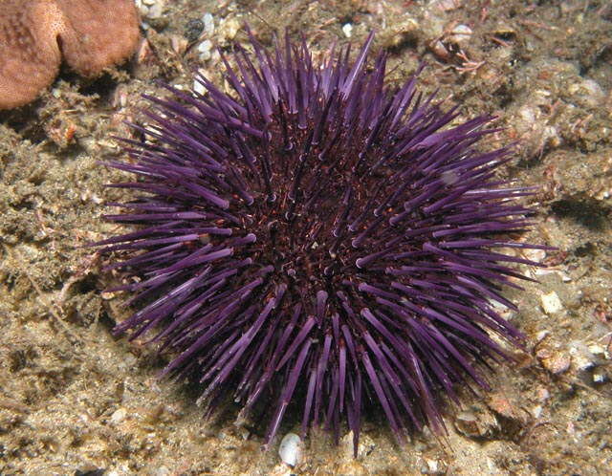
- The oceans have absorbed about half of all the extra carbon dioxide people have put into the air over the last 150 years.
- When CO₂ dissolves in seawater, it forms carbonic acid, which releases hydrogen ions into solution. Here are the equations that represent this process
CO₂ + H₂O <-> H₂CO₃
Carbon dioxide combines with water to form carbonic acid

H₂CO₃ <-> H⁺ + HCO₃⁻
Purple sea urchin (www.stanford.edu)

Carbonic acid dissociates (comes apart) and forms hydrogen and bicarbonate ions
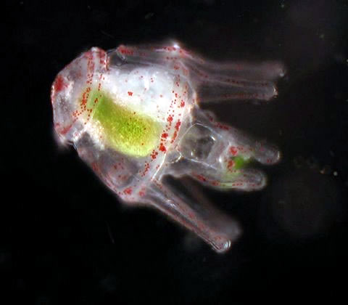
- The increase in the hydrogen ion concentration causes a decrease in pH. In addition, hydrogen ions combine with any carbonate ions in the water to form bicarbonate:
H⁺ + CO₃²⁻ <-> HCO₃⁻.
- This process removes carbonate ions from the water. Calcifying organisms like sea urchins use carbonate to combine with calcium to make calcium carbonate. Shells and skeletons are made mostly of calcium carbonate.
Purple sea urchin larva (M. O’Donnell)

- A big question now is whether calcifying organisms will be able to cope with the lower availability of carbonate. In this activity, students will observe the effect of lower pH on shells that have already formed.

Materials (per group of 4-5 students)
- 3 beakers or plastic cups
- Seawater
- White vinegar
- pH paper
- Piece of cuttlefish bone, seashell or chalk
- Balance
- Plastic weigh boats for drying the shells post-treatment

The Prediction
We are going to place shells in three treatments: seawater, a mix of seawater and vinegar (a weak acid), and pure vinegar. What do you think will happen to the shells in these treatments?

Procedure
- Weigh your three shell samples. Record the initial mass (in grams) in your data table.
- Trace each shell on a piece of paper and label the tracings.
- Record initial observations of each shell. For example: What color is it? Lightly press down on the shell. How firm is it?
- Prepare treatment beakers: fill one beaker with seawater, another beaker with ½ seawater and ½ vinegar, and a third beaker with just vinegar.
- Test the pH of each solution with pH paper. Record pH in your data table.
- Place your three shells in each of the three treatments. Let sit for at least 3 hours or leave overnight.
- Remove the shells from the treatments with a spoon onto a paper towel.
- Lightly press down on the shells with your thumb and observe what has happened to them. Record observations in the data table.
- Retrace each of the three shells. Compare the tracings to the originals.
- Let the treated shells dry on a weigh boat overnight and re-weigh them. Record the new masses in the data table.

What’s happening?
Many types of marine organisms make shells or hard exoskeletons from calcium carbonate. Vinegar (acetic acid) is a weak acid. When a shell is placed in a vinegar solution, the acetic acid reacts with the calcium carbonate, forming carbon dioxide and calcium acetate.

CH₃COOH +CaCO₃ → CO₂ + Ca(C₂H₃O₂)₂
Acetic acid and calcium carbonate react to form carbon dioxide and calcium acetate

The calcium acetate dissolves in the water, so the mass of the shells in the vinegar should decrease and they should get a little smaller. The carbon dioxide is released as a gas. This is why students may have observed bubbles forming on the surface of the shells in the vinegar solutions.
The ocean will never become as acidic as acetic acid solution, but the lower pH in this activity allows the effects to be seen over a shorter amount of time. For a longer-term experiment that more accurately models ocean chemistry, place shells in soda water (water with CO₂ bubbles) for days to months and observe the effects.

Discussion
- Did you notice any bubbles on the shells in any of the three treatments? What are these?
- How did the shell feel after being in the vinegar? Why do you think it felt this way?
- How did lower pH affect the size and mass of the shells?
- What was your control group in this experiment? Why was it important to have this group?
- How do the pH values for your treatments compare with the pH of the ocean now and the predicted pH of the ocean in the future due to ocean acidification? Do you think our experiment is a good model for what will happen to calcifying organisms if the ocean continues to become more acidic? Why or why not?
- Oysters make shells using the calcium and carbonate from the ocean. What are other examples of calcifying organisms?
- How do you think calcifying organisms will be affected if the ocean continues to become more acidic? How will the changes in the calcifiers affect the community? The ecosystem?
- How can humans slow the acidification of the ocean?

